**The SAS CMS project**

**Functional Reference Manual**

**Manpower**

*Document type: Description*

*Document status:*

*Last changed: Mar14, 2013*

*Owner: Ann Lindberg, Jeppesen*

Table of Contents

1 Introduction 7

1.1 This Document 7

1.2 Change History 7

2 Miscellaneous 9

2.1 Crew Filter 9

2.2 Scenarios and Revisions 10

2.3 Accumulation 10

2.4 Scripts 10

3 Crew 12

3.1 Explanation on detailed information 12

3.1.1 PRE 12

3.1.2 Last Flown 12

3.2 Technical summary 12

3.3 Rave 12

3.4 Database Tables 12

3.5 Scripts 13

3.6 Forms 13

3.7 Reports 13

3.8 Configuration 13

4 Crew Establishment 14

4.1 Drivers 14

4.1.1 DriverAssignedInActivity_ 14

4.1.2 DriverFreeDaysVariable_ 14

4.1.3 DriverPartFreeVariable_ 15

4.1.4 DriverFreeLHBaseAct_ 15

4.1.5 DriverFreeReductionVariable_ 15

4.1.6 DriverPartReductionVariable_ 16

4.1.7 DriverFreeDaysFixed_ 16

4.1.8 DriverFreeReductionFixed_ 17

4.1.9 DriverPartFreeFixed 17

4.1.10 DriverPartReductionFixed_ 17

4.1.11 DriverPairing_ 17

4.1.12 DriverStdParamForm_ 18

4.1.13 DriverSmearing_ 19

4.1.14 DriverSupply_ 20

4.1.15 DriverFreeDaysVariableParam_ 20

4.1.16 DriverFreeReductionVariableParam_ 21

4.2 Reports 21

4.2.1 map_establishment_tasks 21

4.2.2 Free Days Calculation 22

4.3 Pairing export data 23

4.3.1 View Pairing Export Data 23

4.3.2 Configure Establishment Settings. 24

4.4 Manage Request Quota 24

4.5 Trip definitions and actual results 25

4.5.1 Trip definition 25

4.5.2 Activity codes 25

4.5.3 Ranking in order of priority 27

4.6 Accumulation 27

4.7 Technical summary 27

4.7.1 Free day drivers distribution 27

4.7.2 Rave 29

4.7.3 Database Tables 29

4.7.4 Scripts 30

4.7.5 Forms 30

4.7.6 Reports 30

4.7.7 Configuration 30

5 Training 31

5.1 Training Effects 31

5.1.1 crew_rest_acqual 31

5.1.2 crew_qual_acqual 31

5.2 Rules 31

5.2.1 No overlap 31

5.3 Reports 32

5.3.1 course_list 32

5.3.2 Schoolplan 33

5.3.3 Course_details 34

5.4 Course Participant best guess 35

5.4.1 Unknowns – existing crew 35

5.4.2 Unknowns – new crew 35

5.5 Course Release 36

5.5.1 Release Course Examples: 37

5.6 Crew Publish 40

5.7 Technical summary 40

5.8 Rave 40

5.9 Database Tables 40

5.10 Scripts 41

5.11 Forms 41

5.12 Reports 42

5.13 Configuration 42

6 Seniority 43

6.1 Technical summary 43

6.2 Rave 44

6.3 Database Tables 44

6.4 Scripts 44

6.5 Forms 44

6.6 Reports 44

6.7 Configuration 44

7 Transition 45

7.1 InterBids Import 45

7.1.1 Import Bids 45

7.2 The transition run 45

7.2.1 Transition rank 45

7.2.2 Automatic calculation of new promotions 45

7.2.3 Predefined Assignments 45

7.2.4 Vacancy bidding and total bidding 47

7.2.5 The assignment 48

7.2.6 Qualifications 48

7.2.7 Minimizing the number of movements 49

7.2.8 Maximizing bid fulfillment 49

7.2.9 Movement restrictions from and between crew groups 49

7.2.10 Consideration to part time work rate 49

7.2.11 Determination of changed crew parameters 50

7.2.12 Assigning per base 50

7.2.13 Assignment rules 52

7.3 Reports 54

7.3.1 compare_transitions 54

7.3.2 transition_list 55

7.3.3 transition_matrix 55

7.4 Bid types 56

7.4.1 FBID Bids 56

7.4.2 ATPL Bids 57

7.4.3 CCAC Bids 57

7.5 Crew Portal Bid Configuration (for Transition) 57

7.5.1 Bid Awarding Config View 57

7.5.2 Bid Awarding Config View- Bid Period Tab 57

7.5.3 Bid Awarding Config View- Bid Group Tab (not shown in JMP) 58

7.5.4 Bid Awarding Config View- Bid Group Bid Type Tab (not shown in JMP) 59

7.5.5 Bid Awarding Config View- Bid Group Bid Period Tab 59

7.5.6 Show Transition Bids 60

7.6 Technical summary 61

7.7 Rave 61

7.8 Database Tables 61

7.9 Scripts 61

7.10 Forms 61

7.11 Reports 61

7.12 Configuration 61

8 Leave 63

8.1 Account balances 63

8.1.1 Account baseline 63

8.1.2 Accumulation 63

8.1.3 Crew accounts 63

8.1.4 Save vacation 64

8.1.5 Short vacations 64

8.2 Configure leave settings 64

8.2.1 Rules 64

8.2.2 Bid Comparison settings 68

8.2.3 Periods and seasons 72

8.2.4 Rotations 74

8.2.5 Points and historic data 78

8.2.6 Parameters 80

8.2.7 Available Parameters 81

8.2.8 Available Parameter Types 82

8.3 Crew Portal Bid Configuration (for Leave) 82

8.3.1 Leave Season Bid Information Tab 83

8.3.2 Leave Season Bid Types Tab 84

8.4 Configure Leave Entitlement Settings 84

8.4.1 General 84

8.4.2 Leave Reduction 86

8.4.3 Available Reduction Categories 88

8.4.4 Available Reduction Groups 89

8.4.5 Activities in Reduction Groups 89

8.4.6 Entitlement for retired crew 90

8.5 Bid Transactions 90

8.6 Edit vacation bids 91

8.7 Initiate season data for crew in filter 92

8.8 Reports 92

8.8.1 assigned_vacation_list 92

8.8.2 bid_grantorder_list 93

8.8.3 bid_grantorder_on_day 94

8.8.4 bidding_list 95

8.8.5 crew_no_bid 96

8.8.6 crew_no_planned_vacation 97

8.8.7 illegal_bidding_list 98

8.8.8 illegal_bidding_list_incl_rotations 99

8.8.9 key_values 99

8.8.10 illegal_crew_list 100

8.8.11 overridden_rules_crew_list 101

8.8.12 activities_overlapping_with_leave 101

8.8.13 check_rotation_entries 102

8.9 Bid types 103

8.9.1 Vacation Bids 103

8.9.2 Join Vacation Bids 103

8.9.3 In Rotation Bids 103

8.9.4 No Vacation Bids 104

8.9.5 Postpone Vacation Bids 104

8.9.6 Transfer Vacation Bids 104

8.9.7 Extra Vacation Bids 104

8.10 Automatic leave assignment 104

8.10.1 Automatic vacation assigner 104

8.10.2 Rest assigner 105

8.10.3 Automatic Assigner Config 106

8.10.4 Automatic Pattern Leave Assignment 108

8.10.5 Exclude crew from automatic vacation assignment 108

8.10.6 Exclude crew from a specific date for automatic vacation assignment 109

8.10.7 Publish vacation assignments 109

8.11 Check Crew 110

8.12 InterBids Import and Export 112

8.12.1 Import Bids 112

8.12.2 Export Crew Info 112

8.13 Create leave 112

8.14 Graphical objects in Leave (GOB) 112

8.14.1 Bid alternatives 113

8.14.2 Activity 113

8.14.3 Legality 113

8.14.4 Publish 114

8.15 Rave parameters 114

8.15.1 Rotation prios 114

8.15.2 Vacation type 114

8.15.3 Move of bids 114

8.15.4 Rotations 115

8.15.5 Prio 1 bids replacing rotations 115

8.15.6 Valid rotations 116

8.15.7 Minimum vacation length 116

8.15.8 Codes that override VA 116

8.15.9 Crew type 116

8.15.10 Extended seasons 116

8.15.11 Special entitlement 117

8.15.12 Special Reduction 122

8.15.13 Borrow days from next year 122

8.15.14 Codes and accounts 123

8.15.15 Vacation overlap 123

8.15.16 Reduction table 124

8.15.17 Rotation start 124

8.15.18 Reduction rounding 125

8.15.19 Connection between vacations 125

8.15.20 Short Vacation crew 126

8.16 Technical summary 126

8.16.1 Rotation calculation 126

8.16.2 Rotation Prio 126

8.16.3 Leave entitlement and reduction calculation 127

8.17 Rave 127

8.18 Database Tables 128

8.19 Scripts 129

8.20 Forms 130

8.21 Reports 130

8.22 Configuration 130

9 Bids 131

9.1 Technical summary 131

9.2 Python 131

9.3 Rave 131

9.4 Database Tables 131

9.5 Scripts 131

9.6 Forms 132

9.7 Configuration 132

# Introduction

## This Document

This document contains a description of the SAS-specific Carmen Manpower application.

## Change History

|  |  |  |
| --- | --- | --- |
| Version | Author | Description |
| 3.0 | Berkay Beygo | Added balance_rule_for_postpone_transfer, max_min_rule_for_postpone_transfer,  max_min_rule_for_extravac rules. crew portal bid configuration subchapter, Extra Vacation Bid. |
| 3.0 | Max Franklin | Added Bids Chapter |
| 3.0 | Erik Fjelkner | Added info on rule no_period_overlap |
| 3.0 | Erik Fjelkner | Training rule |
| 3.0 | Ann Lindberg | All changes between 2.41 and 2.43 in CMS1 |
| 3.0 | Ann Lindberg | Leave details |
| 3.0 | Erik Fjelkner | Rest Assigner |
| 3.0 | Ann Lindberg | Free Day Drivers (Updated Ch 4.1.2,4.1.5,4.1.6,4.1.8,4.1.9 and 4.6.1) |
| 3.0 | Peter Schulz | Updates to leave tables (v.2.44 in CMS1) |
| 3.0 | Ann Lindberg | More updates on FreeDayDrivers, same chapters |
| 3.0 | Ann Lindberg | Added info for school report |
| 3.0 | Max Franklin | Updated special VA entitlement. |
|  | Max Franklin | Removed effective supply driver. |
|  | Mikael Doverhag | Changed entitlement recalculation info. |
| 3.0 (09-07-12) | Lars Roldsgaard | Updated Has_leave_rotation-table in 8.13.4 ref Jira 3329 |
| 3.0 | José Cortés | Added exceptional cases to map task codes in Establishment. |
| 3.0(31-07-12) | Ann Lindberg | Improved Freedaydriver descriptions, Split driverPartAndFreeFixed into driverFreeDaysFixed and driverPartFreeFixed ref SASCMS-3732. Added 4.2.2 Free Days Calculation |
| 23-9-12 | Ann Lindberg | Improved Freeday driver formulas, removed INCREASE and DECREASE from freeday reduction and added chapter 4.4.2.2 on new activity codes. |
| 26-10-2012 | Per Andersson | Added manage request quota chapter |
| 12-11-2012 | José Cortés | Updated Norwegian special entitlement |
| 14-03-2013 | José Cortés | Updated Best guess strategy, Automatic Assigner Config |
| 15-03-2013 | Anton Shumeika | Added 8.7.13: check_rotation_entries report  Removed part from 2.2  Added information regarding dates in 8.3, 8.3.1 |
| 8-04-2013 | José Cortés | Added Extravacation GOB color and the menu command “Show Bid Transactions” |
| 9-04-2013 | José Cortés | Added “Exclude crew from a specific date for automatic vacation assignment” and “Check crew” functionalities. |
| 20-9-2013 | José Cortés | Updating transition bid groups and Transition Bid View. |
| 4-10-2013 | José Cortés | Updated no_overlap_training_rule and ilc_restricition_rule definition. |
| 5-11-2013 | José Cortés | F7 is rounded mathematically for all crew groups including Swedish CC and FD |
| 11-11-2013 | José Cortés | Updated section **Borrow days from next year** |
| 24-02-2014 | José Cortés | Updated sections Crew Rotations Baseline and Crew Rotations Actual specifying in what DB tables are stored the info. |
| 18-08-2014 | Lars Westerlind | Changes to leave handing: new/temporary vacation order, report changes, rule prioritized vacation types, rule minimum vacation length |
| 18-08-2014 | Lars Westerlind | Update documentation for old CRs 5510 and 6044 |
| 27-10-2016 | Lena Heed | Added filter component. |

# Miscellaneous

## Crew Filter

It is possible to create crew filters that will filter on several different crew characteristics. The different parts of the filter must be given in a specific order and separated by a colon.

The following crew filter fields are defined:

1. **Cga Crew Group**e.g. DUTY_FC_36_SK, DUTY_FC_76_SK, DUTY_FC_90_SK
2. **AC Qual**e.g. 36, 37, A2, A3, M8
3. **Base**BJS, CPH, NRT, OSL, SHA, STO, SVG, TOS, TRD
4. **Rank**AA, AH, AP, AS, FA, FC, FE, FP, FO, FR, FS
5. **Station**any string, e.g. STO, CPH
6. **Contract ID**e.g. F140, V901, V133
7. **Country**Country of employment, e.g. SE, DK, NO,
8. **Company**SK, SC, BU
9. **Region**SKD, SKI, SKL, SKN, SKS
10. **Instructor** (qualification)AS, CRM, INSTR, LIFUS, OPT
11. **Airport** (qualification)  
    e.g. AAL, AAR, ADB, AGH
12. **LCP** (qualification)  
    BCP, CP, LCP
13. **Position** (qualification)  
    FLEET, TEST
14. **New** (restriction)  
    NEW, RANK, 6M, TRAIN
15. **Medical** (restriction)  
    MEDICAL, LOAIL
16. **Training** (restriction)  
    DCT, CAPT
17. **Contract group type**  
    F, V, FV, X
18. **Contract cycle start**  
    e.g. 1, 2, 3, 4
19. **AC Instructor (qualification)**  
    LINST, SFE, SFI, TRE, TRI
20. **ContractDutyPercent**

e.g 100, 80, 50

21. **AgreementGroup**

e.g SKS_FD_AG, NKF_CC_AG

Refer to the Manpower User Guide for examples.

## Scenarios and Revisions

When using Revision date in Open Workset/Open Reference Workset there will be a notification (red circle with a white x) if the date chosen is more than 7 days from the current time. It is still possible to load the workset with the warning but data and crew may be corrupt or missing. To load revisions older than 7 days, use Scenario / Revision and choose a tagged revision. On the 16th of every month a new Revision will be automatically created. It will appear in the list with REV:”date”.

## Accumulation

Every late afternoon an accumulation job is run. The reason for having an accumulation job is to keep data up to date and to add new data if needed.

Cabin and Flight deck crew are accumulated separately and the jobs are run in parallel.

Accumulation is done in three areas; for establishment assignments, for leave data and for updating last flown data. Logfiles can be found in folder CARMUSR/current_carmtmp_cmp/logfiles.

Affected tables in accumulation are:

training_last_flown

leave_historic_data

bid_leave_activity

est_actuals

accumulator_int_run

account_entry

## Scripts

References to scripts used.

|  |  |  |
| --- | --- | --- |
| Name | Location | Description |
| create_revision.py | lib/python/carmusr/manpower/util | The revision is created when called from etc/desmond_tasks.xml via bin/cmp_revision.sh |
| accumulate.py | Lib/python/carmusr/manpower/util | Accumulation is started when called from etc/desmond_tasks.xml via bin/accumulate_cmp.sh |
| accumulate_new_filters.py | Lib/python/carmusr/manpower/util | Accumulation is started when called from etc/desmond_tasks.xml via bin/accumulate_cmp.sh |

# Crew

What columns and sub-tables that are shown in Crew view is customizable in the CARMUSR. Column order, filtering and how to work with the Crew view is covered in the Manpower User Guide.

## Explanation on detailed information

The detailed information tabs that need more explanation are covered here. They will most often have a corresponding column in Crew main view. PRE tab is related to PRE column and Last Flown tab to Last Flown, Flown at and Last Flown At columns.

### PRE

The PRE tab will show personal activities (called pacts). It will show all pacts that overlap the workset (plus one day on each side of the workset). It will also show all pacts that are defined as reducing (see 8.3.6 Activities in Reduction Groups) and overlap the period: workset start - 366 days to workset end + 366 days. Ex. The workset is 01jan2009 – 31jan2009. PRE will contain all pacts that overlap 31dec2008 – 01feb2009 and for reducing pacts 01jan2008 – 01feb2010. The pact only needs to overlap the period with one minute to be considered overlapping.

The column PRE will show the pacts that occur on View date.

### Last Flown

Last flown is calculated during accumulation. The tab will show a table with AC qual and when a flight with that qualification was last flown.

Last Flown column shows the list of AC qualifications from Last flown tab. Flown at column is the list of dates from Last flown tab. Last Flown At column is the latest Flown at date.

## Technical summary

The crew view is fully customizable and columns and tabs can be added or removed. The main view is CARMUSR/data/manpower/layout/table/CrewGridView.xml. Many other tables in Manpower share the same sub-tables and columns to display crew information. See the XML view files and the UDM for full description of the information shown.

## Rave

|  |  |  |
| --- | --- | --- |
| Name | Location | Description |
|  |  | No Rave used for Crew |

## Database Tables

References to tables used.

| Name | Description |
| --- | --- |
| crew | Used for columns: Birth Date, Gender, Retirement Date, Employment Date. |
| crew_employment | Used for columns: Empno, Rank, Title Rank, Station, Base, Company, Country, Carrier, Region, Civic  Used for tabs: Empno, Title Rank, Station, Company, Rank |
| crew_contract | Used for columns: Contract Id, Contract, Duty Percent, Group Type, Cycle Start  Used for tabs: Contract |
| crew_seniority | Used for columns: Seno (sas), Seno (local)  Used for tabs: Seniority |
| crew_extra_info | Used for columns: First Name, Last Name, Name |
| course_participant | Used for columns: Courses, Course Start  Used for tabs: Courses |
| crew_qualification | Used for columns: AC Qual, Instructors  Used for tabs: All Qualifications, AC Qual |
| crew_qual_acqual | Used for columns: Ac Instr  Used for tabs: AC Qual Instructors |
| crew_restriction | Used for columns: Restrictions  Used for tabs: Restrictions |
| crew_restr_acqual | Used for columns: AC Restr  Used for tabs: Ac Restrictions |
| crew_activity | Used for columns: PRE  Used for tabs: PRE |
| training_last_flown | Used for columns: Last Flown, Flown At, Last Flown At  Used for tabs: Last Flown |

## Scripts

References to scripts used.

|  |  |  |
| --- | --- | --- |
| Name | Location | Description |
| accumulate_last_flown.py | lib/python/carmusr/training | The last flown accumulation that is run every late afternoon. |

## Forms

References to forms used.

|  |  |  |
| --- | --- | --- |
| Name | Location | Description |
| CrewGridView.xml | data/manpower/layout/table | The main Crew view table |
| Crew*.xml | data/manpower/layout/table | Follow from CrewGridView |

## Reports

No reports used.

## Configuration

References to common config xml-configuration.

**Note!** Technical details should be documented in the code.

|  |  |  |
| --- | --- | --- |
| Name | Location | Description |
|  |  |  |

# Crew Establishment

## Drivers

### DriverAssignedInActivity_

This driver returns the value that is actually assigned in the corresponding activity. It gathers information about the task codes belonging to the activity and sums them up each day.

This driver can be useful if you have assigned something completely and want to see the assigned values as planned values.

Takes filter-parameters.

### DriverFreeDaysVariable_

This driver handles the free day calculation for crew with variable contracts while taking into account information on already assigned activities. It gets a list of crew with dates valid for the period and crew filter you are looking at. For each crew, it gets the number of free days per month from the contract model in the database.

Free day tasks are all tasks within the same activity as the driver itself.

Reducing days are defined as any task with task codes within the following activity groups, dependent on rank:

**FD**:VA-F7, ILL LONG, OTHER, LOA, CS

**CC**:VA-F7, SD, ILL LONG LOA100-RES, LOA100-LAW, OTHER

The number of monthly contract days is reduced according to the number of reducing days assigned. For each number of monthly reducing days assigned to a crew the reduction is

**#Contract Freedays/Month length**

The number of freedays to allocate to a crewmember in a month therefore is:

**#Freedays to allocate =**

$$\#Contract Freedays - (\#Assigned reducing days in month) *\frac{\#Contract Freedays}{Month length}$$

If ‘#Freedays to allocate’ evaluates negative then 0 freedays are distributed.

A change in contract, base or qualification during the month will result in that number being prorated to the affected period.

The balance of free days is then distributed to the crew according to the following ‘rules’:

1. No free days will be distributed where there is a an assigned reducing activity

2. One full free day will be distributed on each day where there already is a free day assigned

3. Daily values will be attenuated based on the setting for the appropriate ranks/base/qual set-up. This setting is done in the python code, file driver_free_days_variable_.py, see 4.6.1

4. A percentage of the daily values *can* be withheld and added to a smearing bank.

This percentage is defined per Manpower session in **Establishment Config > Parameter Config > Free day smearing**

If a percentage>0 is set for smearing in step 4 , this set percentage will be withheld from the daily contribution and smeared over the entire month. This happens once the daily distribution in step 3 has taken place.

**An example**: A crewmember (C/STO/LH) receives 13 free days/month according to contract. In the current month this crewmember has 2 assigned free days and 1 assigned reducing task. The current month is January (31days). This means that 13-(13/31)*1=12,58 free days will be distributed to this crewmember. 2 of these free days are placed at the same days as the 2 assigned free days. The remaining 12,58-2=10,58 free days will be distributed within January on days with no assigned free days or assigned reducing days. On each of these ‘empty’ days, a free day value of 10,58/(31-1-2)=0,3779 will be the contribution from this crew.

Takes filter-parameters. Set valid for all variable crew.

### DriverPartFreeVariable_

This works the same way as DriverFreeDaysVariable_ in section 4.1.2, except that it looks in a different place in the contract model. It looks for the number of part time free days instead of the number of free days. Parttime tasks are all tasks within the same activity as the driver itself.

Reducing days are defined as any task with task codes within the following activity groups, dependent on rank:

• FD: ILL LONG, OTHER, LOA, CS

• CC: VA-F7, SD, ILL LONG, LOA100-RES, LOA100-LAW, OTHER

Takes filter-parameters. Set valid for part time variable crew.

### DriverFreeLHBaseAct_

This driver is specially designed to return the free days for LH based on base activities. It uses the formula 0,6*BL+0,6*OPC+0,6*SEMINAR+0,6*MTG+0,6*ADM+2/14*SB.

For the values of those activities, it uses the strategies defined on the activities. If no strategy is set, the MAX strategy is used, maximum of planned and assigned. If you want planned values to be used or taken into consideration, make sure that the drivers associated with BL, OPC, SEMINAR, MTG, ADM and SB are calculated before this one.

Takes filter-parameters.

### DriverFreeReductionVariable_

This driver handles the reduction of free days due to planned reducing activities exceeding assigned numbers for variable group crew. The driver collects the daily number of free days to be reduced from *DriverFreeDaysVariable,* after step 4 *.* Both drivers are configured on the same activity in the establishment hierarchy and should be connected by parameter type ‘pair’ according to 4.6.1.

For each day this driver retrieves the free day allocation as provided by the free days driver and divides this number by the total number of crew members active on that day minus crew already assigned to reducing activities. (Crew with assigned reducing days have already been reduced in freedays at that date by the DriverFreeDaysVariable). That ratio is then multiplied by the number of planned reducing activities minus the number of assigned reducing activities. The formula for a day:

**Freeday reduction =**

$$DriverFreeDaysVariable*\frac{(\#Planned reducing activities -\#Assigned reducing activities)}{(\#Crew-\#Crew with assigned reducing activity)}$$

If ‘Free day reduction’ evaluates negative (I.e. #Assigned reducing activities > #Planned reducing activities) then no reduction takes place.

**An example**: on a particular day 73,8 free days are to be allocated to a total of 150 crew members.

10 reducing activities are planned this day. 7 of these are assigned. Consequently there are 3 reducing activities at this date. The calculated free days should be reduced with:

Reduced free days= 73,8/(150-7)*(10-7)=1,548

This driver obtains its filter parameters and reducing activity groups from the driver it is paired with.

.

### DriverPartReductionVariable_

This works the same way as DriverFreeReductionVariable_, with the exception that it is the

equivalent part-time free days driver (4.1.3) that is used as the basis for retrieving filter

parameters and reducing activities groups. Both drivers are configured on the same activity in the establishment hierarchy and should be connected by parameter type ‘pair’ according to 4.6.1.

This driver obtains its filter parameters and reducing activity groups from the driver it is paired with.

### DriverFreeDaysFixed_

Fixed group free days are counted by this driver. The fixed patterns are rolled out in the system, as they are visible in the leave view. This driver is basically the same as driverAssignedInActivity, which returns the actuals of the activity. No reduction of assigned reducing activities is needed for this driver, but the activities are listed here so that the reduction driver knows what to reduce on.

The activity groups that reduce can be different for FD and CC.

Implemented:

• FD: VA-F7, ILL LONG, OTHER, LOA, CS

• CC: VA-F7, SD, ILL LONG, LOA100-RES, LOA100-LAW, OTHER

Filter parameters: This driver should be set valid for all crew with fixed patterns.

### DriverFreeReductionFixed_

Works the same way as DriverFreeReductionVariable_ but reduces the number of free days for fixed group. It collects the number of free days calculated that is to be reduced. This is given by the by the instance of ‘DriverFreeDaysFixed_’ that is configured on the same activity. Both drivers are configured on the same activity in the establishment hierarchy and should be connected by parameter type ‘pair’ according to 4.6.1.

This driver obtains its filter parameters and reducing activity groups from the driver it is paired with.

### DriverPartFreeFixed

Works as DriverFreeDaysFixed, except that it looks in a different place in the contract model. It looks for the number of part time free days instead of the number of free days.It also has other activity groups as reducing:

Implemented:

• FD: ILL LONG, OTHER, LOA, CS

• CC: VA-F7, SD, ILL LONG, LOA100-RES, LOA100-LAW, OTHER

Filter parameters: This driver should be set valid for parttime crew with fixed patterns.

### DriverPartReductionFixed_

Works as DriverFreeReduction fixed, with the exception that it is the

equivalent part-time free days driver (4.1.9) that gives the number of part time days.

This driver obtains its filter parameters and reducing activity groups from the driver it is paired with.

### DriverPairing_

This driver uses data received from the pairing system. Mainly production data, but with small adjustments other forms of data can be imported to manpower as well, as long as it is exported from the pairing system. Currently only production data is exported.

All production is divided among a set of production groups, or pairing groups. Each crew filter can be set to take a percentage of each group’s production. Which crew filter that takes how much production is configurable, and one should make sure that 100% of the production is covered. No check is done to see if all production is covered.

If filter A is said to take the production from group X, and filter B contains filter A, the part given by A will be added when looking at filter B. The same way, if filter B is said to take production from group Y when looking at filter A, that contribution from B will be scaled with the number of crew that are common in A and B.

When export is done from the pairing system, a table is filled with data giving one value per day, crew filter and data type. This data is divided among the crew filters by the pairing driver.

To see the data exported by the pairing system, see *4.3 Pairing export data.*

### DriverStdParamForm_

This is the so called ‘standard driver’. It returns a value that is an absolute value or a percentage of the number of crew or another activity.

To a standard driver a set of parameters can be connected. Each parameter has a crew filter and a number of values connected to it, as well as a calculation order.

The driver loops through the parameters and gets a contribution for each crew in the crew filter we are looking at. If a crew gets a contribution from one parameter, that crew has its contribution and is taken from the rest of the calculation. The loop continues until all crew has got a contribution or no parameters are left.

The parameters can be of types:

‘ABS’: for the entire crew filter, this is the absolute value to use

‘PERC’: The number is interpreted as a percent of another value. The default value is the capacity. If another node is entered as the driver’s depend node, the percentage will be taken from the result of that node instead.

The parameters have a set of values. The values are given as a combination date/value. A value is valid from the corresponding date until a new value has been given.

*Example*s:

Crew filter FC-STO.

Parameters:

filter FC-STO, calculation order 1, type ABS.

Values: 2007-01-01: 10, 2007-01-17: 20, 2007-02-01: 0

This results in the values 10 each day from 2007-01-01 to 2007-01-17, then 20 each day until 2007-02-01, and then 0 forwards.

Another example:

Crew filter FC-STO:

Parameters:

Filter FC-STO-36, calculation order 1, type ABS

Values: 2007-01-01: 5, 2007-01-15: 7, 2007-01-20: 0

Filter FC-STO-M8, calculation order 2, type PERC

Values 2007-01-01: 50

Filter FC-*, calculation order 3, type PERC

Values 2007-01-01: 20

This means, when looking at crew filter FC-STO, that the ones with qualification 36 will, altogether, contribute with 5 between 2007-01-01 and 2007-01-15, 7 until 2007-01-20, and zero after that. The ones with qualification M8 will contribute with 50% of the number with that qualification from 2007-01-01 and forwards (each crew contributes with 0.5 each day), and the rest will contribute with 20% of the number they are from 2007-01-01 and forwards (each crew contributes with 0.2 each day).

If the parameters instead are:

Filter FC-STO-36, calculation order 3, type ABS

Values: 2007-01-01: 5, 2007-01-15: 7, 2007-01-20: 0

Filter FC-STO-M8, calculation order 2, type PERC

Values 2007-01-01: 50

Filter FC-*, calculation order 1, type PERC

Values 2007-01-01: 20

All crew contributes with 20% of the total number they are from 2007-01-01.

Since we have changed the calculation order, all crew get their contribution from FC-* which is calculated first. No crew is left for the other parameters.

Snake:

If a parameter is said to be a snake parameter, the pattern of values entered will be repeated. The pattern should end with a zero.

Eg: values 2007-01-01: **1**, 2007-01-02: **2**, 2007-01-03: **3**, 2007-01-04: **0**

will result in the pattern 1, 2, 3, 1, 2, 3, … starting 2007-01-01

2007-01-01: **1**, 2007-01-02: **2**, 2007-01-03: **3**, 2007-01-05: **0**

will result in the pattern 1, 2, 3, 3, 1, 2, 3, 3, … starting 2007-01-01  
2007-01-01: **1**, 2007-01-02: **2**, 2007-01-03: **3**, 2007-01-04: **0**, 2007-01-04: **0**will result in the pattern 1, 2, 3, 0, 1, 2, 3, 0, … starting 2007-01-01

### DriverSmearing_

The Smearing driver distributes values where there is the most room. It receives the values from all drivers and tasks (notice that drivers calculated after a smearing driver, with a higher calculation order, returns zeros and does not contribute even though they are calculated and give value later) and adds them up using the strategies defined in the activities. The driver then adds values where the difference between supply and demand is the biggest, to even out the differences.

Refer to the Manpower User Guide for more information on configuration.

Example:

Parameter: filter FC-STO-36, values: 2007-01-01: 400, 2007-01-15: 3000, 2007-03-01: 0.

This means that, for crew filter FC-STO-36, 400 days will be distributed between 2007-01-01 and 2007-01-15. 3000 days will be distributed between 2007-01-15 and 2007-03-01. If a shorter period is opened, the number of days will be reduced linearly.

One can also add an activity that the driver depends on. If this is done and parameter type is ABS, the entered values are interpreted as a volume per the mean value per day returned by that activity. If parameter type is PERC the entered values are interpreted as percentage of the activity smeared out.

Example:   
A smearing driver connected to the activity vacation with dependency of the activity capacity.

Parameter: filter FC-STO-36, type: ABS, values: 2007-06-01: 42, 2007-09-01: 0

This means that 42 days per available crew (capacity activity gives all crew) in the filter FC-STO-36 is distributed between 2007-06-01 and 2007-09-01.

Another Example:

A smearing driver connected to the activity vacation with dependency of the activity capacity.

Parameter: filter FC-STO-36, type: PERC, values: 2007-06-01: 42, 2007-09-01: 0

This means that 42% of the sum of available crew (capacity activity gives all crew) in the filter FC-STO-36, in the period, is distributed between 2007-06-01 and 2007-09-01.

### DriverSupply_

The Supply driver returns the number of crew available, including training effects. It calculates and counts the number of crew with the qualifications for the crew filter we are watching, and also includes crew coming and leaving because of training effects.

The activity group CAPACITY should have this driver connected to it. The activity should have strategy PLANNED at all time, to get the result from the driver.

This driver takes no parameters.

### DriverFreeDaysVariableParam_

This works the same way as DriverFreeDaysVariable_ in section 4.1.2, except that it instead takes standard parameters. The parameter values are used to scale the number of freedays from the contract. The value on the first of every month is used to scale that months freedays. If there is no value on the first the closest earlier value is used. The values are valid for their related crew filter so those different crews are able to have different scaling on the same month. Value 0.9 will result in 0.9 * number of freedays from contract.

Example:

The DriverFreeDaysVariableParam_ driver has two standard parameters:

A is defined for FC-STO-36 and has parameter values (2007-01-01, 0.9), (2007-02-01, 0.8).

B is defined for FP-STO-36 and has parameter values (2007-01-01, 1.1), (2007-02-01, 1.2).

For a crew belonging to FC-STO-36 having a contract with 10 freedays a month his contribution will be 9 (0.9*10) for January 2007 and 8 for February 2007.

Another crew belongs to FP-STO-36 in January but changes to FC-STO-36 on February 15. His contract has 15 freedays per month. For January his contribution will be 16.5 (15*1.1). For February the first 14 days are in parameter B and the last 14 in A. This gives the contribution 9 (15*1.2*(14/28)) + 6 (15*0.8*(14/28)) = 15 for February.

Takes standard parameters.

### DriverFreeReductionVariableParam_

This works the same way as DriverFreeReductionVariable_ in section 4.1.5, except that the freedays are given by the DriverFreeDaysVariableParam_ in the same activity.

The activity groups that reduce can be different for FD and CC.

Implemented:

FD: VA-F7, ILL LONG, OTHER, LOA, CS,

CC: VA-F7, SD, ILL LONG, LOA100-RES, LOA100-LAW, OTHER

Takes standard parameters. The reducing driver itself must have a parameter setting but it can be set to ALL filter with start and end dates that at least covers the open workset period. The driver will only be valid for the same crew as the free day instance driver 4.1.15 that it is reducing.

## Reports

### map_establishment_tasks

This report is a list of all task codes in the system. It lists if there are codes that have not been mapped to establishment, and if there are codes that are mapped but doesn’t exist. It lists codes both for cabin and flight deck, and takes the values from the database, and does not include local changes to establishment.

To be able to run the report, you must have an establishment view open.

It is also available as a script, mapManpowerTasks.sh, that gives a comma-separated list, possible to open in e.g. excel.

The report has six columns, corresponding to:

Cat: valid for main category (C/F)

Activity set code: All ground duties and personal activities have codes present in this table

Est Task: The lowest level in the establishment overview. Each activity set code should correspond to an Est Task, but there are also Est Tasks not present in activity set, see 4.4.2.

Est Task group: est tasks grouped together

Est Activity: This is the level that the planning is done on. The activities have drivers that give the planned values. Est Task Groups grouped together

Est Acivity Group: The top level that is presented in establishment. Est Activities grouped together.

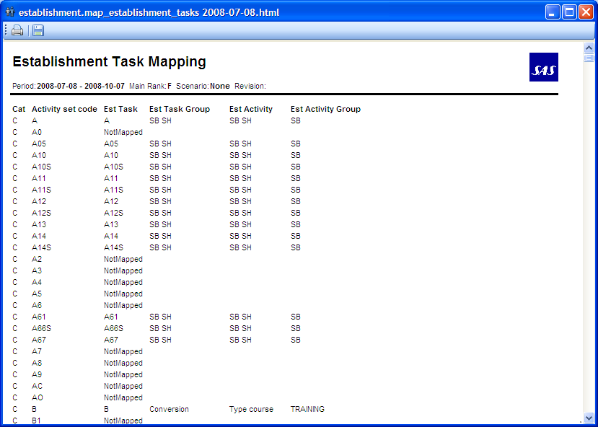

The report says ‘NotMapped’ if a code isn’t mapped to a higher level and NotInList if an Est Task is not present in the Activity set.

### Free Days Calculation

The report displays some figures used when calculating the free day drivers used for a crew group.

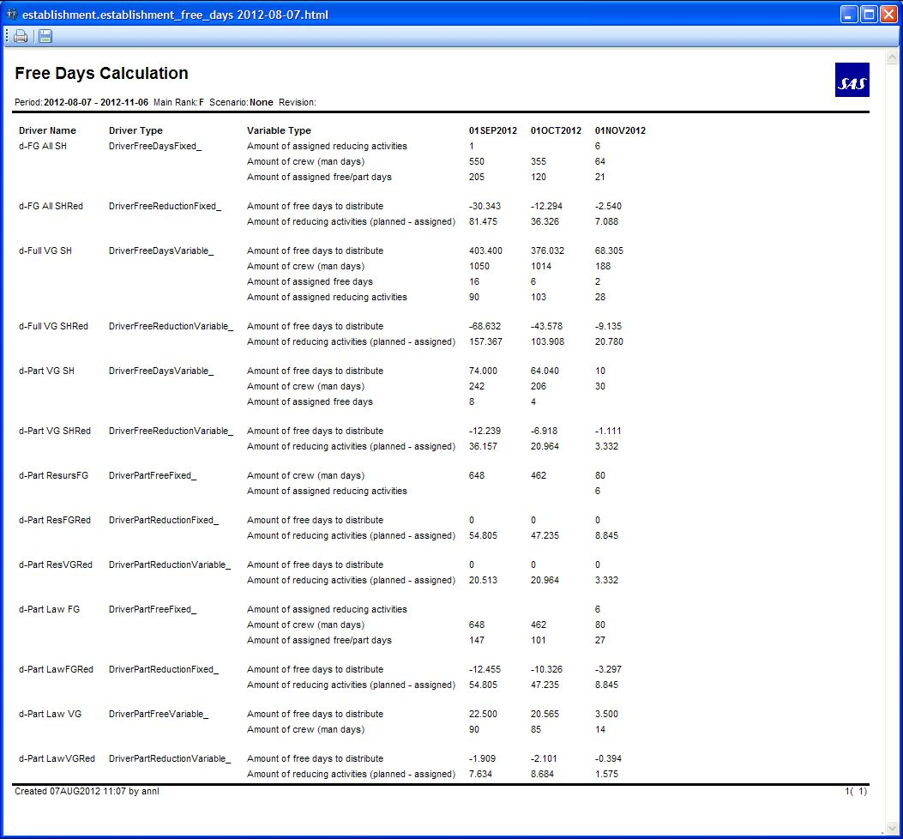

## Pairing export data

### View Pairing Export Data

By selecting ‘View Pairing Export Data’ in the establishment menu, it is possible to see the data exported by the pairing system. You get an overview of different driver names that can be used for a pairing driver, and also see which pairing groups have data, and what source the data comes from.

It’s possible to filter the view on Pairing Group, Date, Driver name and Data source.

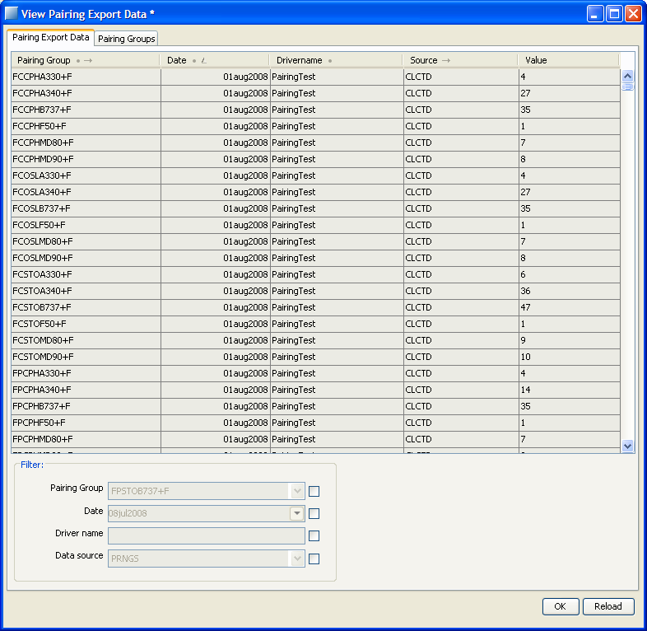

### Configure Establishment Settings.

In this menu additional configurations of the establishment settings is possible, e.g. the settings for the activity hierarchy,the settings for the pairing drivers, 4.1.10 and the setting of smearing percentage for free day drivers _4.1.2.

## Manage Request Quota

In Jeppesen Crew Portal crew can request days off in a FCFS (first come, first served) manner. To limit the amount of days off awarded through this functionality a quota constraint is defined. The quota constraints operate on “request crew groups”. A request crew group is defined as any other crew group but by selecting type=REQUEST.

For each request type (FS and F7S), each request crew group has a limit and an award count, similar to leave groups having a limit and amount assigned.

Whenever a request is awarded, the award count is incremented by one for each request crew group the crew member belongs to. If the award count is incremented above the limit in any group, the request is rejected.

The request limits are setup as rows in Establishment. In the initial configuration they can be found below Effective Supply/KPI/Request Limit.

If the limit values are changed in the Establishment calculation they need to be published in order for them to take effect in Jeppesen Crew Portal. You do this by clicking the Establishment row you want to publish (e.g. FS limit) in the request crew group you want to publish and run the menu command Establishment/Populate Request Limit. Evaluating which crew members belong to which request crew groups are evaluated dynamically. I.e. you do not need to republish limit if crew attributes or crew group syntaxes changes.

The currently published limit and award count can be seen by running the menu command Establishment/Request Limit.

Note that FS award count can be higher than assigned FS if FS activities have been replaced with VA during vacation planning.

For more information regarding days off requests see FunctionalReferenceTracking.

## Trip definitions and actual results

The actual values that are shown in the establishment are calculated in rave and are dependent on the trip definitions and codes that are assigned to the activities there.

### Trip definition

A trip is defined to end where crew has a rest of more than 24 h at his/her home station. It is also ended if the next leg is of another type in terms of flying duty / ground duty / personal activity, if the next leg is considered vacation, or if the next leg belongs to another establishment task group. If the trip is not a flying activity, the trip is also ended if the next leg has another code and is on another day. A special case is if it is a simulator activity; then a debriefing time is added to the last end time.

The first activity of a trip defines the code that is sent to establishment.

To get the start and end times right e.g. for crew that flies to training and has free days on different stations than the home base that should be counted as production, the start and end times of legs that is the first resp last leg of a trip that doesn’t start resp end at home station are adjusted. The value is set to the end time resp start time of the previous resp next leg instead.

### Activity codes

The activity code that is sent to establishment is defined as follows:

If the activity is a flying activity and defined as long haul, that is the ac family is A330 or A340 the activity is set as JLH, long haul production. Passive flight is defined as flying in position DH or XS and the activity is set as PASSIVE.

A flying activity not fulfilling the above said is considered JSH, short haul production.

Non flying activities use the code on the activity as code, where the whole set of codes can be found in the table ‘activity_set’. See report 4.2.1.

If an activity is found in the crew training log (crew_training_log table), the activity description from the crew training log overrides the previously defined codes. That is, if a short haul flight leg is logged as LIFUS in the crew training log, LIFUS will be returned as code instead of JSH. There are a few exceptional cases where the leg found in crew training log is not the activity sent to establishment. See 4.4.2.1

See Functional Reference Training (FRT) chapter 8 and 9, the value in the left column in the tables is the value that needs to be mapped. The contents of the crew_training_t_set referenced in FRT is the same as the flight training course block names and as the values in the tables in FRT chapter 8.

#### Exceptional Activity codes

Exceptional cases to map the task codes in Establishment according of the Training Log Type entries (crew_training_log table):

|  |  |  |
| --- | --- | --- |
| Log type | Categ | Description |
| NEW | CC | Outcome separated between LH production (AL qualification) and SH production (Not AL qualification).  Then NEW log type will be mapped as NEW_SH or NEW_LH in est_task table and sent to Establishment. |
| FLIGHT INSTR | CC | Outcome separated between LH production and SH production.  Then FLIGHT INSTR log type will be mapped as  FLIGHT INSTR _SH or FLIGHT INSTR_LH in est_task table. |
| RELEASE | CC | Outcome separated between LH production and SH production.  Then RELEASE log type will be mapped as RELEASE_SH or RELEASE_LH in est_task table. |
| REFRESHER | CC | For any REFRESHER log type entry will be mapped as the activity code of this entry.  For instance a crew_training_log entry like this:  Crew:11111, typ:REFRESHER, code:NQ12. It will map as NQ12 taskcode in est_task table. |
| REC | CC | For all the REC log type entries with activity code NF* will be mapped as the activity code.  For instance a crew_training_log entry like this:  Crew:11111, typ:REC, code:NF13. It will map as NF13 taskcode in est_task table. |
| COURSE | CC | For all the COURSE log type entries with activity code OK* will be mapped as the activity code.  For instance a crew_training_log entry like this:  Crew:11111, typ:COURSE, code:OK51. It will map as OK51 taskcode in est_task table.  For all the COURSE log type entries with activity code SQ* will be mapped as COURSE WEB.  For instance a crew_training_log entry like this:  Crew:11111, typ:COURSE, code:SQ45. It will map as COURSE WEB taskcode in est_task table. |
| SEMINAR | FD | For all the SEMINAR log type entries with activity code OA7*, OA8* and OA9* will be mapped as the activity code.  For instance a crew_training_log entry like this:  Crew:11111, typ:SEMINAR, code:OA73. It will map as OA73 taskcode in est_task table. |

#### New activity codes

When adding new task-codes to table activity_set they are not directly visible from Establishments Hierarchy Manger.

Manpower will instead use the task-codes available in table est_task. There is no GUI available for adding entries into this table so this have to be done from a table-manager. The rows that you should add in est_task looks like this:

|  |  |  |  |  |
| --- | --- | --- | --- | --- |
| **code** | **cat** | **taskgroup** | **si** | **calcnode** |
| MT8 | C (or F) | <taskgroup wanted> | <empty> | <empty> |
| UF1 | C (or F) | <taskgroup wanted> | <empty> | <empty> |

Now it is possible to map these new tasks in the Hierarchy Manager. The calcnode column should be left empty as it will be modified by the Hierarchy Manager.

### Ranking in order of priority

If two or more codes are returned on the same day, one code is prioritized in the establishment result. Implemented is:

Production (JSH/JLH) is highest ranked, second is VA. The codes F, F88, FP, IL8, LA5, LA8, LA37, LA58, LA84, P and PF are ranked the lowest. In between are all other codes.

If two codes have the same prio according to that rank, the longest trip wins and is calculated with in establishment.

The ranking of codes is found in python module carmusr/manpower/general/sk_trip_strategy.py

## Accumulation

Every late afternoon, an accumulation job is done, updating all assigned data in establishment based on activites in a given time period. This period is one year back for all crewfilters. If a crewfilter is changed or created a special script is called so that all activities from 1Jan2007 will be calculated. This script can only run for a certain amount of time, so if several crewfilters are updated at the same time and you wish to get all the establishment figures to get updated it is possible to run it manually.

## Technical summary

Except from drivers most of establishment is in the CARMSYS. The trip prioritization can be found in lib/python/carmusr/manpower/general/sk_trip_strategy.py. A trips task code is the Rave variable %est_task% and uses training log if present.

### Free day drivers distribution

|  |  |
| --- | --- |
| Free day drivers: | Free day reduction drivers: |
| DriverFreeDaysVariable_ | DriverFreeReductionVariable_ |
| DriverPartFreeVariable_ | DriverPartReductionVariable_ |
| DriverFreeDaysVariableParam_ | DriverFreeReductionVariableParam_ |
| DriverFreeDaysFixed_ | DriverFreeReductionFixed_ |
| DriverPartFreeFixed_ | DriverPartReductionFixed_ |
| DriverFreeLHBaseAct_ |  |

The drivers are paired in the Parameter Config:

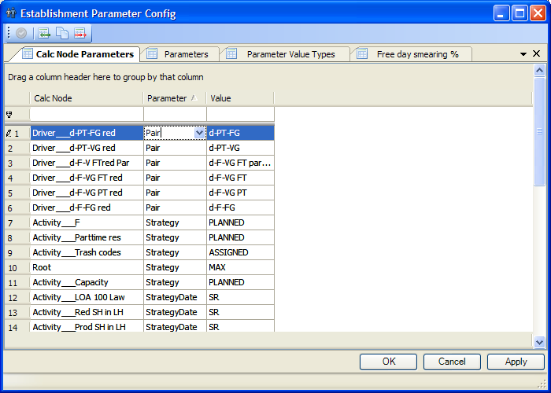

The basis for the free day drivers, except DriverFreeLHBaseAct_,

DriverFreeDayFixed_ and DriverPartFreeFixed are the same. They calculate a value to be distributed each day. In the case of free day drivers, a certain percentage of that value can be omitted from the daily distribution and smeared across an entire month. This percentage is defined in the table _free_day_smear.

In addition, attenuation of the calculated values can be performed based on a crewmember’s

rank, base and qualifications (long-haul vs. short-haul), as well as the days of the week. These

settings are stored in the variable DriverFreeDaysVariable_.attenuation_table, in

$CARMUSR/lib/python/manpower/establishment/driver_free_days_variable_.py. This table

consists of a series of nested Python dict objects, whose keys correspond to:

- Rank (‘C’ vs. ‘F’) — outermost dict

- Base (‘CPH’, ‘STO’ or in the case of Norwegian bases, ‘NOR’)

- Qualifications (‘LH’ vs. ‘SH’)

- Day of the week (0 = Monday, etc.) — innermost dict

Return values should be signed floating-point numbers, such that, for instance:

DriverFreeDaysVariable_.attenuation_table[‘C’][‘STO’][‘LH’][4] = -0.04

Additionally, the following expression should evaluate to true:

sum(DriverFreeDaysVariable_.attenuation_table[*x*][*y*][*z*].values()) == 0

…for all values of *x*, *y*, and *z*.

### Rave

References to Rave variables used.

|  |  |  |
| --- | --- | --- |
| Name | Location | Description |
| %trip_start_time%  %trip_end_time%  %activity_start_time%  %activity_end_time%  %trip_type%  %first_leg_task%  %trip_maintype%  %est_task%  %daysoff_start_time%  %daysoff_end_time% | crc/source/Manpower | Rave module which contains definitions used for establishment roster evaluations in CARMSYS. |

### Database Tables

References to tables used.

|  |  |  |  |  |  |  |  |  |  |  |  |  |  |  |  |  |  |  |  |  |  |  |  |  |  |  |  |  |  |  |  |  |  |  |  |  |
| --- | --- | --- | --- | --- | --- | --- | --- | --- | --- | --- | --- | --- | --- | --- | --- | --- | --- | --- | --- | --- | --- | --- | --- | --- | --- | --- | --- | --- | --- | --- | --- | --- | --- | --- | --- | --- |
| |  | | --- | | est_activity | | est_activity_group | | est_actuals | | est_aggregation_set | | est_bookmark | | est_bookmark_item | | est_bookmark_node | | est_driver | | est_driver_class_set | | est_filter_driver | | est_param_type_set | | est_param_value | | est_resolution_set | | est_std_paramtable | | est_strategy_set | | est_task | | est_task_group | | est_warn_level | | est_warn_level_set | | est_activity | | est_activity_group | | est_actuals | | crew_filter | | crew_category_set | | accumulator_int_run | | pairing_distribution | | pairing_volume | | crew | | pattern_acts | | activity_set | | pairing_metadata_set | | new_crew_contract  crew_training_log | | crew_contract | |  | |  | | See udm.pdf for descriptions |
| _free_day_smear | A single-cell table that stores a value describing what percentage of free day allocations should be smeared across  the month. See 4.1.2,4.6.1 |

### Scripts

References to scripts used.

|  |  |  |
| --- | --- | --- |
| Name | Location | Description |
| accumulate_filter.py  accumulate_new_filters.py | lib/python/carmusr/manpower/util | Used in accumulation. Started from accumulate.py. |

### Forms

References to forms used.

|  |  |  |
| --- | --- | --- |
| Name | Location | Description |
| PairingVolumeView.xml | lib/www/manpower/  forms/establishment/ | The form for viewing imported data from pairing. |
| EstDriverForm.xml | sys/lib/www/manpower/  forms/establishment | The form for configuration of establishment. |

### Reports

References to reports used.

|  |  |  |
| --- | --- | --- |
| Name | Location | Description |
| map_establishment_tasks.py | lib/python/  report_sources/  manpower/ | The report for establishment tasks. |

### Configuration

References to common config xml-configuration .

**Note!** Technical details should be documented in the code.

|  |  |  |
| --- | --- | --- |
| Name | Location | Description |
|  |  |  |

# Training

Training effects are described in the Manpower User Guide in the following sections:

1. User Interface >Training View
2. Manpower commands >Template commands for training effects
3. Manpower commands >Training effect commands.

## Training Effects

For an overview of available field names training for training effects in CARMSYS, refer to Manpower User guide, Manpower Commands >Template Commands for Training Effects >Create Training Effect Template. SAS-specific field names are crew_rest_acqual and crew_rest_acqual.

### crew_rest_acqual

crew_rest_acqual handles restrictions that only apply to one aircraft qualification.

When selecting “crew_rest_acqual”, there is only one value for “Field name”, but that name contains two values, “qual” and “qual_acqual”. “Field value 2” also becomes active, and you must enter values for both “Field value” and “Field Value 2”. The first is for the aircraft qualification and the other for what restriction that aircraft qualification should have. The only restriction available is “NEW+ACTYPE”

### crew_qual_acqual

crew_qual_acqual handles qualifications that only applies to one aircraft qualification.

When selecting “crew_rest_acqual”, there is only one value for “Field name”, but that name contains two values, “qual” and “qual_acqual”. “Field value 2” also becomes active, and you must enter values for both “Field value” and “Field Value 2”. The first is for the aircraft qualification and the other for what qualification should be connected to the aircraft qualification entered. The qualifications that are connected to aircraft qualification are INSTRUCTOR qualifications.

## Rules

### No overlap

If training is created over other assignments, this rule will fail.

Rule failure example:



The rule gives information on which activities are overlapping. In this case LA72 and the training starting with CX53 are overlapping. The following information is displayed:

1. Crew employment number
2. Rule failure start date
3. Rule name
4. Failtext
5. Activity
6. Limit value (if used)
7. Actual value (if used)
8. Over legal limit in time (if used)
9. Over legal limit (if used)
10. User
11. Time

## Reports

You can select any number of courses to be printed. If you click outside the grid, for example in a filter field and deselect all courses, all of them will be printed in the reports below.

### course_list

A list of courses available sorted on startdate.

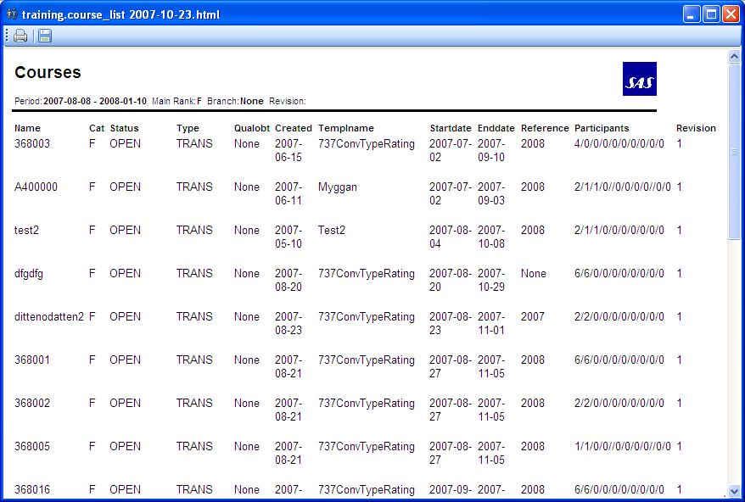

### Schoolplan

Contains information about course blocks, assigned participants, their from- and to-filters etc.

Empno, seniority, rank, qual and station is crewinfo valid on the day before course start.

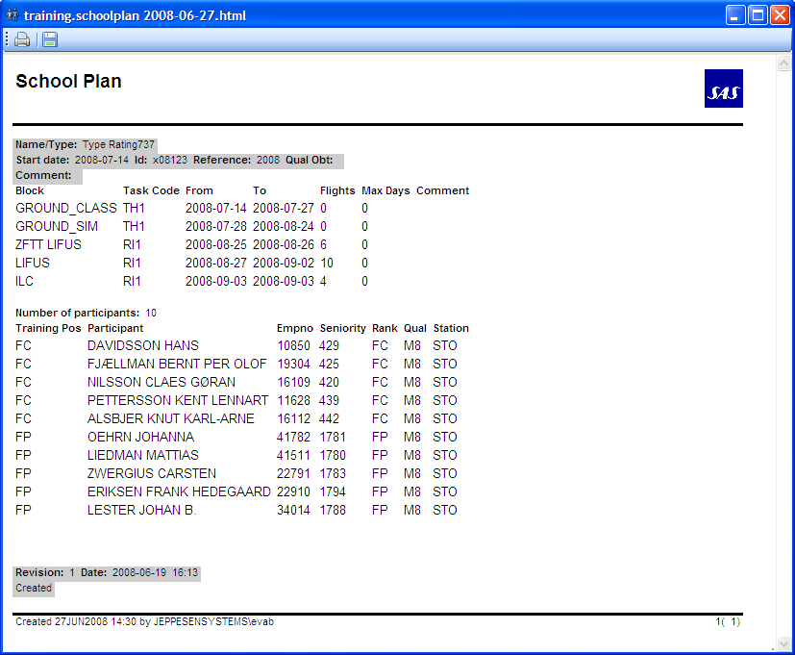

### Course_details

Shows detailed information about a course such as course blocks, training effects and course revisions.

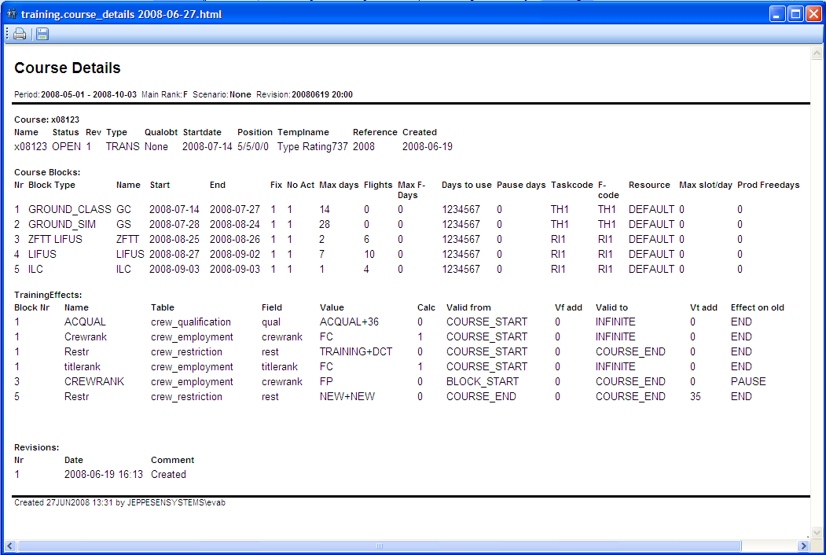

## Course Participant best guess

When a course has participants that are unknowns (do not have a crew assigned) a best guess of who is going to be assigned to the course is done. There are two cases of unknowns, when we use existing crew or when we use new crew.

Unknown participants will affect all of Manpower, e.g. add to capacity of a crew filter in Establishment. If Unknowns are not desirable, change number of participants to match number of assigned crew. For more information see Manpower User Guide.

### Unknowns – existing crew

When we have unknown participants on a course (no crew assigned), the system will do a best guess of which crew will be the one participating on the course. The crew is selected from the crew filter defined in the course participant *From* value. If no crew can be selected (not enough crew in the crew filter that fulfill the requirements) a warning message will be shown in Establishment calculation and in the Show Training Effects. If this happens we will actually NOT get a crew selected and NO training effects will be applied in the Establishment calculation. A solution could be to select another From Crew Filter.

Unknown existing crew are selected from the ***From*** crew filter in the following order:

* the highest seniority
* do not change crew group in the next 12 months
* will not retire in the next 2 years

### Unknowns – new crew

When we have unknown new participants on a course (no crew assigned and *From* is NEW), the system will do a best guess of a crew that we will clone the new crew from. The crew to clone is selected from the group of crew in the crew filter defined in the course participant *To* value. The reason we need to clone a crew is that we want the crew to have crew properties settings for those properties that we do not set in training effects on the course. Eg if there are no training effect that sets contract, we still need our new crew to have a contract to get the calculations right when we are using unknown new in Establishment.

If no crew can be selected (not crew in the crew filter that fulfill the requirements) a warning message will be shown in Establishment calculation and in the Show Training Effects. If this happens we will not get a new crew and NO training effects will be applied and NO increase in the supply in the Establishment calculation. A solution could be to select another crew filter for the participant *To* value that has at least one crew that fullfill the requirements, since we are not moving any crew in this case it doesn’t really matter what crew filter that is selected, the important thing is that the crew in the *To* crew filter has the desired crew attributes for those crew properties that are not set by training effects in the course.

Unknown new crew are selected from the ***To*** crew filter in the following order:

* the lowest seniority
* do not change crew group in the next 12 months
* will not retire in the next 2 years

## Course Release

When a course is released:

* The Establishment calculation stops using the Manpower Course object in the calculations.
* Assignments are added to the course participant’s roster for non flight course blocks.
* Crew info is updated with the training effects.
* Training need is updated for all flight course blocks.

The Manpower course can be updated after release but the effect is only for keeping the history right and that the School plan will be updated. All crew that are affected by the change to the released course must be manually updated in PreStudio, Crew Info and Crew Training.

All participants must be assigned (we can not have any unknowns) before you can release a course.

At release there will be a course alert if there are overlapping activities. Remove those activities by using Pre. It will not be possible to run optimizer in rostering if there are any overlapping activities.

On Course release, for each:

**Ground Training block**

* + **Fixed Length**:
    - A ”placeholder” activity will be added to crews roster, meaning an all day activity for the number of days in the block. A block with period 1jan2008-5jan2008 will create one activity with the task code specified by the block, that starts 1jan2008 00:00 and lasts for 5 days to the 6jan2008 00:00 translated to UTC times. (**PRE Studio actions**)
  + **Non Fixed Length**:
    - For each day with a training activity in the block, an activity will be added to the crews roster. The start and end time of the activity is defined by the start time of the resource used and the duration time defined on the block, translated to UTC times. The task code defined on the block will be used.
    - For each day without a training activity in the block, a training days off activity will be created on the crews roster. The start and end time of the activity is set to be 00:00 – 00:00 the day after (all day activity), translated to UTC times. The freeday task code defined on the block will be used.

**Flight Training block**

* + Entries in **Training Need** will be added (if block name is the same as a predefined training need type). The start time of the first flight training block on the course will be set to the training need start time and the end of course date will be set to the end date in the training need table. The number of flight and max flight days and ac qualification obtained will also be copied to the training need. (**Crew Training actions**)

**Training Effect**

* + Entries in the **crew attribute** tables will be added or changed. (Se training effects above) (**Crew Info actions)**

### Release Course Examples:

We will use 2 templates that are identical except for that the first one uses NON fixed blocks (course Ap1) and the second uses fixed blocks (course AP2). We will then release the courses and see the different release strategies by comparing the result in the systems: PreStudio, Crew Info and Crew Training

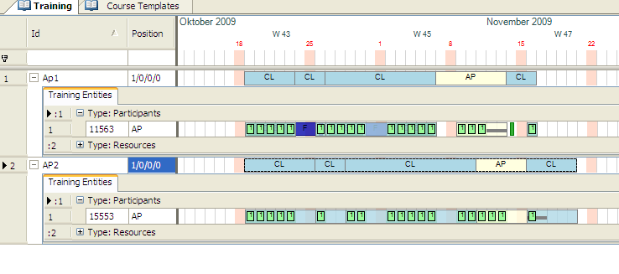

#### Non Fixed Length Blocks Course

Ap1 is a course where the blocks are non fixed:

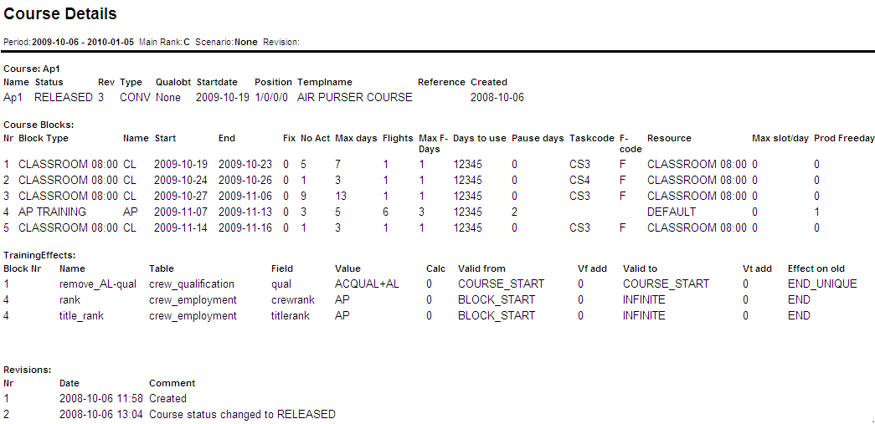

After course realease we will get the following result:

**PreStudio:**

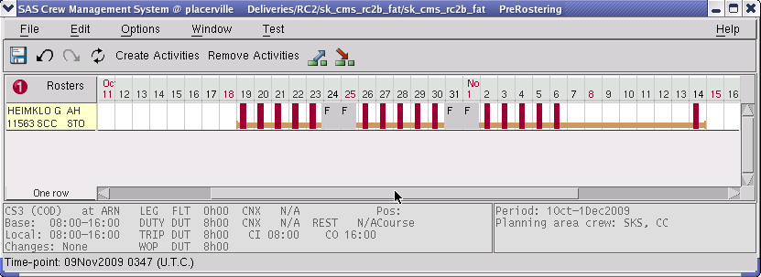

**Crew Info:**





**Crew Training:**

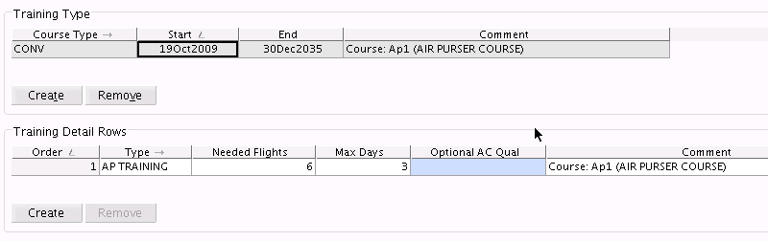

#### Fixed Length Blocks Course

AP2 course where the blocks are fixed:

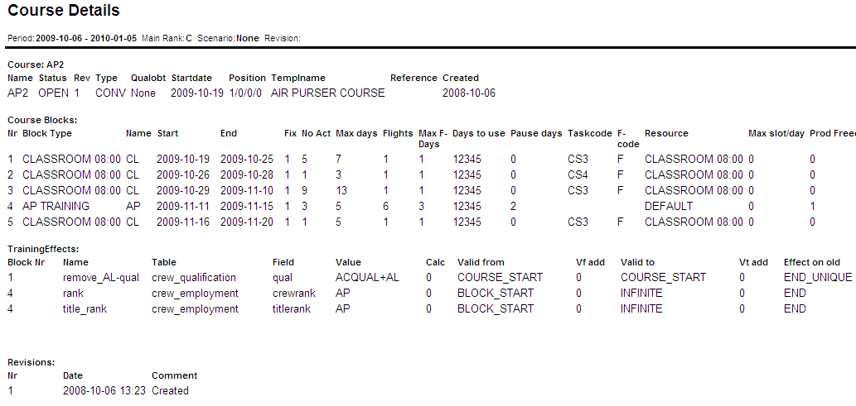

After course release we will get the following result:

**PreStudio:**

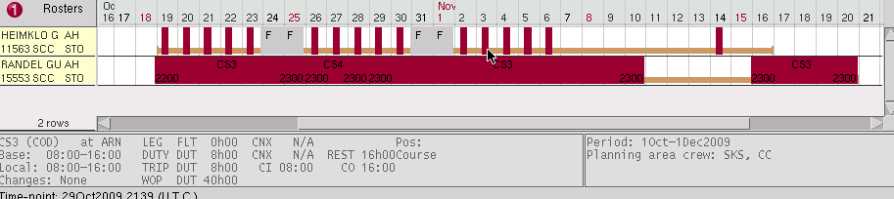

In this printout it is also possible to se the difference between the 2 release strategies. The first crew (11563) have assignments created with a course release strategy NON fixed course blocks and the second crew (15553) have assignments created with a course release strategy fixed course blocks.

**Crew Info:**





**Crew Training :**

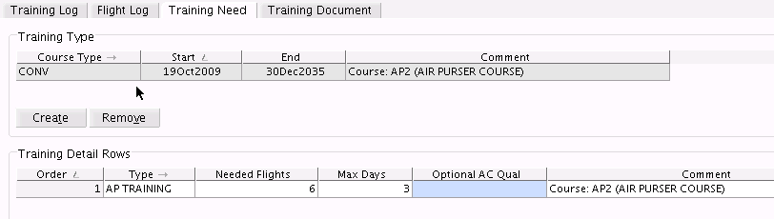

## Crew Publish

When course activities on crews’ roster should be visible for crew in Crew Portals etc, use Crew Publish to publish the training activities for that course. All training activities created for this course for all the crew assigned to the course will be published. This can also be done in PreStudio.

## Technical summary

Most of training is in the CARMSYS. In the CARMUSR you find lib/python/carmusr/manpower/training/training_api_sas.py that is the general training SAS code and accumulate_last_flown.py that is explained in 3.1.2 Last Flown.

## Rave

References to variables used.

|  |  |  |
| --- | --- | --- |
| Name | Location | Description |
| Rule no_overlap | crc/modules/training_rules_sk | Rave rule. |

## Database Tables

References to tables used.

| Name | Description |
| --- | --- |
| |  | | --- | | course | | course_activity | | course_block | | course_block_template | | course_block_trip | | course_block_type | | course_participant | | course_participant_trip | | course_publish_effect | | course_revision | | course_status_set | | course_template | | course_type | | crew_qualification | | tr_effect | | tr_effect_temlate | | tr_effect_day_set | | tr_effect_on_old_set | | crew_qualification_set | | resource_def | | resource_group | | airport | | resource_booking | | crew_contract | | crew_seniority | | assignment_set | | training_last_flown | | crew_flight_duty | | ac_qual_map | | crew_qualification_set | | crew_employment | | crew_activity | | crew_training_log | | cabin_training | | training_log_set | | crew_training_t_set | | crew_training_need | | crew | | See udm.pdf for descriptions |

## Scripts

References to scripts used.

|  |  |  |
| --- | --- | --- |
| Name | Location | Description |
| accumulate_last_flown.py | lib/python/carmusr/manpower/  training | Updates the training_last_flown table. Information displayed in the crew view. |

## Forms

References to forms used.

|  |  |  |
| --- | --- | --- |
| Name | Location | Description |
| TrainingConfigurationForm.xml | sys/lib/www/manpower/forms/ | Form for configuration of training |

## Reports

References to reports used.

|  |  |  |
| --- | --- | --- |
| Name | Location | Description |
| course_details.py | lib/python/  report_sources/  manpower/training | Detailed info on a course. |
| course_list.py | List of selected courses. |
| schoolplan.py | List of selected courses. |

## Configuration

References to common config xml-configuration or Studio Resources.

**Note!** Technical details should be documented in the code.

|  |  |  |
| --- | --- | --- |
| Name | Location | Description |
|  |  |  |

# Seniority

The seniority view is used for changing seniority. For full description of the seniority view, see the Carmen Manpower User guide.

At SAS seniority calculation is done differently for Flightdeck and Cabin crew. Flightdeck use LOA as base for calculation, but Cabin does not. That means some functionality is of no use for cabin planners; the LOA and Rest dates entered in Seniority Dates are not used.

The menu functions Calculate Seniority and Calculate LOA are not to be used for Cabin.

Changing codes that affect seniority

The seniority editor uses LOA to calculate new seniority. There is a possibility to view and change the codes that affect the seniority. In the seniority menu, select **Configure Seniority LOA settings**.

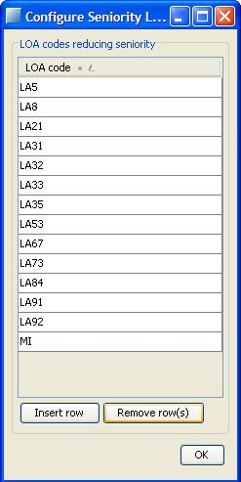

In here, it is possible to remove rows, or add new rows.

## Technical summary

The LOA calculation is found in lib/python/carmusr/manpower/seniority/loa_calculator.py.

## Rave

|  |  |  |
| --- | --- | --- |
| Name | Location | Description |
|  |  | No Rave used for Seniority |

## Database Tables

References to tables used.

| Name | Description |
| --- | --- |
|  | See udm.pdf |

## Scripts

References to scripts used.

|  |  |  |
| --- | --- | --- |
| Name | Location | Description |
|  |  |  |

## Forms

References to forms used.

|  |  |  |
| --- | --- | --- |
| Name | Location | Description |
| SeniorityLOACodes.xml | lib/www/manpower/  forms/seniority/ | The form for configuration of LOA codes affecting seniority. |

## Reports

No reports used.

## Configuration

References to common config xml-configuration.

**Note!** Technical details should be documented in the code.

|  |  |  |
| --- | --- | --- |
| Name | Location | Description |
| EnableTransitionIn | data/config/manpower.xml | EnableTransitionIn is a setting to restrict the ability to use transition for a certain main cat. |

# Transition

## InterBids Import

### Import Bids

The transition bids will be tagged with the date that is currently set as the transition date. When viewing transition bids, you will see the bids that have the same date as the transition date you currently have. If you import transition bids again using the same transition date, old bids will be removed. Importing with a new transition date will not affect old bids.

## The transition run

The automatic transition run is only performed for flight deck crew.

### Transition rank

The rank on which the crew member will be assigned is the rank of crew group that the crew was previously assigned to. Editing a rank of a crew group is done by changing the rank in the Ranks tab in the detail view of the crew group in the Crew Groups view. If no previous assignemt is found (e.g if the crew is a new employee) he will be regarded as a FP.

### Automatic calculation of new promotions

The number of pilots that are going to be promoted to captains can be calculated automatically by the transition system. All pilots that are not already captains and who have captain approval can be promoted to captains. The demand in the captain crew groups and the supply of captains will decide how many pilots that will be promoted.

The total demand of captains in all captain crew groups is calculated. The total number of captains is calculated. Pilots or captains that are manually excluded from the execution or that have such an age that they will retire, are not included in the number of captains or in the number of promotions. In the calculations no consideration is taken for example to captains lockbidded as pilots or captains forced to retire when the group expires. The number of pilots needed to fulfil the demand in the captain crew groups is calculated and that number of pilots is promoted. If the number of captains equals or exceeds the total demand, no pilots are promoted.

### Predefined Assignments

Most of the business rules implemented have the function of deciding which pilots that will have the possibility to be assigned according to seniority and biddings. The rest of the pilots will receive a predefined placement. These business rules are described in the following sections. All crew members that according to rules will receive a predefined placement will be placed in that crew group if and only if the demand in the group is not decreasing. In that case the crew that are least senior in their current group may be forced to another crew group despite any rule that normally would have made their assignment predefined.

#### Crew member manually excluded

If a crew member is marked as to be manually excluded from the execution, the crew member will not receive any assignment at all and no further rules are checked.

#### Exception rule (lock bid)

If a crew member is lockbidded to a crew group, either to the currently assigned crew group or another, this lock bid assignment overrules any other assignment rule (except **Crew member manually excluded** and **Movement restrictions imposed by crew retirement**). No qualifications will be checked and the demand in the crew group will be disregarded. The rest of the rules will be checked but will not affect the assignment of the crew member.

#### Movement restrictions imposed by crew retirement

If the age of a crew member, at the time of the assignment period start, equals or exceeds the age parameter **Retirement age**, the crew member will not receive any assignment at all and no further rules are checked.

#### FC Guarantee

If a crew member has **FC guarantee** it means that he or she will not be able to be assigned according to seniority and rules. If the FC Guarantee is combined with a lock bid, the crew member will be assigned according to the lock bid. Otherwise the crew member will be assigned to the same crew group where he or she was previously assigned. This rule overrules any other assignment rule (except **Crew member manually excluded**, **Movement restrictions imposed by crew retirement** and **Exception rule (lock bid)**). The rest of the rules will be checked but will not affect the assignment of the crew member.

This rule is not checked for new promotions or for new crew members (crew members with no previous assignment).

#### Time-dependent movement restrictions

A crew member has to stay in a crew group for a certain time before he or she can be assigned to another crew group according to bidding and seniority. This rule is controlled by two different parameters:

**Min time locked in crew group when newly promoted**, which is used for all captains assigned at their first captain crew group, and

**Min time locked in crew group**, which is used for all other pilots.

If the current crew group expires (demand = 0), or if the previous assignment was forced, the crew members are allowed to move irrespective of time in current crew group.

This rule is not checked for new promotions or for new crew members (crew members with no previous assignment).

#### Movement restrictions imposed by age

If the age of a crew member, at the time of the education start, equals or exceeds the age parameter **Max age**, the crew member has no right to be moved to another crew group according to bidding and seniority.

Under certain circumstances the crew member can be allowed to move anyway. If the current crew group expires (demand = 0), the crew member is allowed to move if the age does not equal or exceed the value of the parameter **Max age when crew group expires**. If the age of the crew member equals or exceeds even this age limit, he or she will not be assigned at all in this case.

If the crew member did not have seniority to receive a **LH assignment** in the previous assignment, the age of the crew member is checked against the parameter **Max age when not granted LH in previous assignment**. In this case the crew member is only allowed to move to LH crew groups. If the crew member still does not have the seniority for LH, he or she must stay at the previous assignment, or if the crew group expires and the age limit **Max age when crew group expires** is reached, the crew member will not be assigned at all.

This rule is not checked for new promotions or for new crew members (crew members with no previous assignment).

### Vacancy bidding and total bidding

When performing a transition run the crew members are assigned according to seniority and bids. The basic seniority rule is that a crew member cannot be assigned to a crew group if there is a crew member with a lower (better) seniority that has been assigned a crew group that he or she ranks as less interesting than that crew group. However, the seniority rule is applied in two slightly different ways as **vacancy bidding** and **total bidding** respectively. In these two assignment methods the general rank, the seniority, is not used when comparing two crew members, but instead a crew group specific ranking of the crew members is used.

When **vacancy bidding** is applied, crew members currently placed in a crew group are given priority in that crew group to other crew members. Apart from giving priority to crew members currently placed in a specific crew group, crew members that have placed a bid on a crew group are prioritized to crew members that have not placed a bid on that same crew group. If a crew member refrains from placing a bid on a certain crew group, this signifies that he or she has not given a bidding priority on the crew group. A crew member that is promoted to captain will be prioritized, compared to other promoted crew members, in the crew group of the same aircraft type as where he or she is previously placed.

When **total bidding** is applied, crew members currently placed in a crew group are not prioritized to other crew members (not currently placed in that crew group). No consideration is therefore taken to a crew members’ previous placement. As when vacancy bidding is applied crew members that have placed a bid on the crew group is prioritized to crew members that have not placed a bid on the crew group.

The priority rules are applied when the crew members are ranked in each crew group. This priority rule for vacancy bidding and total bidding is summarized in the following tables and describes how two crew members are compared for one specific crew group. If both crew members are in the same box, or in boxes with the same number, the seniority will decide the rank between them. Otherwise the box with the lowest number will be ranked better than the other one.

|  |  |  |  |  |  |
| --- | --- | --- | --- | --- | --- |
| Priority for vacancy bidding | | Has bidded for the crew group | | Will be promoted and comes from the same aircraft type | |
| Yes | No | Yes | No |
| Is assigned to the crew group | Yes | 1 | 2 | -- | -- |
| No | 3 | 4 | 5 | 6 |

|  |  |  |  |
| --- | --- | --- | --- |
| Priority for total bidding | | Has bidded to the group | |
| Yes | No |
| Is assigned to the crew group | Yes | 1 | 2 |
| No | 3 |

### The assignment

The assignment of all crew members, not given predefined assignments, is performed by assigning and deassigning all crew members until all crew members are assigned, all crew group demands are fulfilled or it is not possible to assign the remaining crew members even though all demands are not fulfilled.

### Qualifications

All crew members can not automatically be assigned to all crew groups, since some crew groups may require some specific requirements.

To be assigned to a captain crew group the crew member must either have a captain qualification, or be approved as a captain candidate. A crew member with captain qualification can only be assigned to a captain crew group. He or she must not be assigned to any other crew group.

Some crew groups are defined as long haul, and to be assigned to such a crew group the crew member has to have a D license or be approved for D license. A crew member with D license or approved for D license, can also be assigned to short haul crew groups. All captains and captain candidates are assumed to have D license so this qualification is not checked for them.

### Minimizing the number of movements

To minimize the number of movements the crew members are assigned taking the crew groups as a starting point. One crew group at a time is assigned according to the specific crew group ranking order, until the crew group is full. If a crew member already is assigned to another crew group, the crew member will keep that assignment if he or she has a better bid for that group than for the crew group currently being treated. Otherwise the first assignment is cancelled and the crew member is assigned to the new crew group. Since a crew member assignment can be cancelled, the crew groups must be traversed more than once. The crew group traversing is performed until all crew members are assigned, all crew group demands are fulfilled or when it is not possible to assign the remaining crew members even though all demands are not fulfilled.

### Maximizing bid fulfillment

To maximize the bid fulfillment the crew members are assigned taking the crew member seniority and bid priority as a starting point. The unassigned crew members are assigned in seniority order, and the crew groups are considered in bid priority order. If the crew group the crew member ranks as best is full, there is a check if the crew member is ranked better in the crew group than the least ranked crew member already assigned. If that is the case the crew member with the least rank is deassigned and the better ranked crew member is assigned instead. If the crew member is not ranked better than the least ranked crew member already assigned, the crew members next bid is considered and so on. Since a crew member assignment can be cancelled, the unassigned crew members must be traversed more than once. The crew member traversing is performed until all crew members are assigned, all crew group demands are fulfilled or when it is not possible to assign the remaining crew members even though all demands are not fulfilled.

### Movement restrictions from and between crew groups

It is possible to give movement restrictions from a crew group and between crew groups. These transition limits can not be exceeded. A crew member can not be forced to remain in a crew group due to movement restrictions if there is a crew member ranked worse in the crew group, i.e. the better ranked crew members will be given the opportunity to move first. In the algorithms described above, the movement restrictions are always checked before a crew member is assigned.

### Consideration to part time work rate

When performing an assignment the crew members are assigned to crew groups according to the resource demand in each crew group. The default is that no consideration is taken to part time work rate but this rule can be turned on or off. When the work rate for each crew member is taken into consideration, the assignment goes on until the sum of the work rates of the assigned crew members is equal to the demand or more. No attempt is made to come as close as possible to the demand. Crew members on LOA are also considered according to their given work rate. When the rule is turned off the demand is interpreted to be the number of crew members needed irrespective of their work rates.

### Determination of changed crew parameters

There are some crew member parameters that depend on the new assignments and that will affect the assignment in the next assignment period. The values of these crew member parameters are determined after the assignment.

#### Forced assignment

Forced assignments can only occur when vacancy bidding is chosen as assignment method. A forced assignment is an assignment in a crew group which the crew member ranks as less attractive than the crew group in which the crew member was previously assigned. All forced assignments are marked in the **Forced** column in the **Transition Result View**.

For total bidding there can be no forced assignments and this parameter will be set to false.

#### Not granted LH

If a crew member did not have seniority to be assigned to a long haul crew group this is marked in the **Not Granted LH** column in the **Transition Result View**. This is checked for captains and other pilots separately.

#### New promotion

All crew members that are promoted in the performed allotment are marked as new promotions. This information is used in some reports when displaying the allotment result. Crew members who were marked as new promotions in the previous allotment and who are marked in the input data as not being fully qualified as captains, will also be marked as new promotions.

#### First FC duty

All crew members that are promoted in the performed assignment are marked in the **First FC Duty** column in the **Transition Result View**. A crew member that is marked as first FC duty will maintain this value as long as he or she stays at his first captain crew group assignment, and it will change when the crew member moves to another captain crew group assignment.

### Assigning per base

Assignment per base is performed when the demand for at least one crew group is given per base instead of totally for all bases. The base assignment is then performed only for those bases with demands given per base. For the bases with only a total demand given the assignment is performed according to the ordinary rules.

When assigning per base most of the assignment procedures follow the ordinary principles. In this section the base assignment principles differing from the ordinary principles are described.

During an automatic transition assignment a crew base can be set to be treated as any specific base. This can be used when assignment should be done per base and there are crew groups with a demand that should include several bases. For example crew in TRD, SVG and OSL have a common demand while crew in CPH and STO have different demands. Here the bases SVG and TRD can be marked as instances of OSL base. Then crew at TRD, SVG and OSL will all be assigned according to the demand in OSL. This is done by opening the Configure Transition Base Mappings form and selecting for example SVG as Real Base and OSL as Transition Base.

#### Automatic calculation of new promotions

The number of pilots that are going to be promoted to captains can be calculated automatically by the transition system. All pilots that are not already captains and who have captain approval can be promoted to captains. The demand in the captain crew groups and the supply of captains will decide how many pilots that will be promoted.

The automatic calculation of new promotions when assigning per base is governed by two rules. The first rule governs the number of captains to promote. If the rule **Surplus captains assigned to other bases** is turned on, surplus captains on one base are assumed to be possible to assign to other bases with deficit. In this case the number of captains to be promoted is calculated as the difference between the total demand of captains in all captain crew groups and the total number of captains. If the rule is turned off, the need for new captains is considered per base and surplus captains on one base are not assumed to be possible to assign to other bases with deficit. In this case the number of captains to be promoted is calculated as the sum of the deficits on the bases, and bases with surplus are disregarded.

The second rule governs which pilots to promote. If the rule **Promotion per base** is turned on, only pilots on bases with deficit are promoted in seniority order. When the rule is turned off, pilots are promoted according to the common seniority list irrespectively of which bases that have deficits.

#### Assignment

When assigning per base, the demands in the crew groups are primarily fulfilled by pilots on the base where there is a demand. If there is not a sufficient number of pilots on a base to fulfill the demand of a crew group, it is possible to fulfill the demand with surplus pilots from other bases, if the rule **Allow base transitions** is turned on.

#### Base transitions

If the rule **Allow base transitions** is turned off, pilots can only be assigned to their own base.

If the rule **Allow base transitions** is turned on, it is possible to fulfill a deficit on a base with surplus pilots from another base.

If there is not a sufficient number of pilots on a base to fulfill the demand of a crew group, pilots from other bases are assigned in the following order:

1. Surplus pilots from other bases, which have the same crew group. If there are several such bases, the pilots are assigned according to the common seniority order.
2. Surplus pilots from other bases, which do not have the same crew group. If there are several such bases, the pilots are assigned according to the common seniority order.

#### Movement restrictions from and between crew groups

It is possible to give movement restrictions from a crew group and between crew groups. These transition limits can not be exceeded. If movement restrictions are given when assigning per base, all restrictions apply on each separate base which have the specific duty group.

### Assignment rules

Most of the assignment rules can be turned on and off according to the following description.

#### Movement restrictions imposed by age

When this rule is turned off all movement restrictions imposed by age are disregarded. A crew member that does not have to retire will be able to get a new assignment irrespective of age (if allowed according to other rules), i.e. checking the age against the parameters **Max age**, **Max age when crew group expires** and **Max age when not granted LH in previous assignment** will not be performed.

#### Time-dependent movement restrictions

When this rule is turned off all time-dependent movement restrictions are disregarded, i.e. a crew member will be able to get a new assignment irrespective of time at the current assignment (if allowed according to other rules), i.e. checking the time at the current assignment against the parameters **Min time locked in crew group** and **Min time locked in crew group when newly promoted** will not be performed.

#### Movement restrictions imposed by crew retirement

When this rule is turned off all movement restrictions imposed by crew retirement will be disregarded, i.e. a crew member will always receive an assignment irrespective of age (if allowed according to other rules). Checking the age against the parameter **Retirement age** will not be performed.

#### Movement restrictions from crew groups

When this rule is turned off all movement restrictions from crew groups that may be defined are disregarded.

#### Movement restrictions between crew groups

When this rule is turned off all movement restrictions between crew groups that may be defined are disregarded.

#### Forced assignment exceptions

When this rule is turned off no exceptions are made for crew members with forced assignment in the previous assignment.

#### Allow base transitions (when assigning per base)

This rule is only valid when assigning per base, i.e. when the demand for at least one crew group is given per base. When this rule is turned off, pilots are not allowed to be assigned to any other base except their own. When this rule is turned on, pilots are allowed to be assigned to other bases under certain circumstances.

#### Automatic calculation of promotions

When this rule is turned on, the number of pilots that are going to be promoted to captains is calculated automatically by the transition system. All pilots who are not already captains and who have captain approval can be promoted to captains. The demand in the captain crew groups and the supply of captains will decide how many pilots that will be promoted. When this rule is turned off all pilots with captain approval will be promoted to captains irrespective of the demand in the crew groups.

#### Surplus captains assigned to other bases

This rule is only valid when the rule **Automatic calculation of promotions** is turned on, and when assigning per base, i.e. when the demand for at least one crew group is given per base. When this rule is turned on, surplus captains on one base are assumed to be possible to assign to other bases with deficit. When this rule is turned off, the need for new captains is considered per base and surplus captains on one base are not assumed to be possible to assign to other bases with deficit.

#### Promotion per base (when assigning per base)

This rule is only valid when the rule **Automatic calculation of promotions** is turned on, and when assigning per base, i.e. when the demand for at least one duty group is given per base. When this rule is turned on, only pilots on bases with deficit are promoted, in seniority order. When this rule is turned off, pilots are promoted according to the common seniority list irrespectively of which bases have deficits.

#### D license for long haul

When this rule is turned off there will be no check if the pilot is qualified for LH when assigning him or her to a LH crew group. The result column **Not granted LH** will still be determined, and the rule parameter **Max age when not granted LH in previous assignment** will still be checked.

#### Exception rule (lockbid)

When this rule is turned off, all lockbids that may be defined are disregarded and the crew members are assigned according to the other assignment rules defined.

#### Crew members manually excluded

When this rule is turned off all marks for crew members being manually excluded are disregarded and the crew members will be included in the assignment.

#### FC Guaranty

When this rule is turned off all movement restrictions to and from crew groups that may be defined are disregarded, and the crew members are assigned according to the other assignments rules defined.

#### FC Qualification

When this rule is turned off there will be no check if the pilot has approval to be promoted to a captain when assigning him or her to a captain crew group. The demand in the captain crew groups will decide how many pilots that will be promoted, and the pilots are promoted in seniority order irrespectively of captain approval.

#### Precedence (seniority rule)

When this rule is turned off, the assignment will be performed as if all crew members have the same seniority. The crew group ranking will still be considered, according to the definition of vacancy and total bidding respectively.

#### Consideration to part time work rate

When performing an assignment the crew members are assigned to duties according to the resource demand in each crew group. When this rule is turned on the work rate for each crew member should be taken into consideration. The assignment goes on until the sum of the work rates of the assigned crew members is equal to the demand or more. When the rule is turned off the demand is interpreted to be the number of crew member needed irrespective of their work rates.

## Reports

### compare_transitions

The report shows the difference between a transition done in a reference workset and a current open workset with possibly other demands or parameters set.

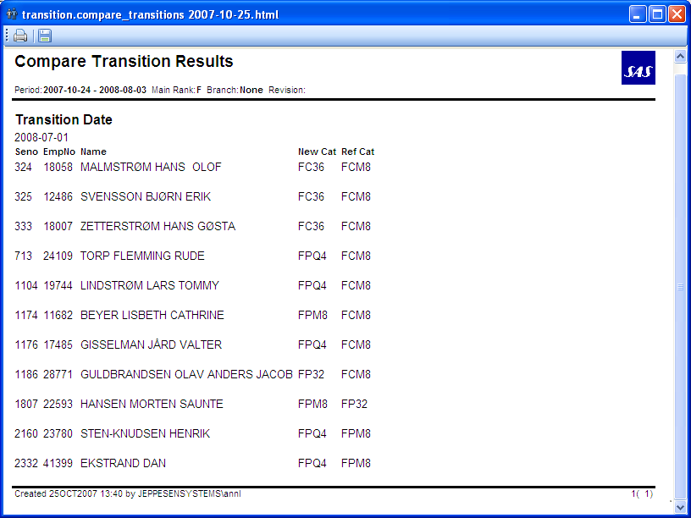

### transition_list

The report lists all crew, in seniority order, who have been assigned to new groups in the transition run.

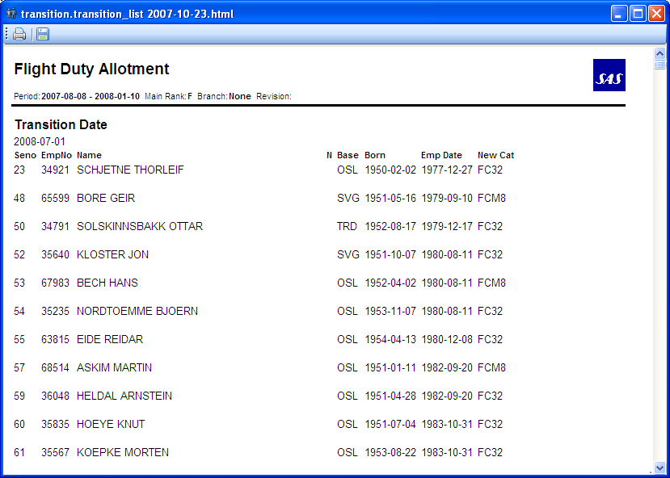

### transition_matrix

The transition matrix is a summary of the effects of one transition run, similar to the one available through Workset Explorer

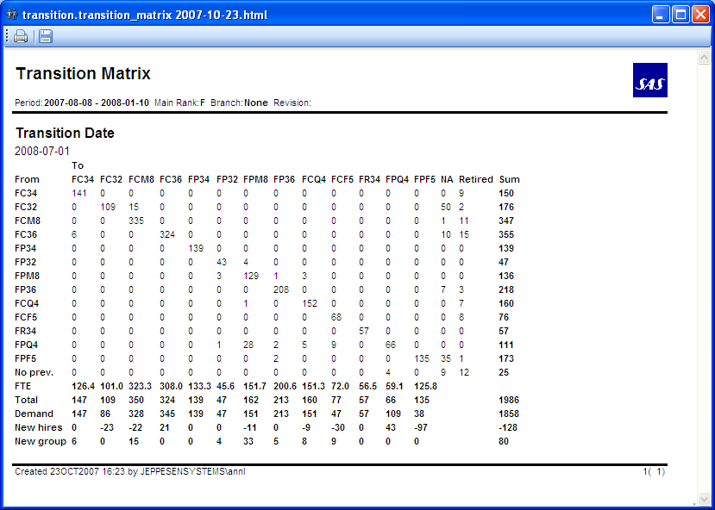

## Bid types

### FBID Bids

Used by FD crew. They can bid for

FC LH

FC Main CPH

FC Main OSL

FC Main STO

FCRC CPH

FO LH

FO Main CPH

FO Main OSL

FO Main STO

Definitions:

* LH= Aircraft qual A3, A4, A3A4
* RC= Aircraft qual CJ
* Main= Any aircraft qual except LH and RC.
* Please note that these names are only for bidding. When crew have been assigned in the FDA assignment, they will be assigned the correct acft type. Example FO Main STO will get acft type 36.

### ATPL Bids

ATPL confirmation.

### CCAC Bids

Used by CC. SKS crew can bid for SH, SH/LH. SKD crew can bid for CJ, AL, A2.

## Crew Portal Bid Configuration (for Transition)

### Bid Awarding Config View

Transition bids configuration is done through “Bid Awarding Config” which can be access from the client menu by “Transition”->”Bid Awarding Config”.

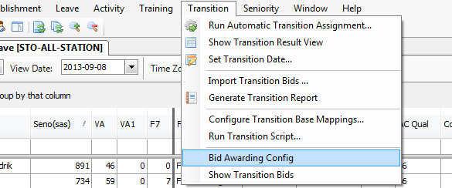

In the new architecture introduced with SP6 we have grouping of bids and association of these groups with bid awardings which will be mentioned below.

In this view it is possible to configure bid awarding and bid group. It is also possible to connect a bid group with a bid awarding and a bid group with a bid type.

### Bid Awarding Config View- Bid Period Tab

Using “Bid Period Tab”, the window/period start and end dates depending on a crew group and bid awarding types are configured. One can give any name for each bid awarding under the “Name” column. Bid awarding type column can either be Transition or Career for the open category. In the future leave bids will be configured the same fashion but for now this new architecture works only for transition bids, so transition is picked from bid awarding type column.

The start date of the period must be before end date of the period and start date of the window must be before the end date of the window.

Since the bid awarding is referenced from bid group bid period a validation check is triggered whenever a row is modified or deleted. The validation checks that the references is still valid and adds a warning to the bid group bid period tab if the bid awarding has been deleted or modified.

When a new entry is entered in the bid awarding(period) tab, the changes must be written to the database first , so that they can be visible in other tabs. For that purpose, you need to click on "apply" in bid awarding(period) tab and it will be propagated to other tabs automatically.

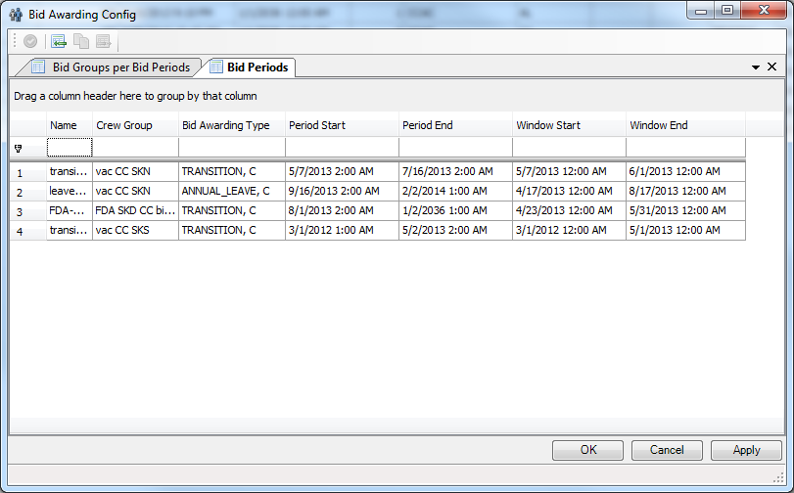

### Bid Awarding Config View- Bid Group Tab (not shown in JMP)

Creates and modifies bid groups. Since the bid group is referenced from both bid group bid awarding and bid group bid type, a validation check is triggered whenever a bid group is modified or deleted. The validation checks existing references and adds a warning to the bid group bid awarding tab and bid group bid type tab if the bid group has been deleted or modified. The available bid groups are populated into SAS database, the view below will be seen in Manpower.

One can check sorted, if the bids are wanted to be seen sorted in crew portal. The default is sorted for all.

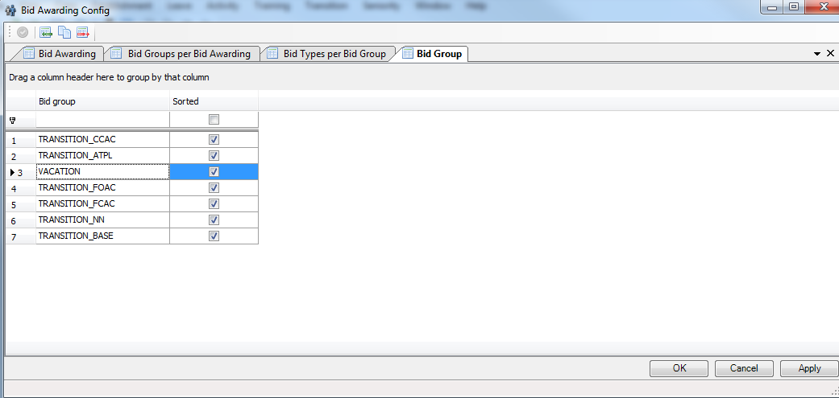

### Bid Awarding Config View- Bid Group Bid Type Tab (not shown in JMP)

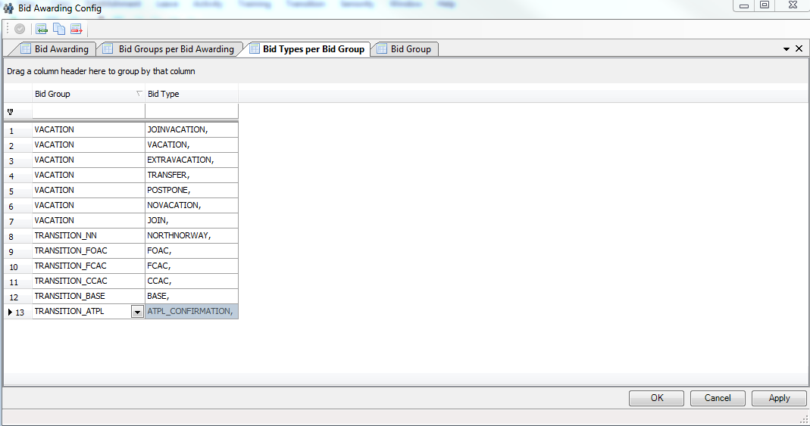

Connects a bid group and a bid type. Here it is defined which bid types belong to which bid group, so we have a grouping of different bid types if desired. This functionality as well only works for Transition bids for now.

Since a reference to bid group is created, a validation check is triggered which checks that the reference exists.

### Bid Awarding Config View- Bid Group Bid Period Tab

Using this tab one can connect bid groups and bid periods. For each bid group desired to be available for a bid period, a new row is entered. In the below figure it is seen that bid groups FBID, ATPL and CCAC are available for bidding for vac SKD/SKS group.

Since all bids grouped within a bid group must have the same awarding type, a validation check is triggered whenever a row is created or modified. The same validation check is also triggered whenever a row is modified in the bid awarding tab. The validation check adds a warning if the awarding type does not match. Since references to both bid group and bid period are created, a validation check is triggered which checks that the references exist.

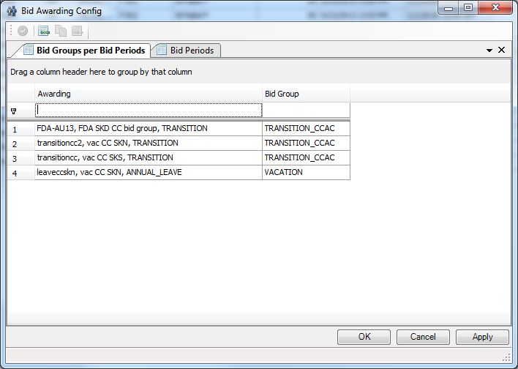

### Show Transition Bids

The Transition Bids grid view can be accessed from the client menu “Transition”->”Show Transition Bids” and select the desired View date. This view is only used for viewing transition bids.

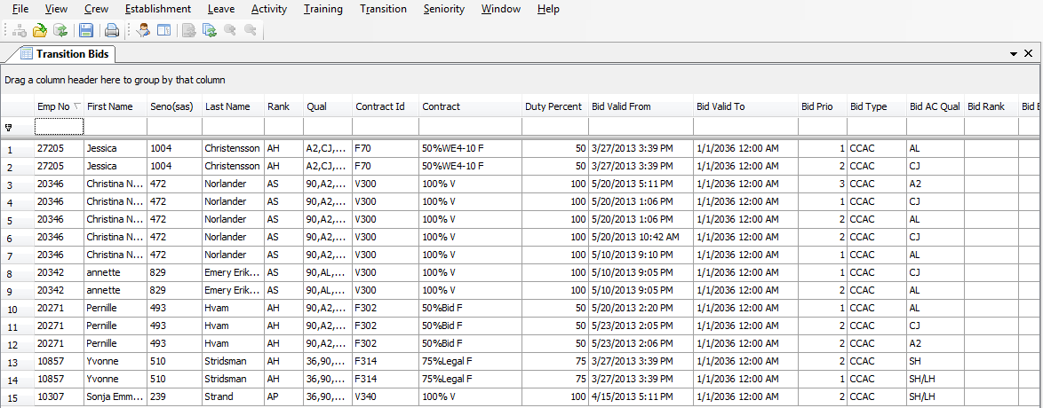

## Technical summary

The Transition codebase is almost entirely in the Manpower client with the exception of lib/python/carmusr/manpower/transition/import_transition_bids.py. It is responsible of parsing the bid files and translating from AC groups to duty groups.

## Rave

|  |  |  |
| --- | --- | --- |
| Name | Location | Description |
|  |  | No Rave used for transition. |

## Database Tables

References to tables used.

| Name | Description |
| --- | --- |
| cga_ | See udm.pdf |

## Scripts

References to scripts used.

|  |  |  |
| --- | --- | --- |
| Name | Location | Description |
|  |  |  |

## Forms

References to forms used.

|  |  |  |
| --- | --- | --- |
| Name | Location | Description |
| BaseMappings.xml | lib/www/manpower/  forms/transition/ | The form for mapping of bases. |

## Reports

References to reports used.

|  |  |  |
| --- | --- | --- |
| Name | Location | Description |
| compare_transitions.py | lib/python/  report_sources/  manpower/transition/ | Compares to a result in a reference workset. |
| transition_list.py | Lists all crew in seniority order that have been assigned to new groups |
| transition_matrix.py | Overview of a transition run. |

## Configuration

References to common config xml-configuration.

**Note!** Technical details should be documented in the code.

|  |  |  |
| --- | --- | --- |
| Name | Location | Description |
|  |  |  |

# Leave

The Leave menu holds two different forms for leave settings and leave entitlement settings.

When working in the leave forms (or any external form in manpower) there are some easier ways to enter data than to click and use the drop-down menus in each cell. They are handy if you don’t know what’s possible to choose from, but if you know what to enter there are easier ways.

* Type in the full name that’s supposed to be there. Case insensitive. Press tab.  
  This is also possible when entering dates. If you have entered an invalid option, the box gets a red square.
* Start typing what you want to enter. Case insensitive. Press SHIFT + Up or Down Arrow. You then cycle through the possible alternatives that start with the letters you have entered.

Note that pressing OK and the red X closing the form means the same thing. All changes made to the settings are applied directly and you cannot cancel without applying the changes. The only way is not to save your changes to the database.

## Account balances

The balances in the leave account are updated dynamically in manpower. When you change the entitlement settings or change the activities on the roster, the balances update accordingly.

### Account baseline

Balances are accumulated during accumulation runs, where the all transactions are updated, and a fixed account balance on a fixed date is set. This fixed balance on a fixed date is called the *account baseline*. This baseline is not updated every day, but rather a few times a year. It needs to be long back enough for all transactions to have settled and not change. In manpower, in the ‘leave history’ tab under each crew in the leave view, you can see the baseline date and all transactions that have occurred since. Only the transactions that occur within the open workset are changed when you change eg entitlement settings. WARNING – if you open a workset that starts before account baseline you cannot trust any balance figures !

### Accumulation

Every late afternoon, an accumulation job is done, updating all transactions in a given time period. This period is one year back and six months in the future. If transactions need to be changed that are more than one year old, but newer than the latest baseline date, updates can be made in manpower if you open a workset containing the right period. All transactions within the open workset period are recalculated.

### Crew accounts

In the application crew accounts you can see all transactions from the beginning of time, not only from the latest baseline. It’s also in crew accounts you can do manual corrections and eg save vacation.

### Save vacation

Saving vacation is done in crew accounts. When saving vacation the days are transferred to an account called VA_SAVED1. This means saved vacation, one year old. Each year on the same date as you get your new vacation, the saved vacation is transferred to an account corresponding to when the vacation was saved. From VA_SAVED5, if not manually withdrawn before that, the vacation is sent back to the VA account.

### Short vacations

#### Some crew (8.11.20) can bid for short vacations; 1,2 or 3 days long. If granted, the corresponding vacations are shown as VAD or VA1D on roster if they are 1 or 2 days long, depending if they are paid or not. The number of days drawn from the VA account will be the double amount of days; 1 day of VAD reduces the VA-account with 2 days. If the short vacation is 3 days long it will be shown as VAH or VA1H and a high rate will be used reducing 5 days from VA account.

These rules are applied also in Studio applications.

## Configure leave settings

Configure leave settings holds a set of tabs, where each tab holds settings for different areas of the leave module.

Some of the tabs have a button called ‘Validate’. Pressing this button performs input validation on that tab. The resulting errors are shown in the text field nex to the ‘OK’ button.

There is also one button called ‘Validate All’. This performs validation on all tabs where there is any validation. This validation also occurs when you press the ‘OK’ button. It is not possible to exit the form using the ‘OK’ button if there are any errors in the data.

If you want to leave the form without correcting the errors, or cannot detect the error from the error message, there is a button called ‘Panic Exit’. It exits the form disregarding the errors. This button should only be used when necessary, since errors in the settings can lead to unexpected result when assigning leave.

When exiting the form, the legality of all crew in the open leave views is recalculated. This is why it can take some time to close. It also takes longer time the more leave views you have open, and the more data is on the rosters, ie which period you have opened.

### Rules

Assignment of leave can be controlled with a number of rules and settings. In this tab it is possible to change the settings.

Rule failures for a vacation can be overridden by using accept rule failures. An example can be that a crew has vacation that ends two days off from the free day pattern. “Accept rule failures” is clicked and the 2 days are stored as a rule exception and the crew becomes legal. If later the pattern is adjusted so the vacation fits the pattern the crew will become illegal as the vacation end legality has been adjusted two days by a rule exception. To remove the rule exception use “consider rule failures”.

#### Leave Rule Settings

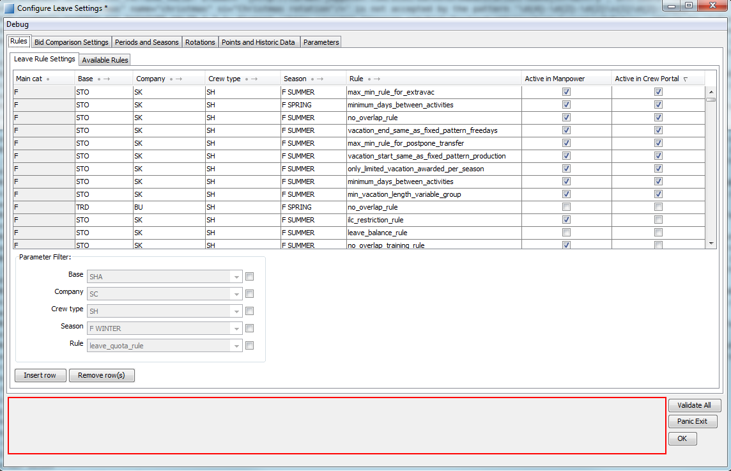

In this view it is possible to configure for which crew a rule should be used or not depending on category, base, company and crew type. The last two columns “Active in Manpower” and “Active in Crew Portal” indicates where the rules will be active. “Active in Manpower” column shows the status of rule in manpower, and “Active in Crew Portal” column shows the status of rule in crew portal. Category is filled in automatically and is not editable. The rules are checked for the season the vacation starts in.

Crew type has three alternatives, LH, SH and ALL:

LH is crew with qualifications A3, A4 or AL.

SH is everyone else.

ALL is all crew.

The program checks LH/SH before ALL crew entries.

#### Available Rules

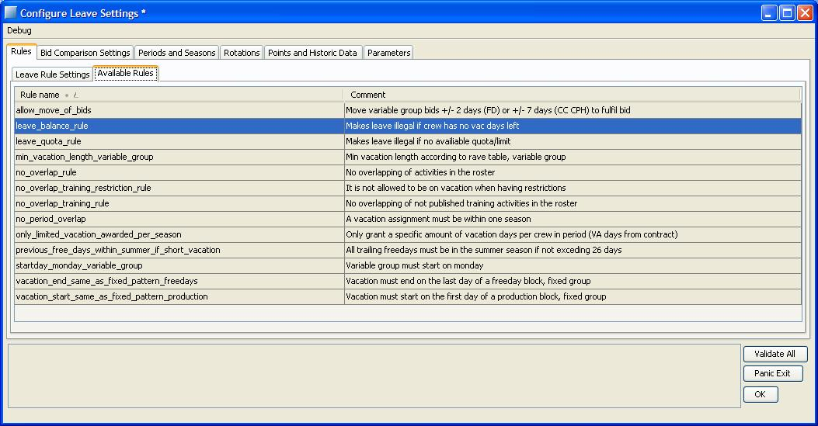

##### Allow_move_of_bids

Tells the system if it is OK to move a bid in order to consider it granted. The number of days allowed to move is defined in Rave rule set, see section 8.11.3

##### No_overlap_rule

A vacation assignment may not overlap other assignments. When the rule is active, there is a number of activities that are allowed to be overlapped. The set of codes are adjustable in cat, base and company and are implemented in the Rave rule set. For a list of codes, see section 8.11. The rule will not break on some fixed patterns after published roster date. This is because these patterns are not “assigned” to crew until they are published. In these cases the rules vacation_start_same_as_fixed_pattern_production and vacation_end_same_as_fixed_pattern_freedays can be used instead.

##### No_overlap_training_rule

A vacation assignment may not overlap not published training assignments. Not published training assignments do not appear in the ordinary roster. When training assignments are released or published the rule checks (only for FD) course start and end date in Crew Training /tab Training Need / Course Start and End date.

For Cabin the rule checks if a vacation assignment overlaps a training (same behavior if the course is open, release or publish)

##### Ilc_restriction_rule

A vacation is not allowed to be closer than 31 days after an ILC. The rule checks against courses that have been created in Manpower, Training and contain a course block with name ILC. The no_overlap_training_rule takes care of when the vacation overlaps the course (and the ILC block).

If the course is released or published the rule checks if ILC is part of the course in Crew Training /tab Training Need and if yes checks that there is no vacation closer than 31 days after Course End date in Training Need tab.

##### Startday_Monday_variable_group

This rule makes a vacation illegal if it doesn’t start on a Monday. The rule is only active for crew in variable group. It also makes sure that vacation rotations start on a Monday if active.

##### Min_vacation_length_variable_group

Vacation assignments for variable group must have a minimum length. The lengths for different crew are defined in Rave rule set, see section 8.11.7. The rule is always invalid for extra vacation bids; instead the python rule max_min_rule_for_extravac is used for extra vacations.

##### Previous_free_days_within_summer_if_short_vacation

This rule should be valid for cabin CPH and limits the free days outside of the summer period if the total vacation days+ free day is lower than 26.

##### No_period_overlap

A single vacation assignment may only be in one planning season. For FD the summer season is extended for crew in rotations 91 and 99. The number of days to extend the season is defined in the rave rule set, see section 8.11.10. Since the rules are checked for the season the vacation starts in, the rule checks if the vacation overlaps into the next season.

If no season is found at vacation end date, the default season is used. This means that the season is considered longer and the rule might not give failure. If no default season exists at vacation end date, the rule will give failure.

##### only_limited_vacation_awarded_per_season

Only grant a certain amount of vacation days in summer season. The limit is ‘noofvadays’ in contract minus granted postponed days and is individual for each crew.

##### leave_balance_rule

Negative balances are not allowed for most crew. The number of days that are allowed to borrow is defined in the rave rule set, see section 8.11.13.

If there are less than the minimum number of allowed balance on a VA or F7 account it will be checked if any new entitlement has been added during the vacation that can be used. Also it will be checked if the prioritized vacation order has been changed (described in 7.9.3).

##### leave_quota_rule

Only a certain amount of vacation for each day can be assigned. The limit is taken from the establishment calculation. It is possible to widen the search span of the days taken into consideration by setting the parameter LimitSearchDepth. For more information see section 8.2.7.

##### Vacation_start_same_as_fixed_pattern_production

The vacation is only considered legal if it starts the same day as a block of production starts in the fixed pattern. The rule handles situations where the fixed pattern both starts and ends with production, or if the possible vacation blocks are of different size.

##### Vacation_end_same_as_fixed_pattern_freedays

The vacation is only considered legal if it ends the same day as a block of free days end in the fixed pattern. The rule handles situations where the fixed pattern both starts and ends with production, or if the possible vacation blocks are of different size.

##### Minimum_days_between_activities

Connection between vacations and between vacations and special activities must be a minimum number of days, specified in table minimum_days_between_activities, 8.10.19. No connection time, 0 days, is also considered legal.

##### balance_rule_for_postpone_transfer

A postpone vacation or a transfer vacation is considered legal if the number of days in bid is less than or equal to the sum of VA and F7 balances.

##### max_min_rule_for_postpone_transfer

A postpone vacation or a transfer vacation is considered legal if the number of days in bid is in a certain min/max range. The min/max range for each bid type depends on the category and crew region.

For postpone vacation:

Max: summer VA in contract

CC SKN: Min=7

CC SKS: Min=1

CC SKD: Min=1

FD SKS/SKN/SKD: Min=7

For transfer vacation:

Min: 1

FD SKN: Max=18

FD SKS/SKD: Max=7

CC SKN: Max=14

##### max_min_rule_for_extravac

An extra vacation is considered legal if the number of days for each alternative in the bid is greater than or equal to 1 and less than or equal to 9.

### Bid Comparison settings

In an automatic assignment, the bids need to be compared to be granted in the right order. The bid comparison settings define the way bids are sorted.

#### Bid comparer settings

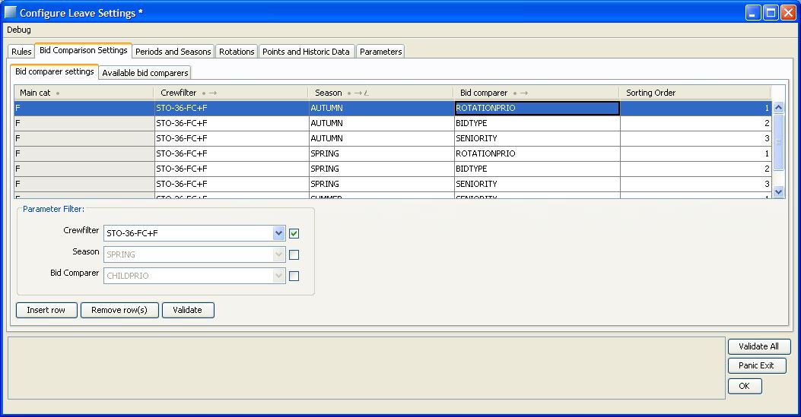

The comparers are set at a crew filter level. Since a crew filter can consist of crew from different bases etc, you define the comparer for the crew filter you are working on. It must be the exact same filter as you are working on.

Different comparers can be used in different seasons, without need to change them. If no bid comparer exists, the bids will be granted in a random order.

The sorting order makes a big difference. If the system cannot separate two bids with comparer number 1, it tries comparer number 2 and so on, until it can tell which bid is higher prioritized. You can control the sorting order in the report ‘bid_grantoder_list’, 8.6.2. Also note that to get the rotations to be awarded first, the BIDTYPE comparer needs to be active.

*Example:*

We have two crew with two bids each:

crew 1 with seniority 1 and bids with prio 1 (1.1) and 2 (1.2)

crew 2 with seniority 2 and bids with prio 1 (2.1) and 2 (2.2).

If the comparer looks like

SENIORITY 1

PRIO 2

The resulting sorted list of bids will be

1.1, 1.2, 2.1, 2.2, Since seniority is ranked higher than bid prio, all bids from the crew with best seniority will be on top of the list, sorted by prio.

If we change the comparer to

SENIORITY 2

PRIO 1

The result will be

1.1, 2.1, 1.2, 2.2, Since bid prio is higher ranked than seniority, all bids with prio one will be on top of the list, sorted by seniority.

#### Available bid comparers

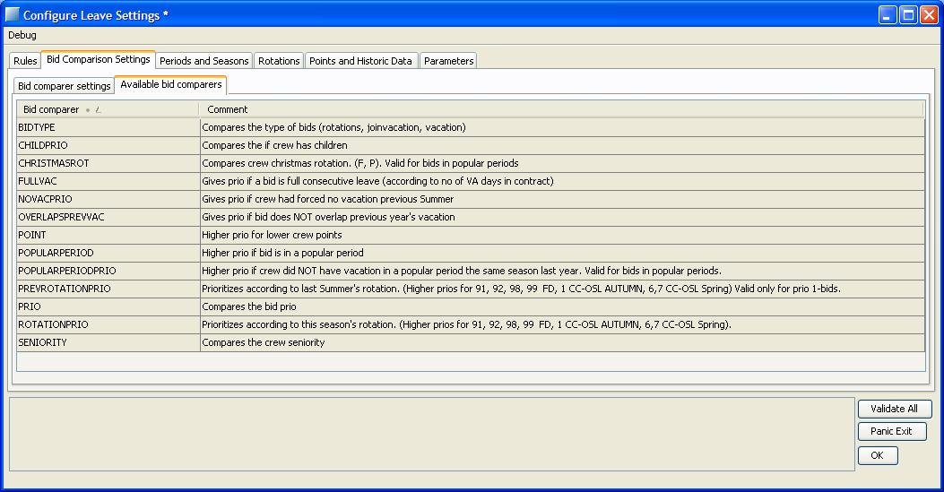

‘

This tab displays the available bid comparers, with an explaining comment.

#### BIDTYPE

The bids will be sorted according to the bid type.

1. Inrotation bids will be first.

Joinvacation bids second.

Normal vacation bids third.

Inrotation bids are not actual bids, but the rotations are modeled and handled as bids in the system. For more info on the rotation settings, see section 8.2.4. BIDTYPE should be used when crew has vacation rotations, FD, summer; CC OSL

#### CHILDPRIO

If a crew member has children he or she might have an extra priority that gives the crew member an advantage over people who do not have children. Whether a crew got children or not is defined in the special_schedules table in the database. If you want to modify a crew member so that it is considered to have children you need to open the crew info application. In the Crew Info interface a tab for Special Schedules is available. A new item is created by setting the required keys (Valid from, Type (HasChildren) and Note) to unique values. After an item is created the other fields can be changed.

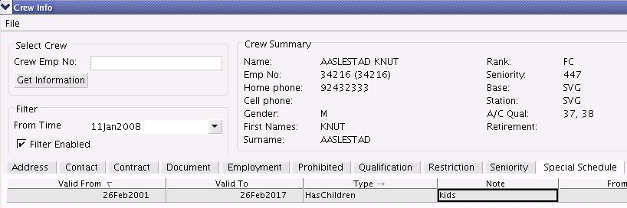

The above example shows a crew that is considered to have child priority from the 26thFeb2001 until the 26Feb2017.

#### CHRISTMASROT

If a bid is considered to be in a popular period and also is in a season where crew has Christmas rotations, crew with some Christmas rotations are prioritized higher. Prioritization order defined in Rave rule set, see section 8.10.1

#### FULLVAC

Vacation bid that are considered as full consecutive leave will have a higher priority than other vacation bids. Full consecutive leave is when the bid is only one period and at least the number of days defined in the contract.

#### NOVACPRIO

If a crew member did not receive any vacation by force in the previous summer season he/she will have a higher priority for the current season. This prio is valid for the bid, including alternatives, that crew prioritizes as number 1, and only for that bid. It is not valid if crew got a granted No Vacation-bid.

#### OVERLAPSPREVVAC

This comparer looks at the vacations crew had the same season previous year. If the bid overlaps the previous vacation with more than one week, the bid will have a lower priority.

#### POINT

The bids will be sorted according to the number of points a crew member has. The lower the points, the higher the bid will be in the list. Newly employed crew members will have 9999 points and will end up on the bottom of the list. The points are defined according to section 8.2.5

#### POPULARPERIOD

This comparer gives extra priority to all bids which are considered to be in the popular periods. It should be used if the popular periods should be awarded first. This can make a difference in the outcome, since a bid can only partly be in a popular period, but still be considered a popular period bid. For popular period settings, see section 8.2.3.3

#### POPULARPERIODPRIO

If a crew member has had a vacation in popular period in the last year he/she will have lower priority. The period is taken from the start date the same season last year to the start date of this season. For popular period settings, see section 8.2.3.3

#### PREVROTATIONPRIO

This comparer looks at the rotation in the latest summer season and sorts according to that. For FD crew with published vacation in rotation 91,92, 98 or 99 will be prioritized. One bid, that crew prioritizes as number 1, will be prioritized. This prio can only be utilized ones in autumn assignment or spring assignment, not in both seasons. Prioritized rotations are defined in the Rave rule set. See section 8.10.1.

The rotation is saved as a historic activity, see 8.2.5.3, the first time vacation is published in manpower. If a rotation entry already exists for that season in the historic data, that data entry will not be changed. The lookup of rotations are done according to the rotation period settings, 8.2.4.2.

#### PRIO

Sorts on the bids priority. High prio (a low number) will be treated first.

#### ROTATIONPRIO

The bids will be sorted according to the rotation crew has this/current season. See section 8.10.1.

#### SENIORITY

The bids will be sorted according to seniority. The highest seniority (low number) first: seniority 1, seniority 2 and so on. If there is a seniority of type LOCAL it will be used, otherwise the one with type SAS is used.

#### VACNUM

A temporary possibility for sorting the bids, using an explicit crew attribute in a dedicated Etable. This should not be used except by personnel with special knowledge.

### Periods and seasons

Leave planning is done for different seasons. These seasons must be defined to start and end at different dates. The dates are defined on category, base, company and crew type. If the dates are not specified for a crew, the system looks at common dates. It is of great importance the seasons do not overlap, since this will give unwanted and unpredicted behavior in rules and automatic vacation assignments. The dates on crew must also lie within the dates of the common season, that is, the common season must include all possible individual season dates.

The system uses the common dates to determine if the open workset is big enough to work with. To extract reports, run automatic vacation assignments or export data to interbids, the entire common season needs to be opened, with some exceptions.

It is also important to have definitions of all seasons within the open workset, or the rules might fail or not trigger.

#### Crew season definition

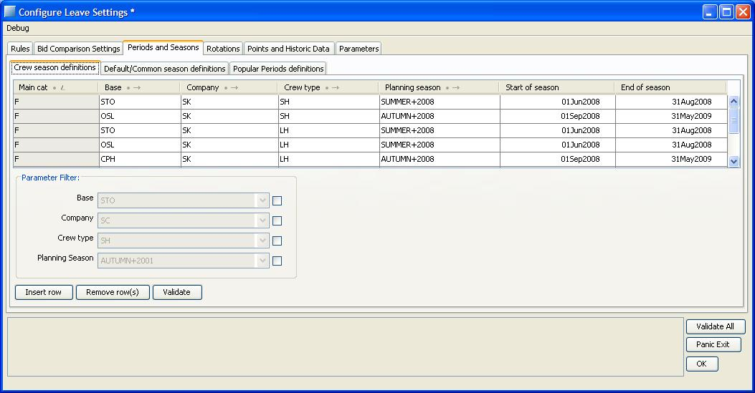

The crew season definition defines between which dates different seasons are for different crew. It can be defined on main cat, base, company and crew type. Crew type is defined as described in *8.2.1.1 Leave Rule Settings.*

If no entry is found in this table, the system will look in the default/common season definitions instead. There the seasons are often overlapping, meaning that there might be strange rule behavior for vacations starting or ending on dates included in multiple seasons.

Important and recommended is to always define the correct seasons in the crew season definitions.

#### Default/Common season definitions

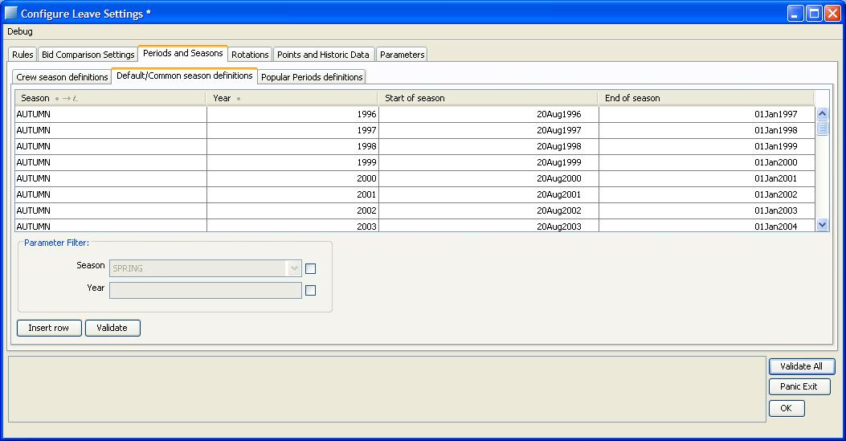

This defines the default settings, see above. The start of a season should be the earliest start that anyone has and the end should be the latest end that anyone has. This means that for example all summer seasons 2007 defined crew season definitions should be included in the dates defined here on summer 2007. The system looks in this setting to determine if a season is fully included in the open workset, for instance at an automatic leave assignment or reports.

This setting is common for all users of the system, and should only be changed by a super user. This user should make sure that upcoming seasons are entered into the system and that suitable dates are entered. To work on vacation planning during a season, the entire interval defined here for that season must be opened.

#### Popular Period definitions

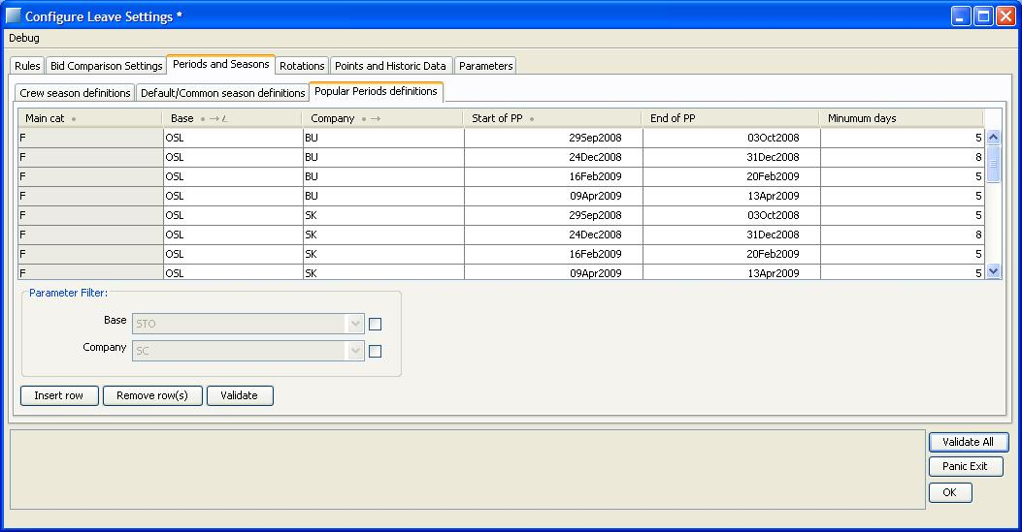

Some crew uses popular periods. This is where the dates of the popular periods are defined, based on main cat, base and company. There is also a minimum days that should be filled in. It is the minimum number of days in a vacation block that needs to be inside the popular period for the block to be considered in the popular period.

### Rotations

Crew can have vacation rotations and Christmas rotations. Vacation rotations have a period associated with them, which is the base of the vacation that will be assigned by the automatic assigner. Christmas rotations are used by the bid comparers, and also for information for the user.

#### Rotation orders

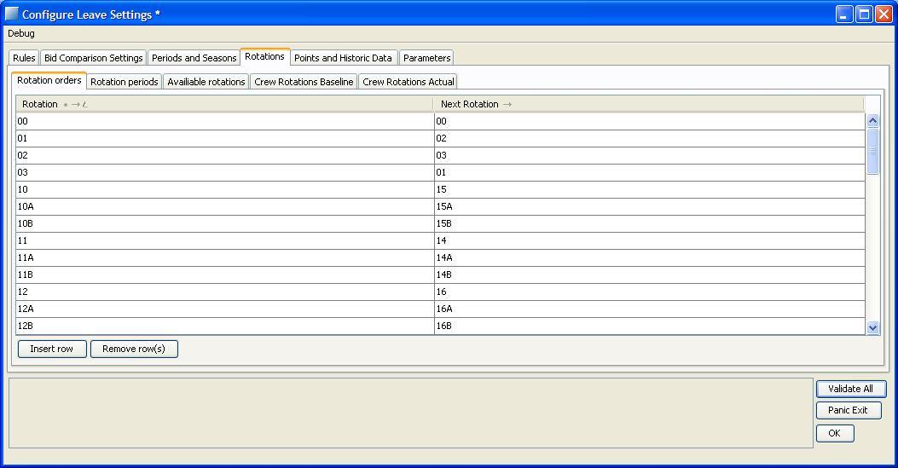

This table defines how a crew changes rotation from year to year. The design is to enter which rotation comes after which rotation. In this example you rotate 01-02-03-01

#### Rotation Periods

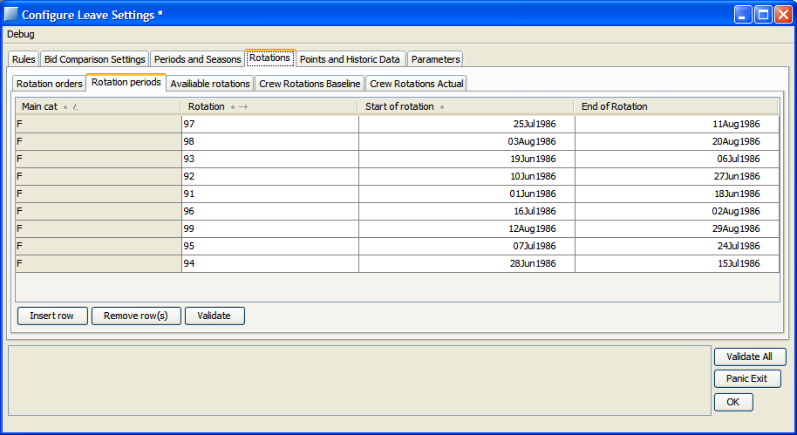

This table is used to identify which period belongs to a rotation. All rotations should have the year 1986, which means the same dates every year. Each rotation may only have one period. If a period passes new year the end date should be 1987.

#### Available rotations

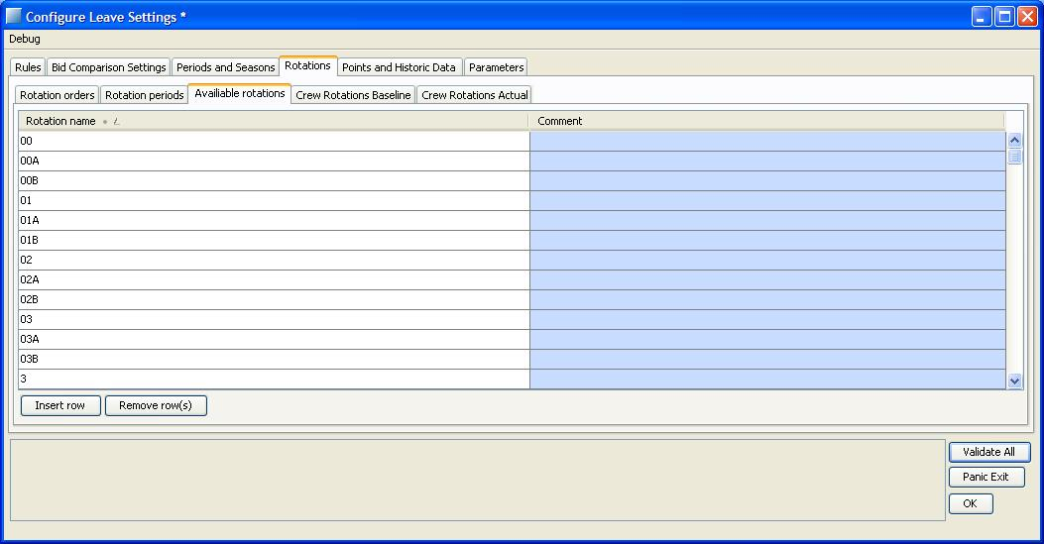

The rotation set defines all available rotations.

#### Crew Rotations Baseline

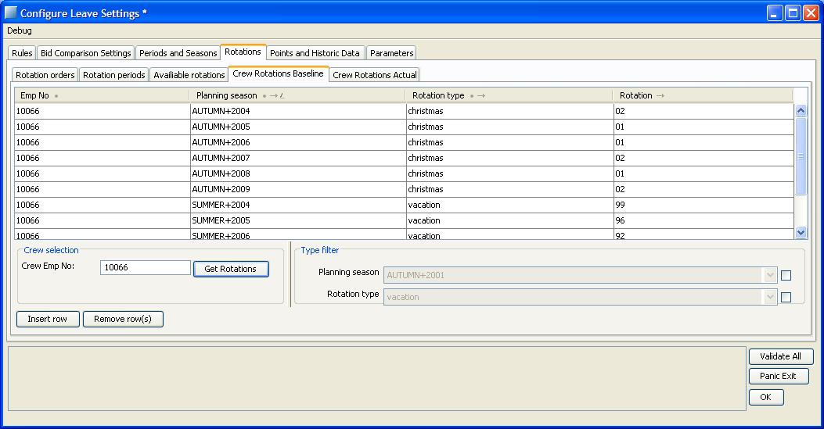

This view defines the rotations ‘baseline’ for each crew (the info is stored in leave_crew_rotation table). This is the starting point for the rotation order in the Rotation order tab. Crew does not need one entry for every season as long as the crew stays in the same rotation. If you change in this table, crew changes rotation permanently and rotates according to the rotation order from this rotation.

Enter an employee number and click Get Rotations to view rotations and change if desired. When an employee is selected it is also possible to create new entries for that crew.

#### Crew Rotations Actual

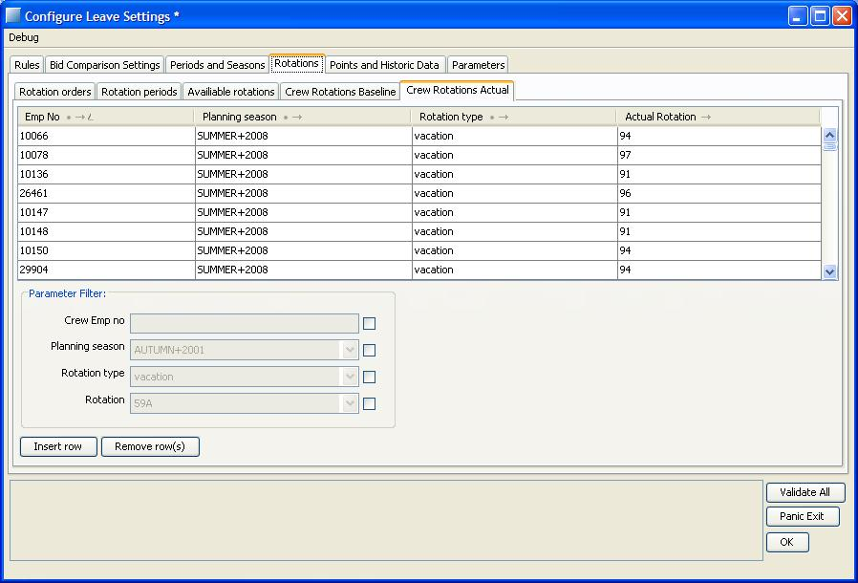

This table holds the actual rotation that is used each season (the info is stored in leave_actual_rotation table).. This is where the system first looks for rotations. If no entry exists here, rotation calculation is done from the last entry in *crew rotations baseline 8.2.4.4.*  A check is done if the calculated rotation is valid for each crew. If an invalid rotation is encountered, the system rotates more steps until a valid rotation is found or all rotations have been tried. The validity of rotations is implemented in the Rave-code, see section 8.10.6

If a crew member temporarily changes his rotation for any reason, this is where to change it. If there is a rotation in this table it is used, regardless which rotation is specified in the baseline. The rotations can be recalculated from the baseline using ‘Initiate season data’, see 8.5.

#### Awarding leave rotations

Awarding of leave rotations is done in automatic leave assignment by the BidAssigner. Rotations are modeled as ordinary bids and can be prioritized to be awarded first by using the right comparer. See section 8.2.2.3. Rotations are awarded no matter if there is quota to take from or not. All other rules are however checked as for any other bid. Setting the quota to zero, or to limit usage of the available quota to zero, will result in only awarded leave rotations.

Rotations are adjusted to fixed patterns. It is moved so that the start will be on the start of the closest production block. If the closest block is outside the extended leave season, section 8.10.10, it will be moved the other way. If crew is covered by the tables 8.10.17 the rotation start in fixed patterns are handled separately. For CC in table 8.10.17 the rotation start is the first possible start in the valid rotation period. For FD in table 8.10.17 the rotation start is calculated from a fixed start date, 30 May. The rotations 91-99 give the number of cycles to step forward. For example 92 means 1 cycle, nine days forward and 93 means 2, 18 days forward. The rotation start will be the first production day after the forward steps are made.

Calculation of the adjusted rotation end might be affected if crew changes from fix to variable contract shortly after. Especially if vacation starts later than configured rotation start, it is necessary to change contract some days after adjusted rotation end. Otherwise the automatic assigner will assign a too short rotation.

For a variable group, the system checks if the ‘startday_monday_variable_group’-rule (8.2.1.2.5) is active. If this is the case, the rotation is adjusted to start on the closest Monday. For crew in variable group, the length of the vacation awarded will be scaled according to duty percent and the number of vacation days defined in the contract.

### Points and historic data

The "Leave Points definitions"-table defines how many points are generated by having vacation on a day. The points are summed for all vacation days within the period. Periods as defined in 8.2.5.2. Functionality is enabled by filling in the "Leave Points definitions"-table for a cat, base and company.

#### Leave Points Definitions

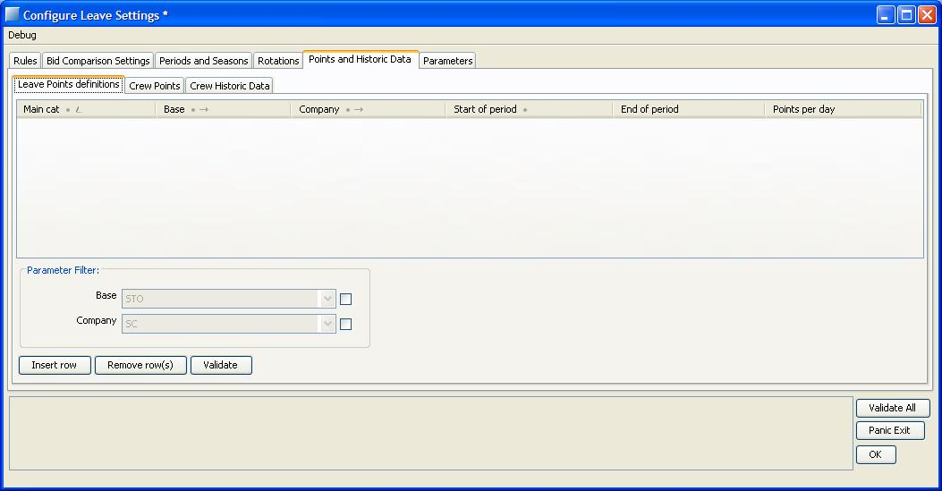

This table defines the number of points a crew gets for every day he is on vacation in the given period. It’s defined on category, base and company.

#### Crew Points

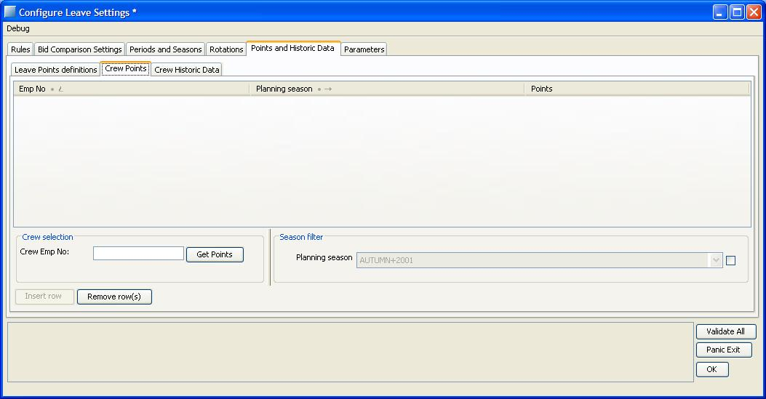

This table defines the number of points that a crew member is considered to have for each and every season. For SUMMER the points are earned the season before, for instance the points for SUMMER 2007 are earned the previous summer, SUMMER 2006, and can be used during the bid sorting in SUMMER 2007. For AUTUMN and SPRING the earning period is the period between the two previous summers. I.e. for AUTUMN 2009 the points are earned during both AUTUMN2008 and SPRING2009. For SPRING 2010 the earning period and therefore the points are the same as for AUTUMN 2009.

Enter an employee number and click **Get Points** to view or change points. When an employee is selected it is also possible to create new entries for that crew, or edit available entries.

The points for a crew and a season are calculated the first time it is needed, and stored in the table. If the wrong points have been calculated, for example if not all data was present the first time a points’ entry was requested, it is possible to reset by using ‘Initiate season data’, see Carmen Manpower User Guide.

#### Crew Historic Data

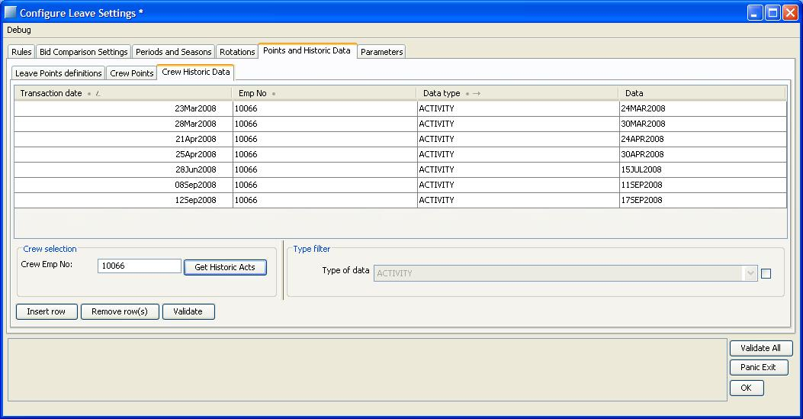

In this table all historic data on a crew member is stored. Today there are four different kinds of historic data that are stored. These are activities, rotations, used previous summer prio and granted novacation bids. Activities and novacation bids are added in the table during accumulation while rotations and used previous summer prio are added when published. Rotations and usedprevsummerrot are only entered once in the table. This means that if conditions are changed after publish these entries are not updated in the historic table.

The activities are the actual vacations that crew has had, rotation is the rotation that crew had when the vacation was first published and future sorting will be based on, and grantednovacationbid is if crew had a granted no vacation bid. Used previous summer prio is an indication that the comparer prevrotationprio has been used and should not give prio the following season.

Normally you should never change anything in this table since it will affect the result of an automatic vacation assignment. However it can be useful to look at to understand why the results of an automatic assignment look as they do. Enter employee number and click Get Historic acts to view historic data.

When an employee is selected it is also possible to create new entries for that crew.

### Parameters

Some values can be changed using parameters defined in different tables. This section explains them.

#### Leave Parameters

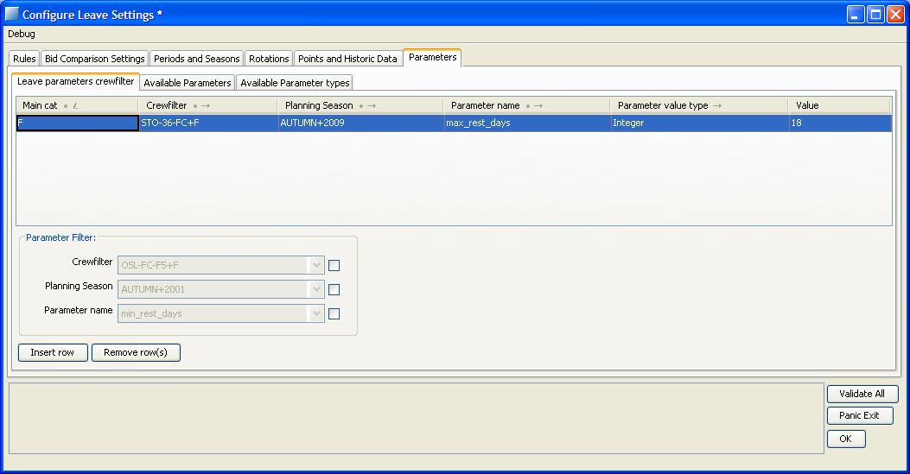

Some parameters are associated with a crew filter. In this table those parameters are entered. Choose crew filter and leave season and enter the wanted parameter, its value type and the value.

### Available Parameters

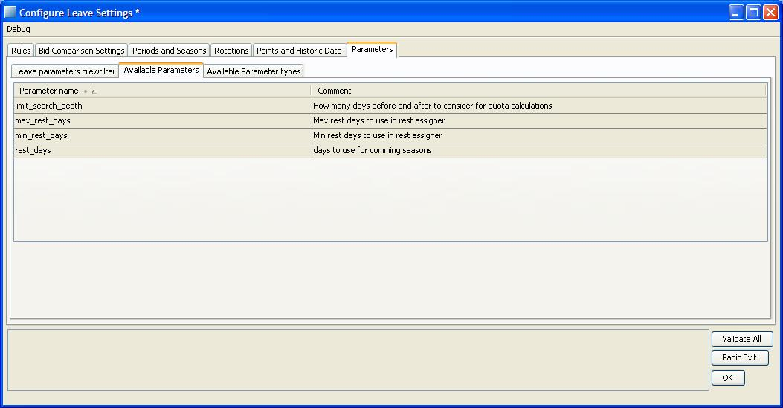

This is a list of the available parameters.

#### Max_rest_days

This parameter is used by the rest assigner, and defines the maximum days per crew to be tried to assign. Type Integer.

#### Min_rest_days

Used by the rest assigner, defines minimum days per crew to be tried to assign. Type Integer.

#### Rest_days

The minimum number of days that should be left in the leave accounts by the rest assigner this season, to be able to use the next season. Type Integer.

#### LimitSearchDepth

The limit search depth relaxes the limit rule, as it will widen the span that is checked. It adds the number of days on each side of the current day, and takes the mean. Type Integer.

To give an example, if the parameter is set to 1, the quota rule will consider 3 days. It will look at the mean of the quota on the day in question, and the day before and after. If you go above quota on the day in question, the system will then also consider the two other days and check how much room is left on those days. If the mean value over the three days is still positive it is considered legal.

LimitSearchDepth is only valid during automatic leave assignments. When you try to grant bids manually, or assign vacation manually, you always get the real result of the quota rule.

During an automatic leave assignment the conditions can change after limitsearchdepth has been used. This means that an assignment seams illegal in the end result, but was legal the moment it was assigned during automatic leave assignment.

### Available Parameter Types

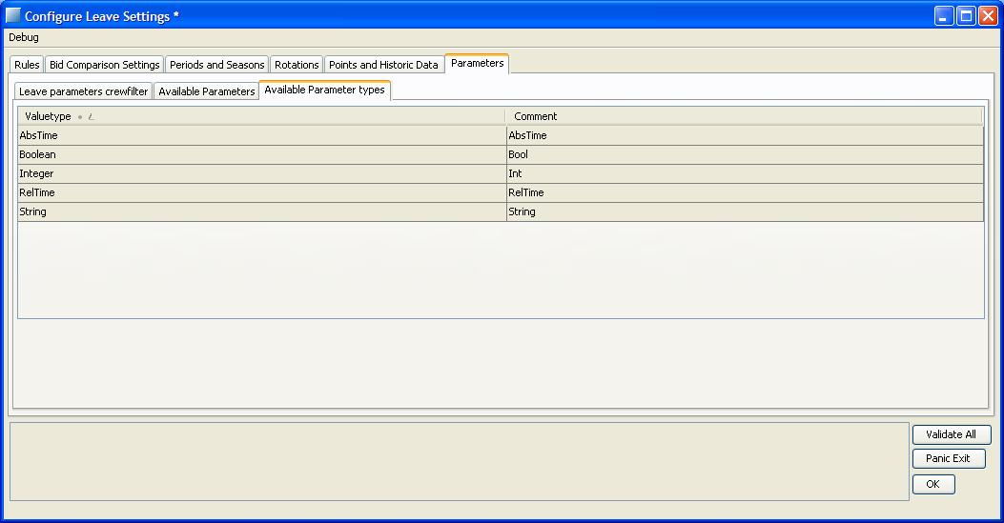

This table defines which value types are available for the parameters. All parameters available are of the type Integer.

## Crew Portal Bid Configuration (for Leave)

Crew Portal Bid Configuration which is located under the Leave tab consists of two tabs: “Leave Season Bid Information” and “Leave Season Bid Types”. Using these tabs new entries can be saved, existing entries can be updated and deleted.

### Leave Season Bid Information Tab

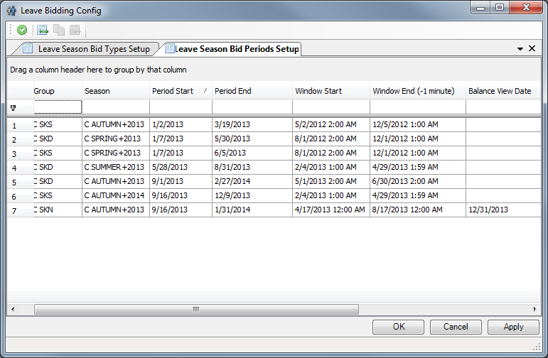

Using this tab planners decide which crew filters for which seasons can place bids. Period Start and Period End dates show the dates when the season starts and ends respectively. Window start is the date when crew members can start bidding for the bid season, and Window End date is the last date crew members can place their bids for the bid season.

Period Start and Period End **are inclusive** dates.

Balance View Date controls the date from which the balance is visible to crew in the crew portal. If this column is left empty, season end will be used.

### Leave Season Bid Types Tab

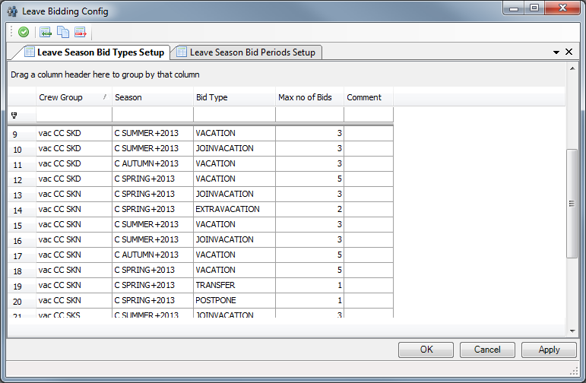

Through the Leave Season Bid Types tab, planners enter the bid types which can be bid by the crew members in the season. Values in Bid types column and Crew Portal Bid Types column should be the same. Maximum number of bids column indicates the maximum number of bids crew can bid for a bid type.

## Configure Leave Entitlement Settings

### General

The annual earning of vacation days is called *leave entitlement*. The reduction of this entitlement because of LOA is called *leave reduction.*

Two dates decide when you get your vacation earnings: Entitlement Start date and Transaction date. The Entitlement start date is when you get your earned vacation, and defines the vacation year. The transaction date is when you actually get access to the vacation days, previously earned.

The days earned are the number defined in the table, with possible adjustments for part time. The time that the vacation is earned is from the previous entitlement date until this entitlement date, or if you earn the days in advance, from this entitlement date until the next entitlement date. The next entitlement date is which comes first, the previous entitlement date plus one year, or the next date according to the table. The previous entitlement date is always the previous valid date in the table, with addition of a number of years to get the entitlement period equal to or less than one year.

Reduction is done on the equivalent entitlement period; with a reduction of the amount of days earned per day that period times the number of reducing days.

Earned days will be credited to an *entitlement account*. When a new vacation year starts the days are transferred to a *buffer account*, and from there transferred to the vacation account on the transaction date. If the transaction date and entitlement start date is the same, the days will go directly to the vacation account from the entitlement account.

Part time crew who earn vacation days according to work rate will get entitlement of unpaid vacation, VA1, for the part time days in the same manner as described above.

Reduction of entitlement will be seen as a transaction from the VA entitlement account to one of the VA1 accounts, depending on the transaction day.

The VA1 account will be emptied on the transaction day, before new days are entered.

Entitlement is recalculated in two different ways:

1. Nightly run that recalculate entitlement transactions for all crew one year back and a half year forward.
2. Commands from the Manpower GUI that will recalculate all entitlement transactions that occur during the opened workset:
   * Leave menu -> Recalculate entitlement for all crew in workset
   * Leave menu -> Recalculate entitlement for all crew in current leave view
   * Leave menu -> Recalculate entitlement for selected crew

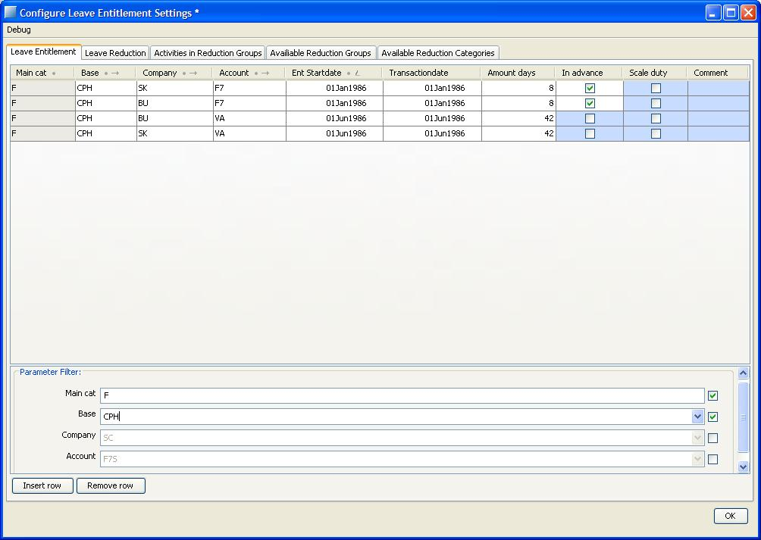

Entitlement is the annual earning of leave balance. To add entitlement, define the base and company of the crew and select a vacation account where amount should be added. Category is filled in automatically. Only accounts VA and F7 are applicable. The Entitlement date defines when you get the vacation days to the entitlement account, not when you start to earn them. When new crew starts earning entitlement the start date is given by the crew contract. Many entries with different dates are possible. When calculating the next entitlement date, the system takes which comes first; the next date in the table, or the addition on a number of years to the biggest date that is smaller than the current date in the table.

Set the following parameters:

|  |  |
| --- | --- |
| Parameter | Description |
| Ent Startdate | Date for entitlement. Entitlement is earned between two entitlement dates. |
| Transactiondate | Date when earned vacation gets available for crew. |
| Amount days | The amount of leave earned between two entitlement dates. |
| In advance | If entitlement is earned in advance, the days are earned from the entitlement date until the next entitlement date. If not, the days are earned from the previous entitlement date until the entitlement date. |
| Scale duty | With scale duty true, the amount earned will be scaled according to the duty percent that crew works according to contract.  Eg a 50 percent crew will get 21 days if the entitlement amount is 42 days. |

When you try to remove a row, the system controls if there are any reductions linked to the entitlement. If there are, you cannot remove the entitlement until you have removed the reduction. If the entitlement line is not completed as a unique line before you try to remove it, it will not be removed. All key fields need to be filled in before you can remove it. The key fields are Category, Base, Company, Account and Ent Startdate.

### Leave Reduction

Reduction of leave entitlement is calculated by gathering information about reducing activities occurring during the entitlement-earning period. Activity codes are divided into groups which can reduce the entitlement in different ways. Reduction is shown as a negative number in Leave History, VA_ENTITLEMENT column, for each crew. It is also shown as a corresponding positive number in Leave History, VA1_ENTITLEMENT. The reduced vacation is thus transferred to VA1. For F7 special reduction see 8.10.12.

The reduction is coupled to an entitlement. If you change the entitlement by adding a new entitlement row with a new entitlement date, reduction needs to be coupled to that entitlement.

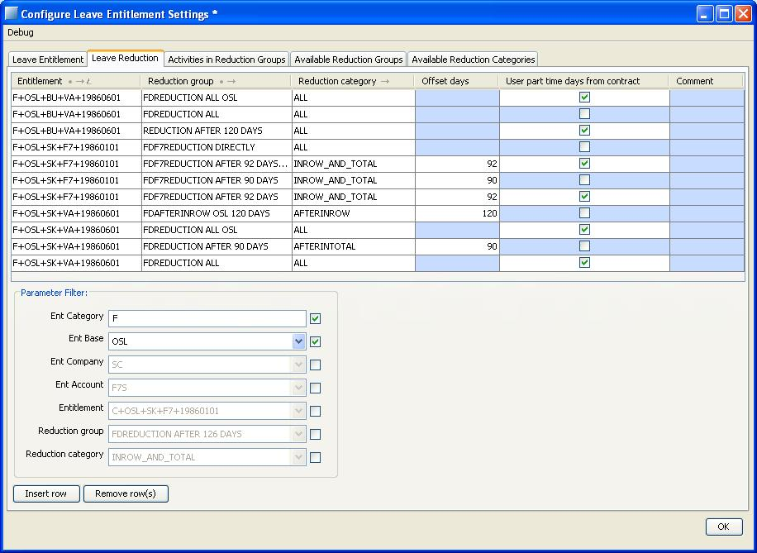

This table associates the reduction groups with different leave entitlements, that is different crew, and reduction categories. Before you can add reduction, you need to define reduction groups, see 8.3.5. Then select the entitlement of the crew and add the desired reduction group.

Set the following parameters:

|  |  |
| --- | --- |
| Parameter | Description |
| Offset days | Set if reduction group has category AFTERINTOTAL, AFTERINROW or INROW_AND_TOTAL. Number of days with activities that is not reducing before reduction should take place.  Not necessary for category ‘ALL’ or ‘ALLTABLE’. |
| Use part time days from contract | If this option is chosen and the part time code of a crew is part of the reduction group, the number of days with that code will be taken from the contract instead of the roster. Useful eg when entitlement is done in advance and reduction should be done for part time days.  **Note:** The part time code **must** be part of the reduction group; it is not enough just to mark this option. |

### Available Reduction Categories

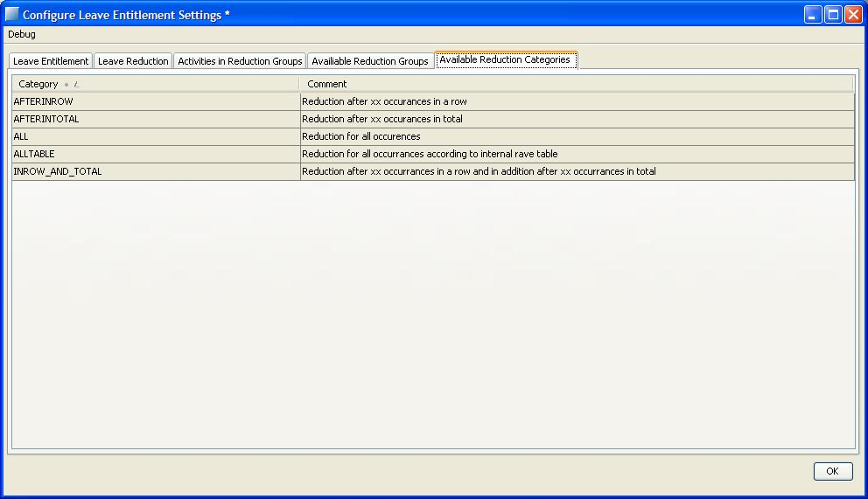

View the available categories that can be assigned to reduction groups. Possibilities:

ALL:  Reduction is done for all occurrences of the activities within the reduction period. Only the parts of the activities that are inside the period counts.

AFTERINROW: Reduction is done after a number of activities in a row. The system starts counting at the beginning of an activity, even if it is outside the reduction period. Only days within the period can be reducing.

AFTERINTOTAL: Reduction is done after a number of activities in total during the period. Only the parts of the activities that are inside the period counts.

ALLTABLE: Reduction for all occurrences of the activities according to a predefined RAVE-table. The reduction is summed up month by month to yield a result for a whole entitlement period. See section 8.10.16.

INROW_AND_TOTAL: This option is a combination of AFTERINROW and AFTERINTOTAL. The system reduces according to AFTERINROW, but also reduces for the amount of days exceeding the offset days and the already reducing days.

Non-editable and not-filterable.

The picture describes the differences between INROW_AND_TOTAL, AFTERINTOTAL and AFTERINROW reduction. The offset is 50 days.

50 40 10

50 50 50

50 40 50

reduction period 1 reduction period 2

1. INROW_AND_TOTAL Reducing activities, not reducing due to offset
2. AFTERINTOTAL
3. AFTERINROW Reducing activities

### Available Reduction Groups

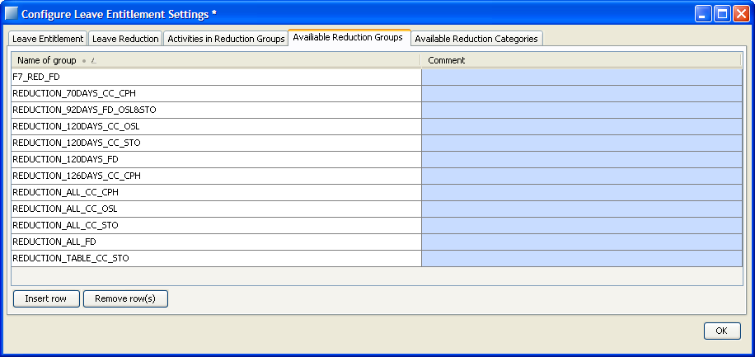

A list of all available reduction groups. It’s possible to create new groups, and useful to have a naming convention to keep track of the groups.

Editable and filterable.

### Activities in Reduction Groups

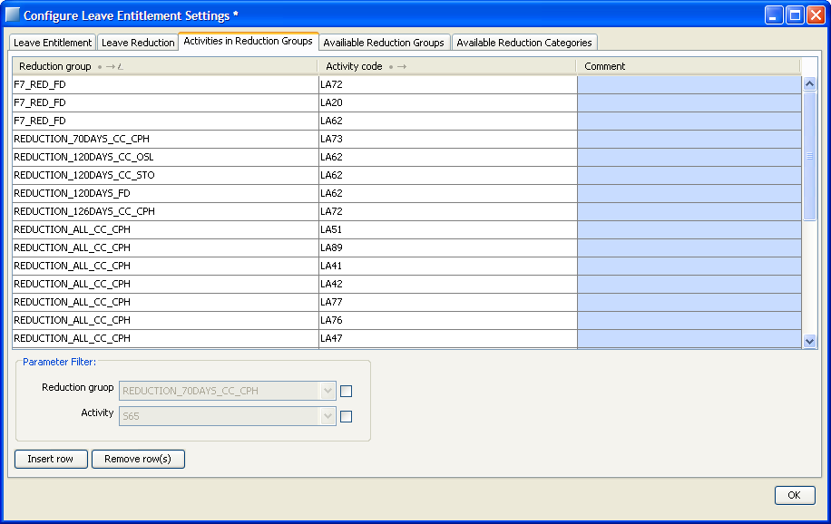

This table defines which activities that belong to which reduction group. One group can hold many activities.

Editable and filterable.

### Entitlement for retired crew

Crew is considered retired when a contract with grouptype “R” is active. Crew who will retire during one year will get the vacation earned during that year on the next leave entitlement date, as for anyone else. To get access to that vacation earlier on, eg to assign it, a manual transaction of the correct amount can be done, resulting in negative balance on the account from the time of the transaction until the entitlement is done.

## Bid Transactions

You can check the bidding log in Leave menu > Show Bid Transactions

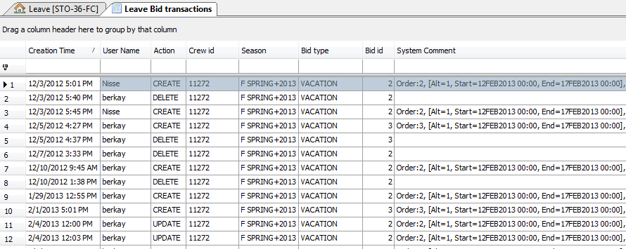

## Edit vacation bids

When the final import from Interbids for a vacation season has been done you can add, remove and edit the bids. The changes for all edited crew are saved when closing the form either with OK or the cross in the upper corner. There is some basic validation. E.g. that end date is bigger than start date and that no necessary field is empty. If you wish to cancel the changes you have done for a crew and see the data as it was when opening the form you can press Revert Changes for current crew.

If you by some reason want to edit bids that are already fulfilled you should remove the assigned vacation first.

Note that the changes made in Manpower are overwritten when making a new import for the same crew and same season from Interbids. Since the import is done by filter you have to pay special attention to crew changing filter so that no one accidentally overwrites your edited bids.

VACATION and JOINVACATION bids are found in Vacation tab.

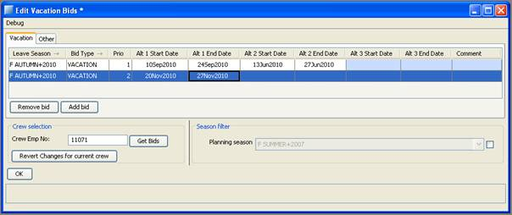

NOVACATION, POSTPONE and TRANSFER bids are found in Other tab.

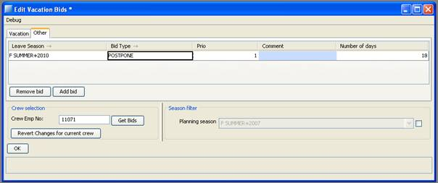

## Initiate season data for crew in filter

The command ‘Initiate season data’ in the leave view does three things.

* Recalculates crew points
* Recalculates vacation rotations
* Recalculates Christmas rotations

This means that the entries that exist for the active season, including manual changes, are removed, in Crew Rotation actual 8.2.4.5 and Crew Points 8.2.5.2, and then recalculated. The first time automatic assignment is run for each season it will calculate season data if it hasn’t already been done.

## Reports

### assigned_vacation_list

A list containing all crew in the filter and their assignments, bids and preactivities for the selected season.

Crew balances are on the date chosen as ‘View Date’ in the leave view.

Under **Assigned Vacation** only non-published assignments of type VA, VA1, F7S, F7 will be shown

Under **Bidding List** crew’s biddings of type VACATION or JOINVACATION with comments for the season is presented.

**Other Bid List** will be present if there are any other bids of type NOVACATION, POSTPONE or TRANSFER for crew this season

Under **Preactivities** any other personal activities and published activities of type VA, VA1, F7S and F7. Some freeday/parttime patterns are filtered out, depending on the contract on View Date .

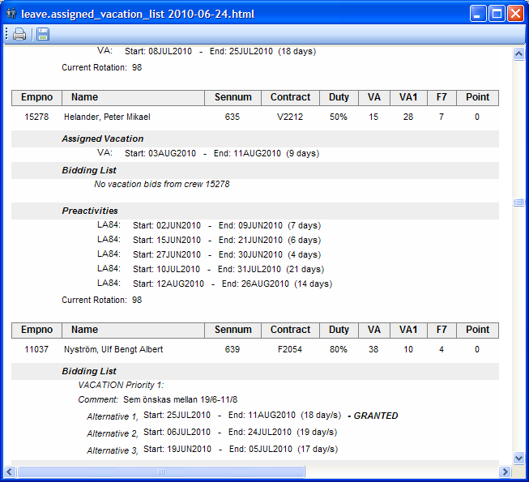

### bid_grantorder_list

This is the order in which the bids will be/are granted by the automatic leave assigner.

Only vacation bids within selected season are shown. Granted bids are marked as granted.

After a granted Vacation bid, the corresponding assigned vacation is shown.

Crew balances are on the date chosen as ‘View Date’ in the leave view.

The data for each bid is dependent on what comparers are set and which season is used.

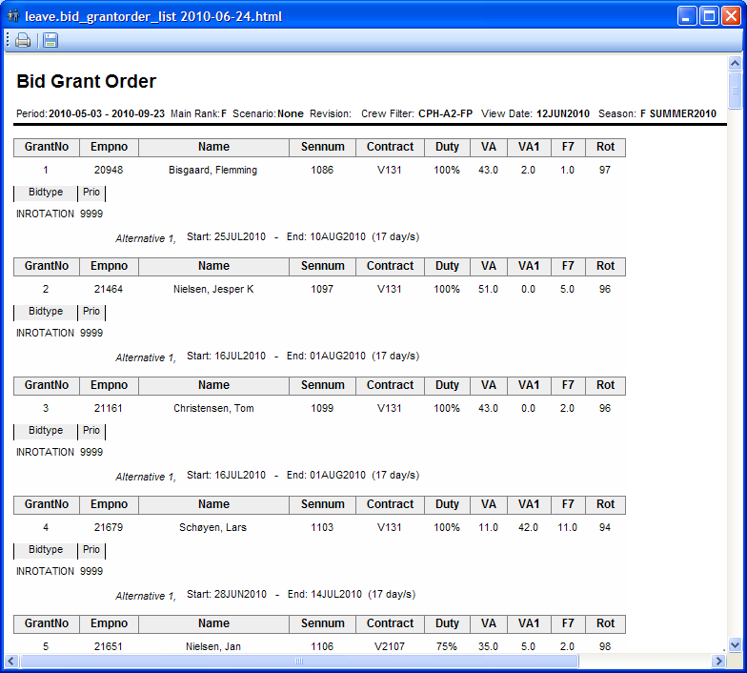

### bid_grantorder_tbl_csv

This report show the same data as in bid_grantorder_list, but as a table, in CSV format. The report should be run as txt format, and saved as .txt file. Then rename the file to .csv and open it with Excel or similar.

### bid_grantorder_tbl_html

This is exactly the same as bid_grantorder_tbl_csv, but formatting is as html, which allow for presenting and saving as html and csv report.

### bid_grantorder_on_day

This report only shows the bids that have an alternative that covers the view date. The bids are displayed in the same order as bid_grantorder_list, that is according to the leave comparer set. The global grantorder number is also shown.

The report can be useful to track in which order crew has been assigned vacation on a certain date. Note however that the report shows the bids in the grantorder, not the order the vacations have been created, and is therefore only useful as long as the same bidcomparer is used.

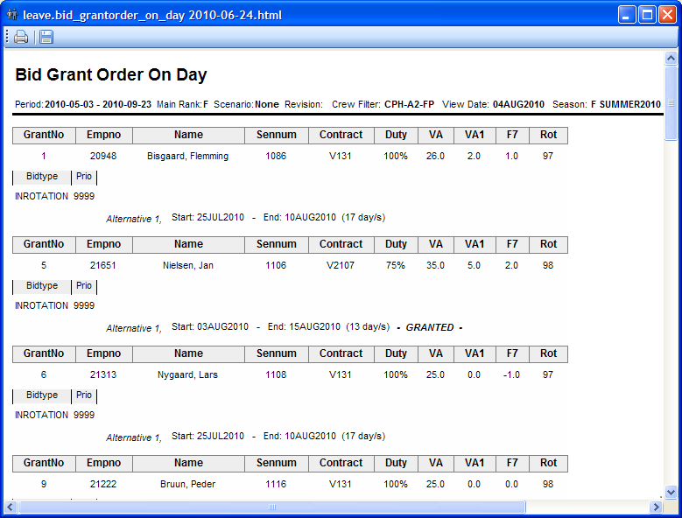

### bidding_list

A list containing all crew in the filter and their current bids for the selected season.

Under **Preactivities** personal activities and published vacation is displayed.

Crew balances are on the date chosen as ‘View Date’ in the leave view.

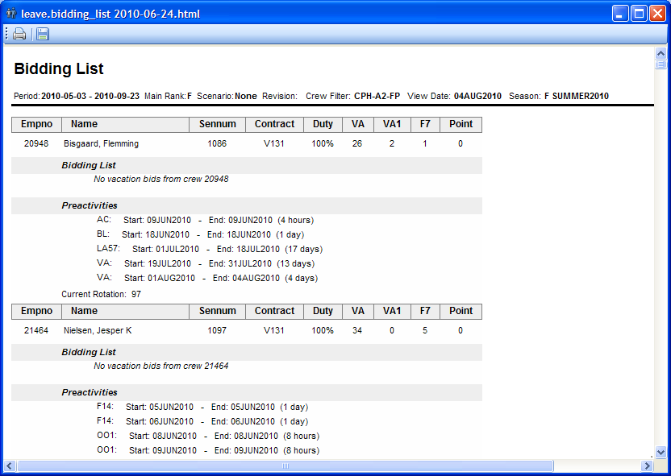

### crew_no_bid

A list containing all crew in the filter without any current bids for the selected season. Preassigned activities and published vacation will also be displayed.

Crew balances are on the date chosen as ‘View Date’ in the leave view.

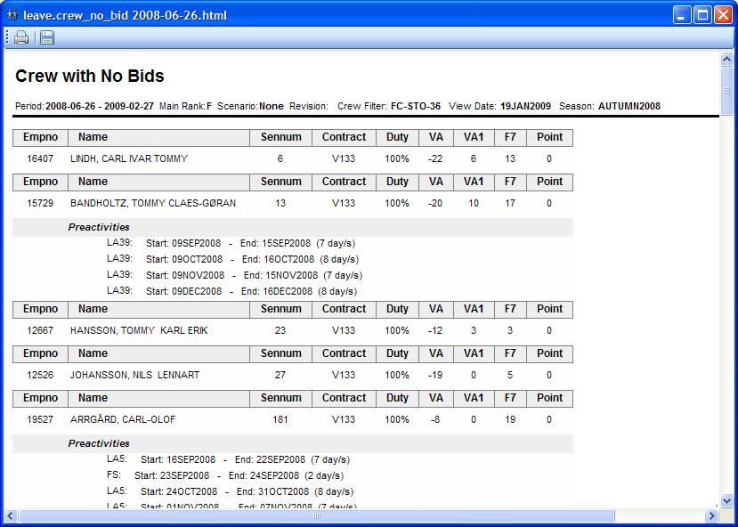

### crew_no_planned_vacation

This report is a list of crew that hasn’t been assigned any vacation during the set season. Preactivities, balances and bids are also shown.

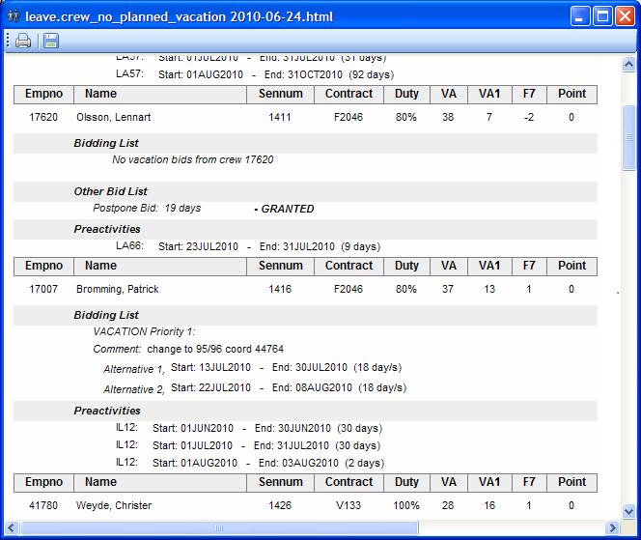

### illegal_bidding_list

This report contains all bids considered illegal with the current rules. The system tries to assign the bids, and reports all the illegalities it finds. Note that illegalities regarding quota only is applicable if there is no quota at all. This since all quota is available when each bid is being treated. Also note that illegalities already present when running the report also will be listed, since it lists the resulting illegalities.

If crew already has assignments representing the bid, the bid can also be marked as illegal because of overlapping activities.

Crew balances are on the date chosen as ‘View Date’ in the leave view.

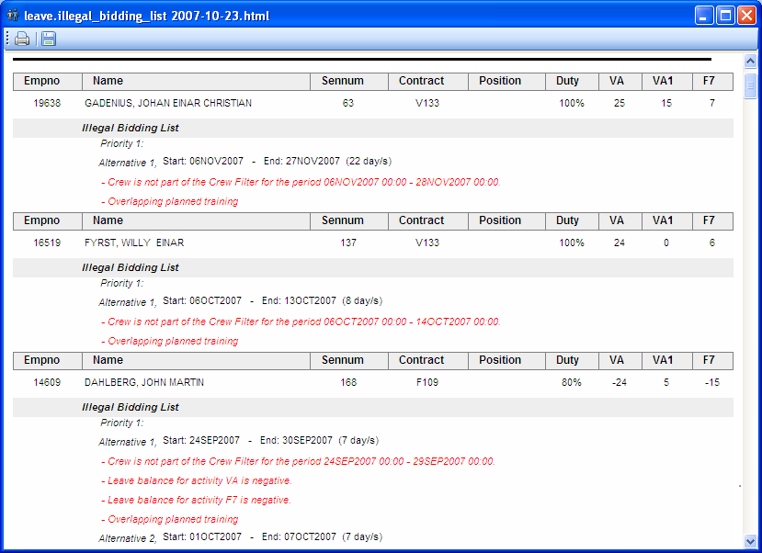

### illegal_bidding_list_incl_rotations

This report contains a list of all crew and the corresponding illegal bids they have. The difference in this report compared to illegal_bidding_list is that all rotations also are included. If a crew for some reason has not been awarded his rotation, it is possible to see the reason in this report.

### illegal_crew_list

This report shows all crew with illegalities and their rule failures. This report is season independent, and is possible to run no matter what season is set. The resulting illegalities are also all the illegalities found for the crew, covering the entire open workset.

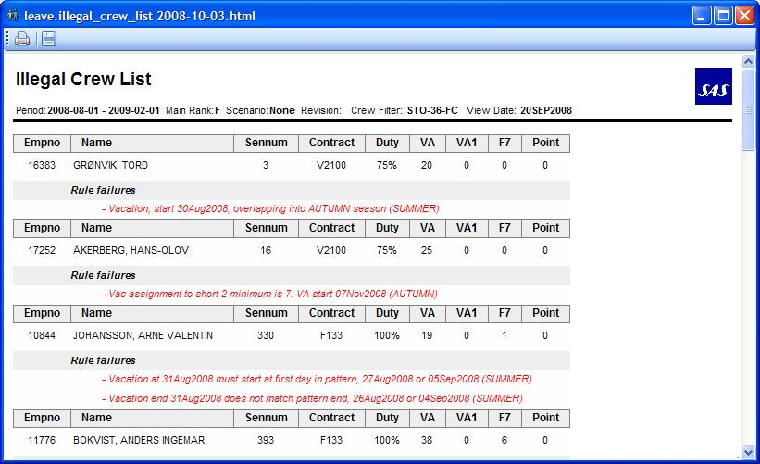

### overridden_rules_crew_list

The report contains all crew that have overridden rules and what rules that have been overridden. This report is season independent, and is possible to run no matter what season is set. The resulting illegalities are also all the illegalities found for the crew, covering the entire open workset.

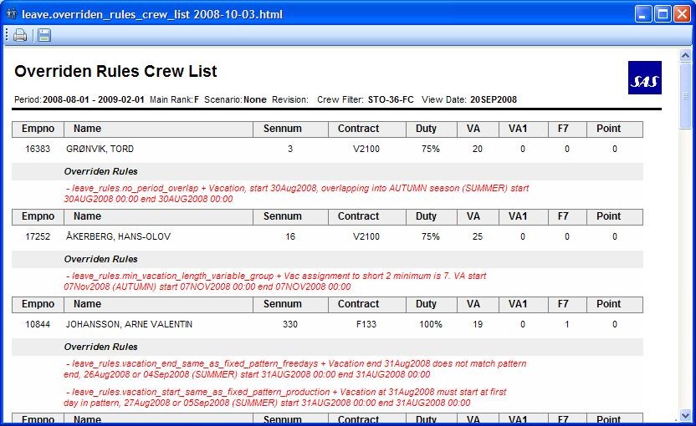

### activities_overlapping_with_leave

This report shows the overlapping activities with already assigned leaves in the current season. The need for this report is detecting the overlaps before publishing leave so that this time can be better spent with other quality checks in the leave assignment.

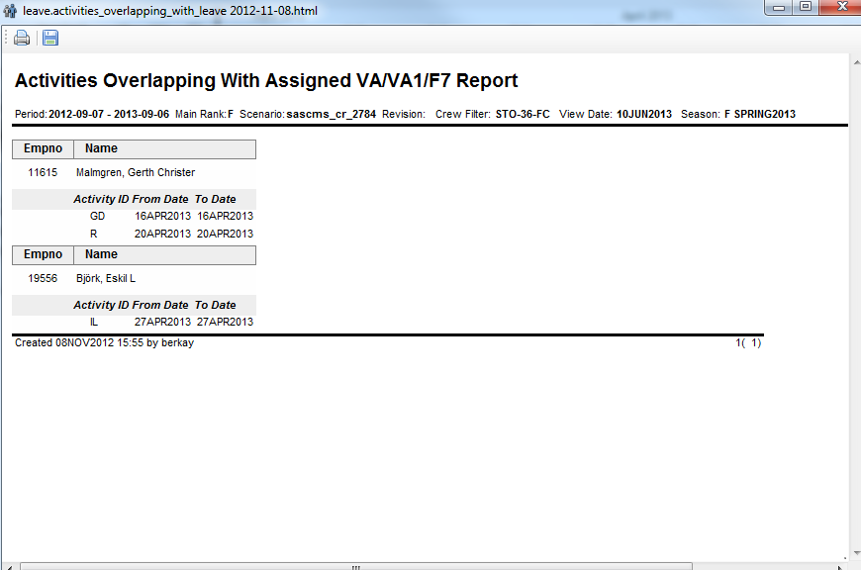

### check_rotation_entries

The report can be run in Summer or Autumn season. Important to know that both Autumn and Summer seasons should be loaded in the workset in order for Autumn season report to produce reliable results.

This report if run for Summer will show the list of crew which has summer vacation covering fully or partly any rotation (among 91, 92, 98, 99, 1, 6) and if this crew has a record in the *leave_historic_data* table. Partial coverage of rotation means that the vacation may exceed the rotation by +/- 2 days or vacation is shorter than the rotation.

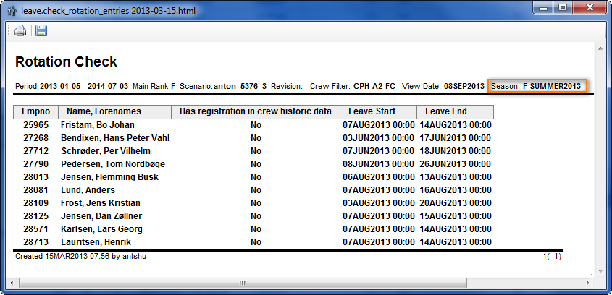

For Autumn season the report will list the crew which have a vacation within summer rotation **and** have a priority 1 bid granted in Autumn season. The report will list that crew and mention if the crew has registration in the *leave_historic_data* table.

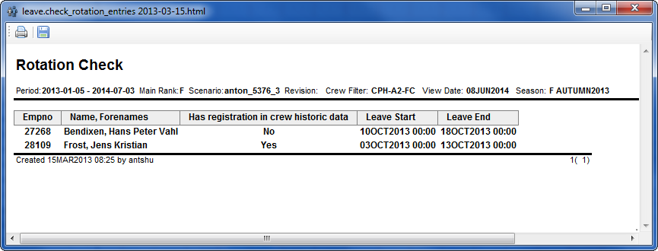

Along the registration in the *leave_historic_data* table the report also lists the beginning and the end of leave that it is referring to.

## Bid types

### Vacation Bids

Vacation bids are bids imported from Interbids. Crew adds vacation bids and they can be imported to manpower. A bid has a prio, where prio 1 is the bid that crew wants most. Each bid can have a number of alternatives, where a fulfilled alternative means a fulfilled bid. The system tries to grant alternative 1 first, then the rest. If the rule allow_move_of_bids 8.2.1.2.1 is valid, the system tries the alternatives once more, this time trying to move them.

For some crew, see section 8.10.5, prio 1, 2 and 3 bids have different properties. Prio 1 bids can only be awarded instead of a rotation, while prio 2 and 3 bids only can be awarded in addition to a prio 1 or rotation vaction. If a prio 1 bid or rotation is not present, the prio 2 and 3 bids still can be awarded. A rotation or prio 1 bid is not necessary to grant these bids.

Vacation bids and join vacation bids are matched against roster assignments to see what is granted. If there are several bids covering the same assignment they will all be marked as granted.

### Join Vacation Bids

Crew can bid join vacation bids in interbids. They are higher ranked when using the ‘BIDTYPE’-comparer 8.2.2.3. The bid should have a number of days that equals the number of days crew has vacation left. There is no automatic control or adding of days to the bid.

### In Rotation Bids

In rotation bids are bids that crew doesn’t need to bid. They are only visible in some reports in the system. They are highest ranked by the BIDTYPE’-comparer 8.2.2.3, but lowest ranked by crew if crew has vacation bids. The rotations are set according to 8.2.4.

### No Vacation Bids

No vacation bids can be bidded in interbids. No vacation bids can be seen in the ‘Other bids’- tab, either on each crew in a crew view, or for a whole crew filter in the workset explorer. Granting is done manually by right-clicking on a bid and select ‘Grant bid’. No vacation bids are valid in AUTUMN, and a granted no vacation means that the system doesn’t try to assign any vacation to the crew.

### Postpone Vacation Bids

Postpone vacation bids can be bidded in interbids. Postpone vacation bids can be seen in the ‘Other bids’- tab, either on each crew in a crew view, or for a whole crew filter in the workset explorer. Granting is done manually by right-clicking on a bid and select ‘Grant bid’. Postpone vacation bids are valid in SUMMER. The number of postponed days in the bid is used in the rule 8.2.1.2.9 only_limited_vacation_awarded_per_season. The postponed days are also taken into account when calculating number of rest days in summer, 8.8.2.

### Transfer Vacation Bids

Transfer vacation bids can be bidded in interbids. Transfer vacation bids can be seen in the ‘Other bids’- tab, either on each crew in a crew view, or for a whole crew filter in the workset explorer. Granting is done manually by right-clicking on a bid and select ‘Grant bid’. Transfer vacation bids are valid in AUTUMN for cabin crew and SPRING for flight deck crew. When granting a transfer vacation bid, the number of days on the bid are transferred to the next vacation year. A transaction is created, removing the days from the VA account on the first day of the season. The days are entered to the entitlement account, and will be transferred to the VA account on the first day of the next vacation year. If no days are specified in the bid, the number of days of the last day of the season, or the last day of the vacation year, which comes first, is used.

### Extra Vacation Bids

Crew can bid extra vacation bids in interbids. This is a bid for asking more VA during summer than allowed. Extra vacation bid can only be granted manually by the planners. It costs the crew additional vacation days so it is separated from the normal bid.

## Automatic leave assignment

### Automatic vacation assigner

The automatic vacation assigner collects all the bids belonging to crew in the selected crew filter, including rotations if crew should have them. It sorts them according to the selected bid comparer, and tries to assign them one by one according to the list.

If a bid is not assigned, it is added to a special list of unassigned bids.

If a bid fails to be assigned the first time, the system tries to deassign other bids belonging to the same crew having lower prio than the current bid. For example: a crew has a rotation and another bid. The comparer ‘BIDTYPE’ is active, making the rotation more prioritized in the assignment bid list, but less prioritized for crew. If the rotation is assigned and the system fails to assign the bid, the rotation will be deassigned and the bid tried again. If it succeeds, the rotation is thrown away. If it fails, the rotation is assigned back and the failed bid is added to the list of unassigned bids. Each time room in the quota has been created by successfully deassigning a vacation to fulfill a higher prio bid, the system runs through the list of unassigned bids to try to assign them again.

For some crew, see section 8.10.5, the bids are treated a bit differently. A rotation can only be deassigned in favor of a prio 1 bid, and the rotation is not replaced if the prio 1 bid is successfully awarded. Also, the prio 1 bid can only be assigned if there is no rotation awarded. This means that prio 1 bids replace rotation vacations, and both can not be awarded for the same crew at the same time. The rotation can not be deassigned in favor of prio 2 or prio 3 bids. These bids cannot replace the rotation vacation. If a rotation vacation has been awarded first, the prio 2 or 3 bid can be awarded in addition to that vacation, but not replace it.

Bids that have one alternative in a popular period (see section 8.2.3.3) receive a special treatment. If crew already has a granted popular period vacation in the same season, other popular alternatives are placed in a special list. This list is treated when the original bid list has been treated. This way no crew gets a second popular period bid fulfilled until all crew who has placed bids on popular periods has gotten one fulfilled.

### Rest assigner

The rest assigner tries to assign vacation to crew sorted in reverse seniority order who has not placed enough bids. In the summer time, the max amount of vacation is taken from the contract. Granted postponed days are subtracted from the max amount. If crew has not been assigned enough vacation, the system tries to add more vacation to that crew. In other seasons than summer, the system tries to empty the balance in the leave accounts. The number of days is the minimum balance between the date selected as ‘View Date’ and the end of the leave season.

The rest assigner only tries to assign one block of vacation. No consideration is taken to previously assigned vacation. The maximum amount can be controlled with the parameter *max_rest_days*, see section 8.2.7.1. If *max_rest_days* is not set, it will get the default value 50. It is also possible to specify the number of days that should be saved in the balance for the coming season by setting the parameter *rest_days*, see section 8.2.7.3.

When the number of days to assign for a specific crew has been calculated, the rest assigner tries to assign the days as a consecutive vacation. The rest assigner will try to assign the vacation at the best possible day according to limit left in season. If the assign is not successful the assigner will move on and try the second best day in season. When all possible days have been tried in season, the assigner will shorten the vacation by one day and do the same iteration again. It will stop when vacation is assigned or the number of days to assign is less than *min_rest_days*, see section 8.2.7.2. If *min_rest_days* is not defined, one day vacation is the default minimum.

Vacation assigned by rest assigner can be removed with command “Clear Rest Assignment” in the leave menu.

### Automatic Assigner Config

To configure parameter settings for automatic leave assignment. You can access clicking on the Leave Menu > Automatic Assigner Config.

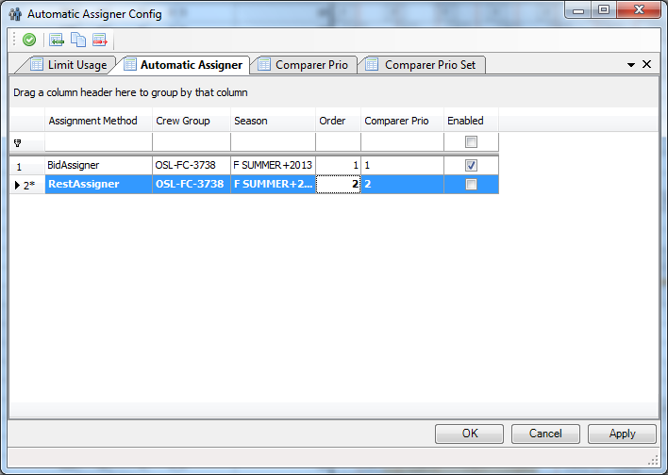

After SP6 release this windows has two new tabs, Comparer Prio and Comparer Prio set.

These two new tabs have been added due to a new functionality in carmsys to set the bid comparer and sorting order, but so far SAS user will not use those tabs, we keep setting the bid comparison in the menu Leave > Configure Leave Settings for a while (see 8.2.2 Bid Comparison settings section).

Anyway those new tabs (Comparer Prio and Comparer Prio set) should be set with a dummy data in order to be able to run the automatic assigner:

So first insert these two entries in the ‘Comparer Prio Set’ tab, click on the button Apply:

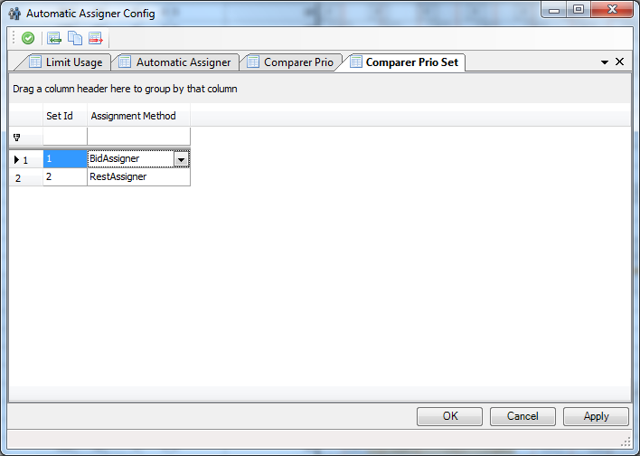

Second insert these two entries in the ‘Comparer Prio’ tab ( it doesn’t matter which comparer type you choose) then click on the button Apply:

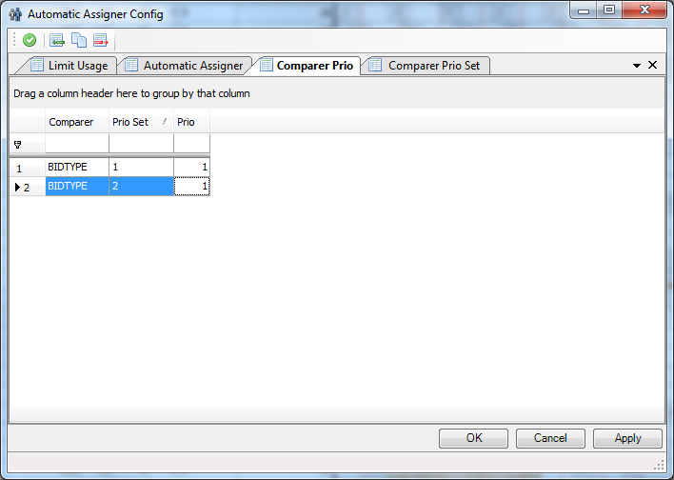

Finally the Automatic Assigner tab is the important tab in order to be able to run the automatic assigner. The columns Assignment Method, Crew Group, Season and Enabled work exactly the same as in SP5. You only need to fill the column Order to set if the bidAssigner will be run first than the RestAssigner (it must to be check the Enabled column if you want to the bidAssigner or RestAssigner ). The Comparer Prio column must be filled according to the dummy data inserted in ‘Comparer Prio Set’ tab so the comparer prio value for bid assigner should be “1” and “2” for RestAssigner.

If you insert more entries for other crew group or season you still will use ‘comparer prio’ = 1 for the bidAssigner entries and ‘comparer prio’ = 2 for RestAssigner entries.



### Automatic Pattern Leave Assignment

The automatic pattern leave assigner assigns vacations according to the fixed patterns of crew.

The vacations are rolled out from day of operation until the period end for the crew in the leave view. All leave legality rules that are configured to be checked are checked except the limit rule.

### Exclude crew from automatic vacation assignment

It is possible to exclude crew form automatic assignment. When filtering in leave view, it is only the visible crew who will be assigned in an automatic assignment. It is also possible to specify crew who should be excluded. This is done in two steps. First select crew in leave view by pressing the “Ctrl” key and then click on the crew rows you want to exclude. Then choose “Exclude Selected Crew In Automatic Assigner” in leave menu “Excluded Crew”.

To view which crew have been excluded choose “Show Excluded Crew For Group And Season”. As the name implies, only excluded crew from chosen season and opened crew group will be shown. This view will not be automatically updated when excluded crew is changed, instead a planner need to regenerate it.

When including crew in automatic assignment, do same steps as in exclude but choose “Include Selected Crew In Automatic Assigner” instead.

Crew who are selected as excluded will be stored in database when saved. This means that they will be excluded in next Manpower session as well.

In the following example crew 29951 and 29945 will be excluded in “CPH-ALL-FC” and ”2011 F AUTUMN”:

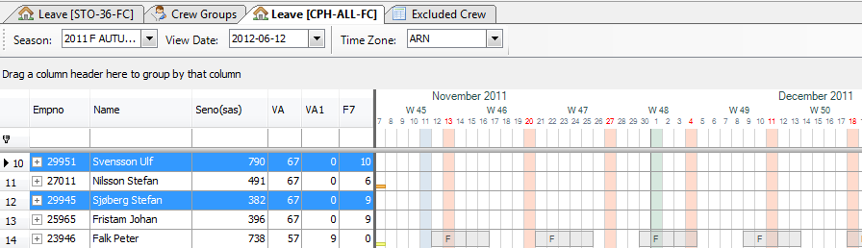

### Exclude crew from a specific date for automatic vacation assignment

It is possible to exclude crew from a specific date to the end of the season for automatic assignment. When filtering in leave view, it is only the visible crew who will be assigned in an automatic assignment. It is also possible to specify crew who should be excluded from a specific date. This is done in three steps. First select crew in leave view by pressing the “Ctrl” key and then click on the crew rows you want to exclude (or Highlighting a group of crew). Second step, choose “Exclude Selected Crew From Specific Date In Automatic Assigner” in leave menu “Excluded Crew” and finally choose the specific date.

To view which crew have been excluded choose “Show Excluded Crew From Specific Date For Group And Season”. As the name implies, only excluded crew from chosen season and opened crew group will be shown. This view will not be automatically updated when excluded crew is changed, instead a planner need to regenerate it.

When you want to include crew back from the whole season in automatic assignment, You do same steps as in exclude but choose “Include Selected Crew From Specific Date In Automatic Assigner” instead.

Crew who are selected as excluded from a specific date will be stored in database when saved. This means that they will be excluded in next Manpower session as well.

### Publish vacation assignments

At vacation publish, crew will be informed about vacation assignments. Only activities overlapping the published season will get published. Crew Portal cannot handle overlapping activities, so there will be a stopping warning on what crew has to be handled before publish can be performed. The overlapping activities should be removed in PreStudio.

It is possible to publish selected crew. Select crew by pressing the “Ctrl” key and then click on the crew rows you want to publish. To publish only for selected crew choose “Publish Vacation Assignments For Selected Crew” in leave menu.

In the following example activities for crew 37286 and 37643 will be published:



## Check Crew

It has been added a checkbox “Select” to the Leave View. This checkbox could be use for different purposes but the idea is to filter the crew who are checked or not checked and then run the automatic assigner for that filter.

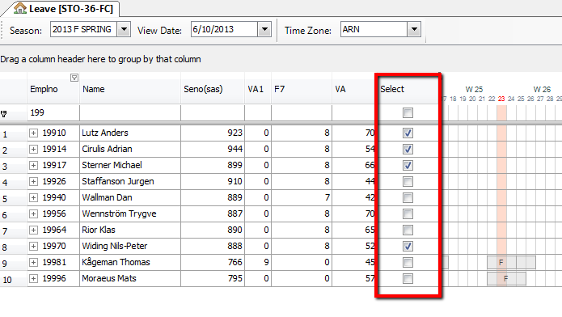

You can mark the crew as selected in two steps. First select crew in leave view by pressing the “Ctrl” key and then click on the crew rows you want to exclude (or Highlighting a group of crew). Second step, right-click mouse and choose the command “Check crew”. To unselect a crew do the same steps but choosing “Uncheck crew” command.

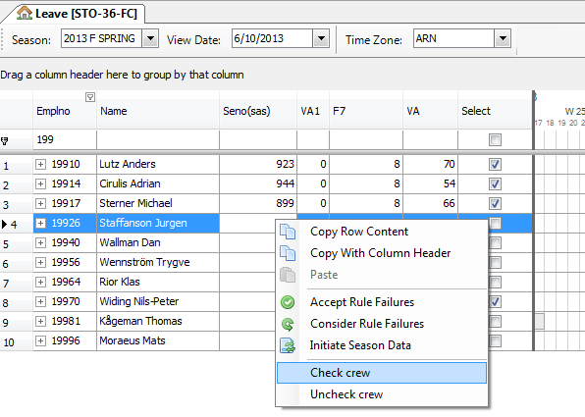

In order to check/uncheck all the crew in the current filter, you should left-click mouse on the left column in the Leave view (see the picture below).

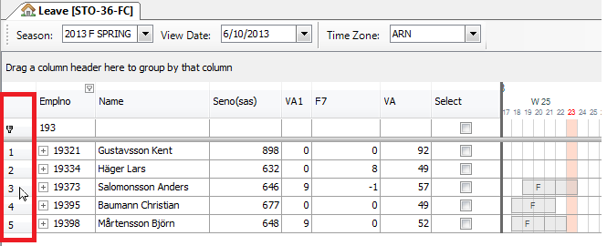

and then press “Ctrl +A”, then all the crew in the filter will be highlighted. Then right-click mouse and choose “Check crew” or “Uncheck crew” command.

NOTE: The selected crew will **not** be stored in database when saved. This means that all crew will be unselected in next Manpower session.

## InterBids Import and Export

### Import Bids

Interbids exports a file with vacation bids from one or several crew groups. By default it will be called bids.etab and will be stored on Desktop. This file has to be moved and renamed manually to a directory under CARMDATA. The directory is current_carmdata/Manpower/VacationBids/ of the sk_cms_user. The filename has to contain the extension .etab; for instance FC-STO-36_vac.etab.

In Manpower, enter chosen filename (FC-STO-36_vac) and choose season. All imported crew should be open in one or several leave filters when importing bids. A non-existing filename will give an error message.

The vacation bids will appear in Leave view under each crew.

Any bid from undefined crewId will be neglected.

Old bids for the same crew and season will be removed.

### Export Crew Info

From Manpower you can export data for current crewfilter. Start with selecting season to export info from. When exporting info to autumn bidding, the autumn season shall be loaded.

Also select the correct ViewDate for balances. Give the file a describing name, for instance fc-sto-36-au11. The file will be created in a directory under CARMDATA and Interbids database will be updated.

It will contain balances (VA, VA1 and F7), rotations, points, max summer vacation,. The vacation length is taken from the contract the first day of the loaded season. The balances are taken from the day indicated by ViewDate. Also preactivities in the current season will be exported, both the published activities and the freeday patterns as seen in Manpower leave view.

In order to insert data into Interbids you have to run sqlplus with the right ORACLE_HOME defined. Enter

SQL>@fc_sto_36.sql

This is normally done by CSC,

## Create leave

When creating manual leave you can choose what activity code to use. There is a special option, if you select AUTO, Manpower will use vacation codes in the order defined in 8.11.2.

It chooses activity codes just as the automatic assigner would have done.

## Graphical objects in Leave (GOB)

Colored vacations and indicators are supposed to make it easier to get an overview of the current roster state.

### Bid alternatives

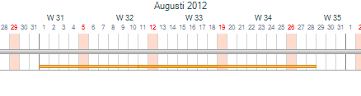

Each bid alternative is shown as a colored line on the roster. The color represents bid priority or join vacation bid. The following colors are implemented:

Black = join vacation bid

Red = extra vacation bid

Orange = priority 1 bid

Yellow = priority 2 bid

Gray = priority 3 bid

Pink = priority 4 bid

Green = priority 5 bid

When a season is published for crew, all bid indicators will disappear for bids belonging to that season.

GOB information is available in info window when clicking on the object.

### Activity

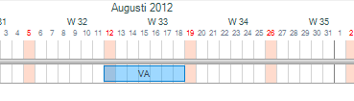

Vacation activities get a color indicating how it was assigned. The following colors are implemented:

Blue = Assigned bid during automatic assignment

Light blue = Manual assign (Manual grant bid or manual assign on roster).

Light pink = Rotation

Purple = Assigned during automatic rest assignment

Gray = Published vacation

Green = Extravacation

GOB information is available in info window when clicking on the object.

### Legality

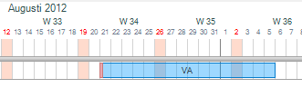

If a vacation activity is illegal a red indicator will appear on the left side of the activity. It will turn green when accepting the rule failure.

GOB information is available in info window when clicking on the object.

### Publish

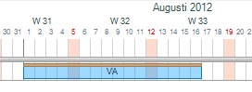

When a vacation activity is published a brown or red line will appear on top of the activity. Brown is when the vacation is temporary published, which means it is not saved to master yet (scenario). When it is saved to master it will be red.

GOB information is available in info window when clicking on the object.

## Rave parameters

Due to the complexity of the leave problem, with many different companies with different rules and exceptions, some of the settings have been written in Rave, and is possible to change. A compilation of the Rave rule set is needed for the changes to take effect. Do not confuse with changeable rave parameters configurable via ‘Configure leave settings’.

The implemented tables and parameters are:

### Rotation prios

**Rotation_prio_table:**

Defines which summer rotations that should result in prioritized bids the given season.

Implemented:

CC: rot F: prio 1, rot P: prio 2

CC, OSL, TRD, SVG: AUTUMN rot 1, 21 : prio 1 SPRING rot 6,7,26, 27: prio 1

FD: rot 99, 98, 92, 91: prio 1

FD,OSL,TRD,SVG: AUTUMN rot1: prio 1 SPRING rot 6 : prio 1

### Vacation type

**Prioritized_vacation_type:**

Defines in which seasons F7 should be considered before VA and vice versa.

Implemented:

CC, STO, AUTUMN: F7, VA, VA1

CC, STO, SUMMER: VA, F7, VA1

CC, STO, SPRING: F7, VA, VA1

-, -, AUTUMN, time of year > 01jul: F7, VA, VA1

-, -, AUTUMN, time of year < =01jul: VA, F7, VA1

-, -, SUMMER: VA, VA1

-, -, SPRING: VA, F7, VA1

-, -, WINTER : VA

### Move of bids

**Valid_vacation_moves:**

Defines how many days you are allowed to move bids and still consider them granted.

Implemented:

FD, variable: -1, -2, 1, 2

CC, CPH, variable: -1, 1, -2, 2, -3, 3, -4, 4, -5, 5, -6, 6, -7, 7

### Rotations

**Has_leave_rotation_table:**

Defines if crew should have a rotation of different kinds.

Implemented:

|  |  |  |  |  |  |  |  |  |
| --- | --- | --- | --- | --- | --- | --- | --- | --- |
| F | - | BU | - | - | - | SUMMER | vacation | True |
| F | - | BU | - | - | - | SPRING | vacation | False |
| C | OSL | SK | - | - | LH | SUMMER | vacation | True |
| C | OSL | SK | - | AH | SH | SUMMER | vacation | True |
| C | OSL | SK | - | AP | SH | SUMMER | vacation | True |
| C | OSL | SK | - | AS | SH | SUMMER | vacation | True |
| C | TRD | SK | - | AP | SH | SUMMER | vacation | True |
| C | TRD | SK | - | AH | SH | SUMMER | vacation | True |
| C | TRD | SK | - | AS | SH | SUMMER | vacation | True |
| C | SVG | SK | - | AP | SH | SUMMER | vacation | True |
| C | SVG | SK | - | AH | SH | SUMMER | vacation | True |
| C | SVG | SK | - | AS | SH | SUMMER | vacation | True |
| C | OSL | BU | - | AH | SH | SUMMER | vacation | True |
| C | OSL | BU | - | AP | SH | SUMMER | vacation | True |
| C | OSL | BU | - | AS | SH | SUMMER | vacation | True |
| C | TRD | BU | - | AP | SH | SUMMER | vacation | True |
| C | TRD | BU | - | AH | SH | SUMMER | vacation | True |
| C | TRD | BU | - | AS | SH | SUMMER | vacation | True |
| C | SVG | BU | - | AP | SH | SUMMER | vacation | True |
| C | SVG | BU | - | AH | SH | SUMMER | vacation | True |
| C | SVG | BU | - | AS | SH | SUMMER | vacation | True |
| F | - | - | - | - | - | SUMMER | vacation | True |
| F | - | - | - | - | - | AUTUMN | Christmas | True |
| C | - | - | - | - | - | AUTUMN | Christmas | True |
| - | - | - | - | - | - | - | - | False |

### Prio 1 bids replacing rotations

**Rotation_and_prio1_table:**

Describes if crew is allowed to be awarded both rotation vacation and prio 1 bids. If False, a prio 1 bid should only be awarded instead of a rotation vacation. Prio 2 and 3 bids are only awarded in addition to a prio 1 bid / rotation vacation.

If True, the system can add prio 1 vacations in addition to rotation vacations, or replace the rotation with a prio 2 or prio 3 bid.

Implemented:

Category Region Company Season can have both rotation and prio1

C, SKN, BU, SUMMER False

C, SKN, SK, SUMMER False

C, SKN, SK, AUTUMN False

C, SKN, SK, SPRING False

F, -, - , SUMMER False

- , -, -, - True

### Valid rotations

**invalid_rotation_table:**

Describes if a certain rotation is invalid for some crew, defined on cat, base, company , type (LH/SH crew) and acqual.

Implemented:

F, -, -, LH _ : 03

F, -, -, SH, F5 : 03

### Minimum vacation length

**Min_length_table:**

Defines the minimum length of a vacation block.

Implemented:

FD, variable: 7

CC, STO, variable: 5

CC, STO, variable: 5

CC, variable: 7

### Codes that override VA

**Va_override_table:**

Defines the codes that, when a VA-activity is overlapping, should not result in a va-transaction.

Implemented:

None

### Crew type

**Crewtype:**

Defines LH and SH

Implemented:

All crew with qualification A3, A4 or AL is LH, rest SH.

### Extended seasons

**Extended_season_due_to_rotation_table:**

Defines the number of days the season should be extended if crew is in a specific rotation.

Implemented:

Rot 91: season starts 2 days before

Rot 99: season ends 4 days after

### Special entitlement

Special entitlement conditions are checked against last day in vacation year (the year where crew use the vacation) for age and employment length and checked against entitlement date for the rest. Contract lookup is done for all contracts in entitlement period. If no special entitlement is found for crew normal entitlement is used.

**Special_VA_entitlement:**

Implemented in the following order:

1. (only valid before 1st Jan 2014) Crew rank FP, age < 35, years since employment < 5: 35 days
2. Norvegian_entitlement (ref p. 121)

**Special_F7_entitlement:**

Implemented:

Norvegian_entitlement (ref p. 121) (only valid before of 1st January 2013)

**Special_VA1_entitlement:**

Implemented:

None

**Norvegian_contract_groups**

This table defines which contract group different Norwegian cabin crew belongs to. Depending on contract group, company and age, crew get different leave entitlement.

Also valid for contracts starting with F, f.ex F816,F831.

|  |  |  |  |  |
| --- | --- | --- | --- | --- |
| Category | Country | Contract id |  | Contract group |
| C | NO | V815 |  | A |
| C | NO | V816 |  | A |
| C | NO | V817 |  | A |
| C | NO | V830 |  | A |
| C | NO | V831 |  | A |
| C | NO | V832 |  | A |
| C | NO | V860 |  | A |
| C | NO | V861 |  | A |
| C | NO | V862 |  | A |
| C | NO | V875 |  | A |
| C | NO | V876 |  | A |
| C | NO | V877 |  | A |
|  |  |  |  |  |
| C | NO | V818 |  | B |
| C | NO | V819 |  | B |
| C | NO | V820 |  | B |
| C | NO | V833 |  | B |
| C | NO | V834 |  | B |
| C | NO | V835 |  | B |
| C | NO | V863 |  | B |
| C | NO | V864 |  | B |
| C | NO | V865 |  | B |
| C | NO | V878 |  | B |
| C | NO | V879 |  | B |
| C | NO | V880 |  | B |
|  |  |  |  |  |
| C | NO | V821 |  | C |
| C | NO | V822 |  | C |
| C | NO | V823 |  | C |
| C | NO | V836 |  | C |
| C | NO | V837 |  | C |
| C | NO | V838 |  | C |
| C | NO | V866 |  | C |
| C | NO | V867 |  | C |
| C | NO | V868 |  | C |
| C | NO | V881 |  | C |
| C | NO | V882 |  | C |
| C | NO | V883 |  | C |
|  |  |  |  |  |
| C | NO | V824 |  | D |
| C | NO | V825 |  | D |
| C | NO | V826 |  | D |
| C | NO | V839 |  | D |
| C | NO | V840 |  | D |
| C | NO | V841 |  | D |
| C | NO | V869 |  | D |
| C | NO | V870 |  | D |
| C | NO | V871 |  | D |
| C | NO | V884 |  | D |
| C | NO | V885 |  | D |
| C | NO | V886 |  | D |
|  |  |  |  |  |
| C | NO | V827 |  | E |
| C | NO | V828 |  | E |
| C | NO | V829 |  | E |
| C | NO | V842 |  | E |
| C | NO | V843 |  | E |
| C | NO | V844 |  | E |
| C | NO | V872 |  | E |
| C | NO | V873 |  | E |
| C | NO | V874 |  | E |
| C | NO | V887 |  | E |
| C | NO | V888 |  | E |
| C | NO | V889 |  | E |
|  |  |  |  |  |
| C | NO | V94 |  | F |
| C | NO | V95 |  | F |
| C | NO | V96 |  | F |
| C | NO | V857 |  | F |
| C | NO | V858 |  | F |
| C | NO | V859 |  | F |
| C | NO | V1014 |  | F |
| C | NO | V1015 |  | F |
| C | NO | V1016 |  | F |
| C | NO | V1017 |  | F |
| C | NO | V1018 |  | F |
| C | NO | V1019 |  | F |
|  |  |  |  |  |
| C | NO | V800 |  | G |
| C | NO | V801 |  | G |
| C | NO | V802 |  | G |
| C | NO | V803 |  | G |
| C | NO | V804 |  | G |
| C | NO | V805 |  | G |
| C | NO | V806 |  | G |
| C | NO | V807 |  | G |
| C | NO | V808 |  | G |
| C | NO | V809 |  | G |
| C | NO | V810 |  | G |
| C | NO | V811 |  | G |
|  |  |  |  |  |
| C | NO | V301 |  | H |
| C | NO | V1001 |  | H |
| C | NO | V1002 |  | H |
| C | NO | V1003 |  | H |
| C | NO | V1022 |  | H |
| C | NO | V1023 |  | H |
|  |  |  |  |  |
| C | NO | V1004 |  | I |
| C | NO | V1005 |  | I |
| C | NO | V1006 |  | I |
| C | NO | V1007 |  | I |
| C | NO | V1008 |  | I |
| C | NO | V1009 |  | I |
| C | NO | V1020 |  | I |
| C | NO | V1021 |  | I |
|  |  |  |  |  |
| C | NO | V443 |  | J |
| C | NO | V1010 |  | J |
| C | NO | V1011 |  | J |
| C | NO | V1012 |  | J |
|  |  |  |  |  |
| C | NO | V88 |  | X |
| C | NO | V89 |  | X |
| C | NO | V90 |  | X |
|  |  |  |  |  |
| C | NO | V1013 |  | Y |
|  |  |  |  |  |
| C | NO | V310 |  | L |
| C | NO | V312 |  | L |
| C | NO | V350 |  | L |
| C | NO | V351 |  | M |
|  |  |  |  |  |
| C | DK | V345 |  | Z |
| C | NO | V845 |  | Z |
| C | NO | V846 |  | Z |
| C | NO | V847 |  | Z |
| C | NO | V848 |  | Z |
| C | NO | V849 |  | Z |
| C | NO | V850 |  | Z |
| C | NO | V851 |  | Z |
| C | NO | V852 |  | Z |
| C | NO | V853 |  | Z |
| C | NO | V854 |  | Z |
| C | NO | V855 |  | Z |
| C | NO | V856 |  | Z |
| C | SE | V00863 |  | Z |
| C | SE | F00863 |  | Z |
| C | NO | F00851 |  | Z |
| C | NO | F00852 |  | Z |
| C | NO | F00853 |  | Z |
| C | NO | F00854 |  | Z |
| C | NO | F00855 |  | Z |
| C | NO | F00856 |  | Z |

**Norvegian****_entitlement**

This table defines the special VA and F7 entitlements that Norwegian cabin crew has.

NOTE: Since 1st of January 2013 these entitlements only affect to Norwegian cabin crew who belongs to contract group Z, before 1st of January 2013 these entitlements remained.

|  |  |  |  |  |  |
| --- | --- | --- | --- | --- | --- |
| Contract group | Company | Age |  | VA days | F7 days |
| A | SK | <45 |  | 35 | 0 |
| A | SK | >=45 |  | 40 | 0 |
| A | BU | <45 |  | 35 | 0 |
| A | BU | >=45 |  | 40 | 0 |
| B | SK | <45 |  | 34 | 0 |
| B | SK | >=45 |  | 40 | 0 |
| B | BU | - |  | 37 | 0 |
| C | SK | <45 |  | 35 | 0 |
| C | SK | >=45 |  | 40 | 0 |
| C | BU | <45 |  | 35 | 0 |
| C | BU | >=45 |  | 40 | 0 |
| D | SK | <45 |  | 34 | 0 |
| D | SK | >=45 |  | 40 | 0 |
| D | BU | - |  | 37 | 0 |
| E | SK | <45 |  | 35 | 0 |
| E | SK | >=45 |  | 40 | 0 |
| E | BU | <45 |  | 35 | 0 |
| E | BU | >=45 |  | 40 | 0 |
| F | SK | <45 |  | 34 | 0 |
| F | SK | >=45 |  | 40 | 0 |
| F | BU | - |  | 37 | 0 |
| G | SK | <45 |  | 34 | 0 |
| G | SK | >=45 |  | 40 | 0 |
| G | BU | - |  | 37 | 0 |
| H | SK | <45 |  | 37 | 6 |
| H | SK | >=45 |  | 43 | 6 |
| H | BU | <45 |  | 37 | 6 |
| H | BU | >=45 |  | 43 | 6 |
| I | SK | <45 |  | 37 | 6 |
| I | SK | >=45 |  | 43 | 6 |
| I | BU | <45 |  | 37 | 6 |
| I | BU | >=45 |  | 43 | 6 |
| J | SK | <45 |  | 37 | 6 |
| J | SK | >=45 |  | 43 | 6 |
| J | BU | <45 |  | 37 | 6 |
| J | BU | >=45 |  | 43 | 6 |
| X | BU | - |  | 37 | 0 |
| Y | SK | >=45 |  | 38 | 0 |
| L | SK | <45 |  | 37 | 6 |
| L | SK | >=45 |  | 43 | 6 |
| M | SK | <45 |  | 37 | 6 |
| M | SK | >=45 |  | 43 | 6 |
| O | SK | <45 |  | 37 | 6 |
| O | SK | >=45 |  | 43 | 6 |
| P | SK | <45 |  | 37 | 6 |
| P | SK | >=45 |  | 43 | 6 |
| Z | - | - |  | 0 | 0 |

### Special Reduction

**Special_f7_reduction_table**:

A check is made at 01Jan, 01Apr, 01Jul, and 01Oct. For each date crews F7 entitlement is reduced by “amount” and added to VA1 at next VA transaction date. This reduction is only applicable between 1Jan2011 – 31Dec2011.

Category Region Group type Amount

"F", "SKS", "F" 1

"F", "SKD", "F" 1

-, -, - 0

**Special_f7_reduction_table2**:

A check is made at 01Jan, 15Feb, 01Apr, 15May, 01Jul, 15Aug, 01Oct and 15Nov. For each date crews F7 entitlement is reduced by “amount”. This reduction is only applicable after 1Jan2012 except for CJ pilots which are from 1Jan2013

Category Group type Ac qual CJ Date Amount

"F", "F", false, >= 1jan2012, 1

"F", "F", true, >= 1jan2013, 1

-, -, -, -, 0

### Borrow days from next year

**Allowed_negative_balance:**

Defines the allowed negative balance, in practice a loan of vacation days from the next vacation year.

Implemented:

|  |  |  |  |  |  |
| --- | --- | --- | --- | --- | --- |
| Category | Base | Group type | Days in Autumn | Days in Spring | Days in Summer |
| "C" | "CPH" | "F" | 0 | 7 | 0 |
| "C" | "CPH" | "V" | 0 | 0 | 0 |
| "C" | "OSL" | "F" | 5 | 0 | 0 |
| "C" | "OSL" | "V" | 5 | 0 | 0 |
| "C" | "TRD" | "F" | 5 | 0 | 0 |
| "C" | "TRD" | "V" | 5 | 0 | 0 |
| "C" | "SVG" | "F" | 5 | 0 | 0 |
| "C" | "SVG" | "V" | 5 | 0 | 0 |
| "C" | "STO" | "F" | 0 | 5 | 0 |
| "C" | "STO" | "V" | 0 | 0 | 0 |
| "F" | "CPH" | "F" | 5 | 5 | 0 |
| "F" | "CPH" | "V" | 0 | 0 | 0 |
| "F" | "OSL" | "F" | 5 | 0 | 0 |
| "F" | "OSL" | "V" | 0 | 0 | 0 |
| "F" | "TRD" | "F" | 5 | 0 | 0 |
| "F" | "TRD" | "V" | 0 | 0 | 0 |
| "F" | "SVG" | "F" | 5 | 0 | 0 |
| "F" | "SVG" | "V" | 0 | 0 | 0 |
| "F" | "STO" | "F" | 5 | 5 | 0 |
| "F" | "STO" | "V" | 0 | 0 | 0 |

### Codes and accounts

**Code2account:**

Defines which activity codes that should result in transactions to which accounts.

Implemented:

|  |  |  |  |  |
| --- | --- | --- | --- | --- |
| Activity | Account | Rate | | |
| "VA" | Va_account | 100 | | |
| "VAD" | Va_account | 200 | | |
| "VAH" | Va_account | 166 | | |
| "VA1" | Va1_account | 100 | | |
| "VA1D" | Va1_account | 200 | | |
| "VA1H" | Va1_account | 166 | | |
| "F7" | F7_account | 100 | | |
| **Prioritized_short_vacation_type:**  Defines which activity codes that should be used for different days and prio.  Implemented:   |  |  |  | | --- | --- | --- | | days | prio | activity | | 1 | 1 | VAD | | 1 | 2 | VA1D | | 2 | 1 | VAD | | 2 | 2 | VA1D | | 3 | 1 | VAH | | 3 | 2 | VA1H | | | |  |  |

### Vacation overlap

**va_overlap:**

Decides which codes it is legal for vacations to overlap even though the ‘no-overlap’-rule is active.

Codes OK to overlap:

|  |  |  |
| --- | --- | --- |
| **Category** | **Base** | **Code** |
| - | - | F |
| C | CPH | F0 |
| - | - | F3 |
| - | - | F31 |
| - | - | F3S |
| - | - | F35 |
| - | - | FS |
| - | - | F14 |
| - | - | F7S |
| - | - | F8 |
| - | - | F88 |
| - | - | FK |
| - | - | KD |
| - | - | ME |
| - | - | MT1 |
| - | - | MT11 |
| - | - | MT12 |
| - | - | MT17 |
| - | - | MT18 |
| - | - | MT2 |
| - | - | MT21 |
| - | - | MT3 |
| - | - | MT4 |
| - | - | MT5 |
| - | - | MT6 |
| - | - | MT7 |
| - | - | MT8 |
| - | - | MT85 |
| - | - | MT9 |
| - | - | OA5 |
| - | - | OF1 |
| - | - | OF2 |
| - | - | OF4 |
| - | - | OK51 |
| - | - | OK53 |
| - | - | ON1 |
| - | - | OO3 |
| - | - | OO5 |
| - | - | OQ1 |
| - | - | YX |

### Reduction table

Entitlement_reduction_table:

Defines the intervals of LOA days that result in fractions of leave entitlement reduction.

You define an interval, resulting in an integer. This integer is the inverted fraction of yearly entitlement. The system counts the number of reducing days in a month, looks in the table for a fraction of the early entitlement that should be reduced because of that month’s LOA activities and sums up.

Implemented:

1-15: 0

16-23: 24 1/24 of a full years’ entitlement

24-31: 12 1/12 of a full years’ entitlement

### Rotation start

**FD_use_special_rot_calc_in_cycle**:

The table defines which crew should use a calculation method to find rotation start date. The method has 30 May as starting point and calculates the start date using rotation number.

Implemented:

Category Rotation Use rotation calculation

"F", "91" true;

"F", "92" true;

"F", "93" true;

"F", "94" true;

"F", "95" true;

"F", "96" true;

"F", "97" true;

"F", "98" true;

"F", "99" true;

**CC_Norway_special_rotation_start_table**:

The table defines which crew should have the first possible rotation start after valid rotation start.

Implemented:

Company Category Base Use first rotation start after valid

"SK", "C", "OSL" true;

"SK", "C", "SVG" true;

"SK", "C", "TRD" true;

"BU", "C", "OSL" true;

"BU", "C", "SVG" true;

"BU", "C", "TRD" true;

### Reduction rounding

**entitlement_reduction_rounding_table**:

The table defines for which crew mathematical rounding is used and for which crew the most favorable rounding for crew is used (denoted as CEILING).

Implemented:

Base Account Entitlement date Rounding

“CPH” - - “MATHEMATICAL”

“OSL” - - “MATHEMATICAL”

“SVG” - - “MATHEMATICAL”

“TOS” - - “MATHEMATICAL”

“TRD” - - “MATHEMATICAL”

“STO” “F7” >= 01Jan2014 “MATHEMATICAL”

- - - “CEILING”

### Connection between vacations

**min_days_between_activities**

This set of codes defines which activities should be affected by the rule minimum_days_between_activities.

Implemented:

VA, F7, VA1, LA57, LA64, LA63, LA65, LA66, TH1

**minimum_days_between_activities**

The table defines the number of days needed between vacations and special activities. The activities affected by this table are defined in min_days_between_activities.

Implemented:

Category Grouptype (Variable/Fixed) Days

C F 8

C V 7

F F 8

F V 7

### Short Vacation crew

**use_short_vacation_code**s

The table defines for which crew the special VA-codes in 8.10.14 will be used when short bids are granted.

|  |  |  |
| --- | --- | --- |
| Cat | Region | Number of days |
| F | SKN | <=3 |

## Technical summary

### Rotation calculation

Section 8.2.4.2 describes how rotations are connected to vacation dates. In section 8.2.4.6 it is described how fixed patterns and some special cases of rotation periods are handled. This technical part of rotations is supposed to work as guide when searching for the rotation functionality.

The function getCorrectedRotationPeriod, in the python module $CARMSYS/lib/python/carmensystems/manpower/private/leave/crew.py, is used to get the correct rotation start and end date. The function starts by retrieving the corresponding start and end for the rotation crew is due for by checking the table in section 8.2.4.2. These dates are used as parameters to the RAVE variables %get_corrected_rotation_start% and %get_corrected_rotation_end%, found in RAVE-module leave_functions. These functions handle all special cases when the dates retrieved in the table are not correct. For crew with fixed patterns, including part time patterns, the rotation period is shifted to fit the pattern. The shift is done by calculating where in the pattern the original start is and then shifting it forwards or backwards. The variable also takes care of the special case, described in section 8.2.4.6, where the rotation start is calculated from a specific date regardless of original start.

### Rotation Prio

This section works as a technical complement to section 8.2.2.12. The rotations are saved as historic activities by the publish script. This functionality is found in python module $CARMUSR/lib/python/carmusr/manpower/leave/publish_strategy.py. CC and FD are handled separately because prio is given differently. CC needs to be due for a rotation and get it to get the prio. FD just need to get the prio rotation. For CC the check is simple, get the corrected start and end and use the RAVE-variable %has_vacation_between% in module leave_functions. For FD it is more complicated. The RAVE-variable %prio_FD_rotations%, in module leave_params, defines which rotations should give prio. These rotations are tested on each crew by getting the corrected start and end dates and then matching these with vacations on the roster. To get corrected start for a specific rotation the RAVE-variable %get_corrected_rotation_start%, in module leave_functions, is used with the special parameter “rotation”. An additional check is made before saving the rotation as a historic activity to see that the vacation is considered a full summer vacation.

The priority given by the comparer PREVROTATIONPRIO can only be used once, either in autumn or spring. The prio is considered used when a prio 1 bid is granted during autumn assignment. This functionality is implemented in $CARMUSR/lib/python/carmusr/manpower/leave/bid_types.py. All autumn, prio 1, vacation bids are checked to see if they are granted. If so, the entry USEDPREVSUMMERROT is set in table leave_historic_data. Once this entry is set the PREVROTATIONPRIO do not give prio the following spring.

### Leave entitlement and reduction calculation

Both entitlement and reduction is calculated for every contract a crew has in the entitlement period and then summed up and rounded to closest whole number. For STO, entitlement is always rounded up to closest whole number and reduction is rounded down (leave_params.%entitlement_reduction_rounding_method%).

**Entitlement**

For a contract the *length of contract period* is only the amount of days that the crew has that contract in the entitlement period. Days outside of entitlement period is not counted. The *length of entitlement period* is the amount of days between two entitlement dates. This is most often one year but if entitlement dates are changed it will be less. The *entitlement amount* is taken from special entitlement and if no match is found the amount from Leave Entitlement in Leave Entitlement Settings is taken. If scale duty is used *entitlement amount* is scaled with the duty percent from the current contract.

sum for every contract

length of contract period * entitlement amount

length of entitlement period

entitlement amount = (special entitlement or Leave Entitlement value) * duty percent

**Reduction**

As you can have several reduction groups setup for a crew, reduction is summed both for all contracts and every *valid reduction group*. A *valid reduction group* is a row in Leave Reduction that is for the entitlement to be reduced. *Length of entitlement period* and *entitlement amount* is same as in entitlement. For the simplest case where reduction category is ALL *number of reducing days* is the sum of the length of all activities on the roster that are reducing for the current *reduction group* and are in the current contract period.

sum for every contract

sum for every valid reduction group

number of reducing days * entitlement amount

length of entitlement period

number of reducing days = amount according to reduction category and offset

For more information see 8.3 Configure Leave Entitlement Settings.

## Rave

References to modules used.

|  |  |  |
| --- | --- | --- |
| Name | Location | Description |
| leave  leave_basic  leave_crewinfo  leave_entitlement  leave_functions_sk  leave_params  leave_rules_sk  leave_tables_sk | crc/modules/ | Rave module which contains definitions used for leave. |

## Database Tables

References to tables used.

| Name | Description |
| --- | --- |
| |  | | --- | | account_entry | | bid_leave_activity | | bid_leave_general | | bid_leave_other | | bid_leave_status_set | | bid_leave_types | | bid_leave_vacation  bid_transaction | | bought_days | | crew_type_set | | leave_actual_rotation | | leave_comparer | | leave_comparer_set | | leave_crew_points | | leave_crew_rotation | | leave_entitlement  leave_excl_crew_from | | leave_hist_data_type | | leave_historic_data | | leave_manual_entry | | leave_param_rave | | leave_parameter_set | | leave_parameters | | leave_period | | leave_points | | leave_popular_periods | | leave_red_category_set | | leave_reduction | | leave_reduction_group | | leave_rot_start_end | | leave_rotation_order | | leave_rotation_set | | leave_rule_set | | leave_rule_settings | | leave_season | | leave_season_set | | param_type_set | | publication_type_set | | published_roster | | rotationtype_set | | rule_exception | | special_schedules | | special_schedules_set | | See udm.pdf for descriptions |

## Scripts

References to scripts used.

|  |  |  |
| --- | --- | --- |
| Name | Location | Description |
| leave_import_export.py | lib/python/carmusr/manpower/leave | Exchanging data with Interbids |
| historic_activity.py | lib/python/carmusr/manpower/leave | Used in accumulation |

## Forms

Forms used.

|  |  |  |
| --- | --- | --- |
| Name | Location | Description |
| LeaveEditBidView.xml | lib/www/manpower/  forms/leave/ | Form for editing vacation bids |
| LeaveEntitlementSettings.xml | Form for leave entitlement settings |
| LeaveSettingsView.xml | Form for other leave settings |
| LeaveBidTransactionsView.xml | data/manpower/layout/table/leave/ | Bidding log view |
| LeaveExcludedCrewFromDateGridView.xml | View with of the crew who has been excluded from a specific date of the automatic assigner. |

## Reports

Reports used.

|  |  |  |
| --- | --- | --- |
| Name | Location | Description |
| assigned_vacation_list.py  bidding_list.py  bid_grantorder_list.py  bid_grantorder_on_day.py  crew_no_bid.py  crew_no_planned_vacation.py  illegal_bidding_list_incl_rotations.py  illegal_bidding_list.py  illegal_crew_list.py  key_values.py  overriden_rules_crew_list.py | lib/python/  report_sources/  manpower/leave | See report section in Leave |

## Configuration

|  |  |  |
| --- | --- | --- |
| Name | Location | Description |
| Leave code nodes | data/config/manpower.xml | Setting of activities that should be possible to assign in leave. |
| Limit value nodes | data/config/manpower.xml | Setting of which establishment node should provide the leave limit. |
| Assigned value nodes | data/config/manpower.xml | Setting of which activities should be checked against limit. |

# Bids

## Technical summary

## Python

References to modules used.

|  |  |  |
| --- | --- | --- |
| Name | Location | Description |
| sk_bids_customer_object_register.py | Lib/python/carmusr/manpower/bids/ | Registering of carmusr strategies. |
| sk_bids_elementtree_factory.py | Lib/python/carmusr/manpower/bids/leave |  |
| sk_bids_service_strategy.py |  |
| sk_next_bid_period_strategy.py |  |
| sk_worker_data_strategy.py | Defines workset and filters to load |
| portal.py | Lib/python/carmusr/manpower/util | Start script for report server portal |
| worker_start.py | Start script for report server worker |
| PlanMonitor.py | Helpfile copied from tracking carmsys to support fancier syntax for configuring dates. |
| Migration_to_bids.py | Data migration script for bid functionality. |

## Rave

References to modules used.

|  |  |  |
| --- | --- | --- |
| Name | Location | Description |
| leave_tables_sk | crc/modules/ | %is_reportserver% is used to determine if a rule should be turned on or off since you can have different settings depending on if it’s a Manpower or Manpower report server session. |

## Database Tables

References to tables used.

| Name | Description |
| --- | --- |
| Leave_season_bid_info  Leave_season_bid_type | See udm.pdf for descriptions |

## Scripts

References to scripts used.

|  |  |  |
| --- | --- | --- |
| Name | Location | Description |
| startReportServer | bin/manpower/bids | Start portal and/or report worker |
| stopReportServer | Stop portal and/or report worker |
| generateCrewGroupFiles | Generates crew group data and saves to $CARMDATA/manpower/crew_information/”crew id”/ crewgroupForNextBidPeriod.xml |
| testReportServer | Script to send of test messages to report server |

## Forms

WRITE WHERE IT’S DOCUMENTED ABOVE IN THE DOCUMENT

## Configuration

|  |  |  |
| --- | --- | --- |
| Name | Location | Description |
| reportworkerjmp.xml | etc/programs | Manpower report worker configuration. Defines workset start/end and start/stop scripts. Used by sysmond. |
| portal.xml | Manpower portal configuration. Defines start/stop script. Used by sysmond. |
| *.xml | etc/host | Defines on which node to start Manpower report servers. |